

David Crook | Microsoft Innovation Centers | January 1, 2016

IoT Hands on Lab

Win 10 + Azure + Raspberry Pi

# Introduction

In this hands on lab, you will be building a system that collects temperature and light data, streams it to the cloud, visualizes that data in real time and can predict values in the future using machine learning techniques. The IoT Hands on Lab is designed to introduce the basics of IoT. It uses a rapid prototyping platform, the Raspberry Pi running Windows 10, breadboards and simple cheap sensors alongside production ready libraries and cloud resources developed by Microsoft.

## Learning Objectives

### Device Setup

You will begin by installing Windows 10 on your device. You will then bridge an internet connection from your computer to the Raspberry Pi and configure it to resolve DNS using Power Shell.

### Hardware Prototyping

You will be wiring 2 analog sensors to a Raspberry Pi using an Analog Digital Converter and learn some basic concepts for embedded systems.

### Data Streaming

You will provision cloud based resources for the device to stream data to as well as deploy a code base to the device that will stream data from the sensors to your provisioned cloud resources.

### Web Based Visualization

You will deploy a website that provides real time visualization of the data stream.

### Exploratory Data Analysis

You will use R Studio to do an initial analysis of your data and rework the device code such that the streamed data is more accurate.

### Machine Learning

You will use the collected data to develop a predictive model to determine likely future values based on previous trends as well as help predict likely missing values in the case of hardware failures.

# Part 1: Device Setup

## Identify and Collect Necessary Parts

### Raspberry Pi v2

The Raspberry Pi v2 is a miniature computer that has a lot of capabilities for basic GPIO. Windows 10 IoT Core also runs on this allowing us to use Visual Studio and C# for rapid development, making it an ideal rapid prototyping platform.

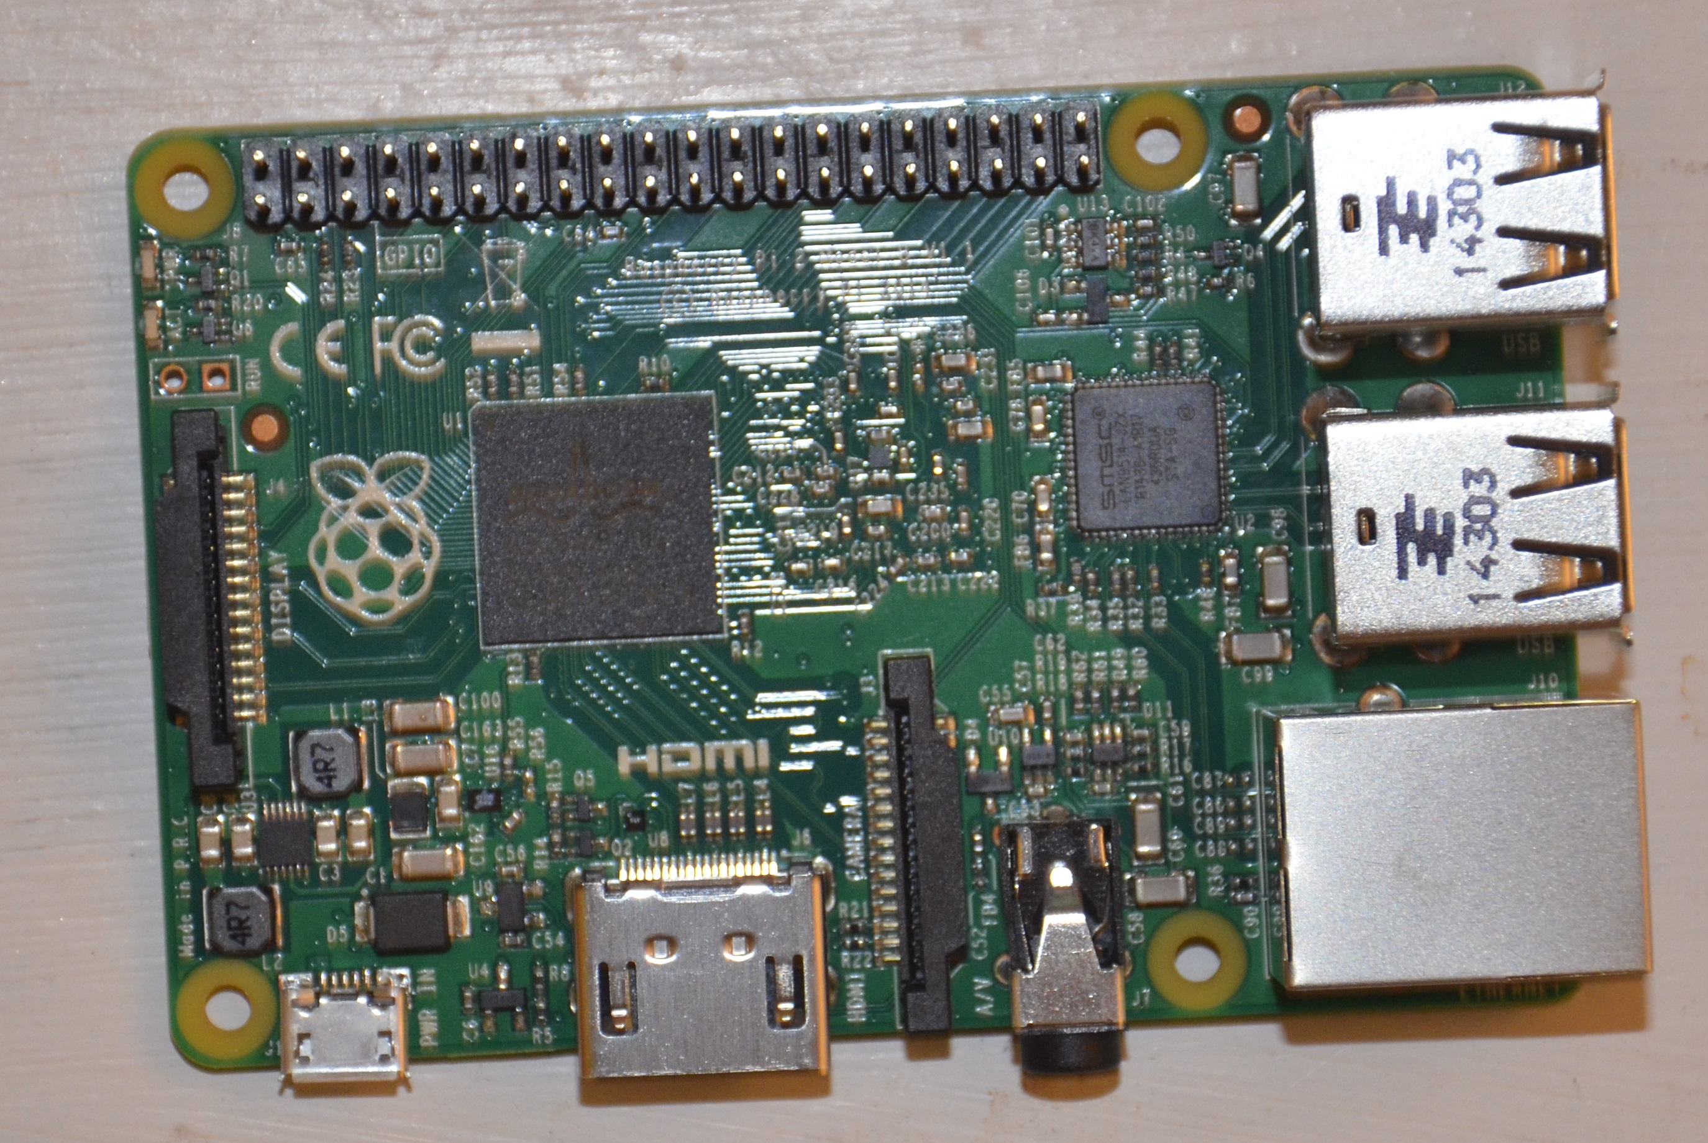

### Miniature SD Card and Adapter

This is the storage device that we will install the operating system to and then insert into the Raspberry Pi.

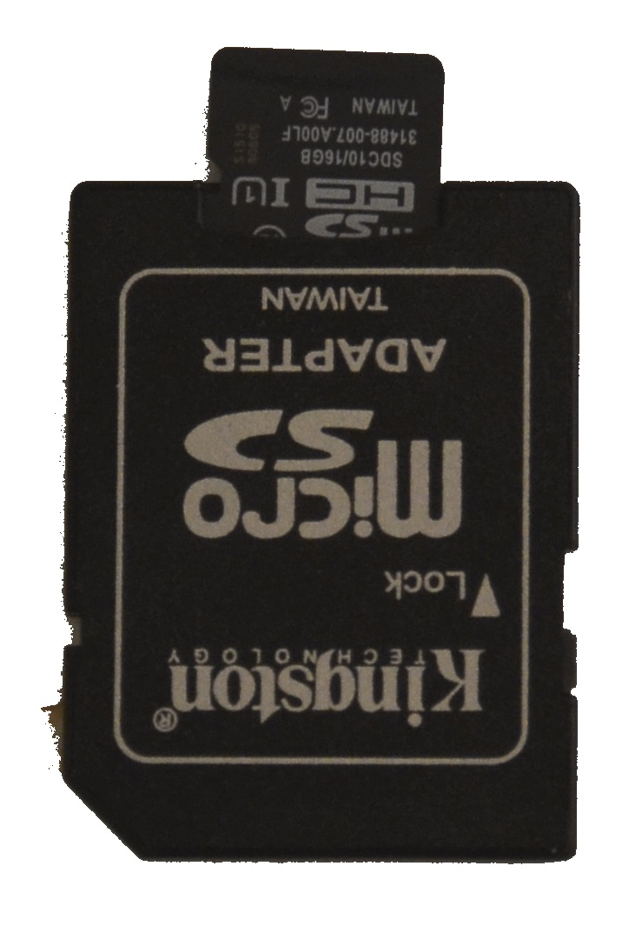

### Ethernet Cable

Used in the Ethernet interface for the Raspberry Pi. This will provide connectivity to the device.

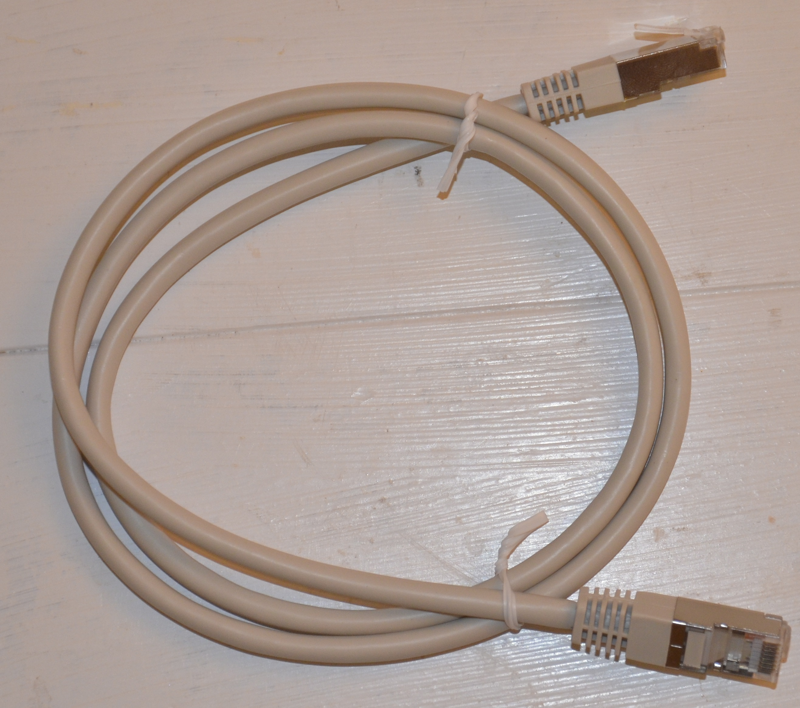

### Ethernet to USB Adapter

Most modern laptops do not have Ethernet ports anymore but rather USB ports. This allows us to convert the signals between the two and create a network connection between the Raspberry Pi and a modern laptop.

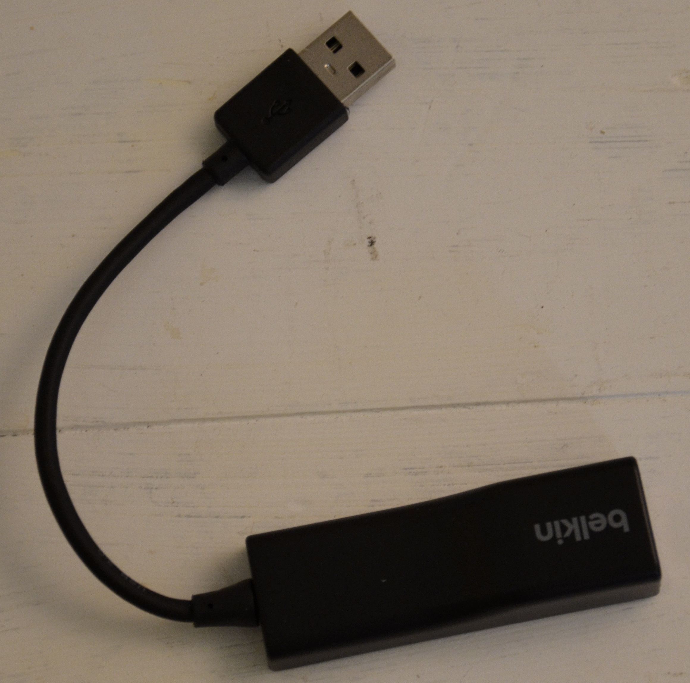

### Phone Charger

Used to power the Raspberry Pi

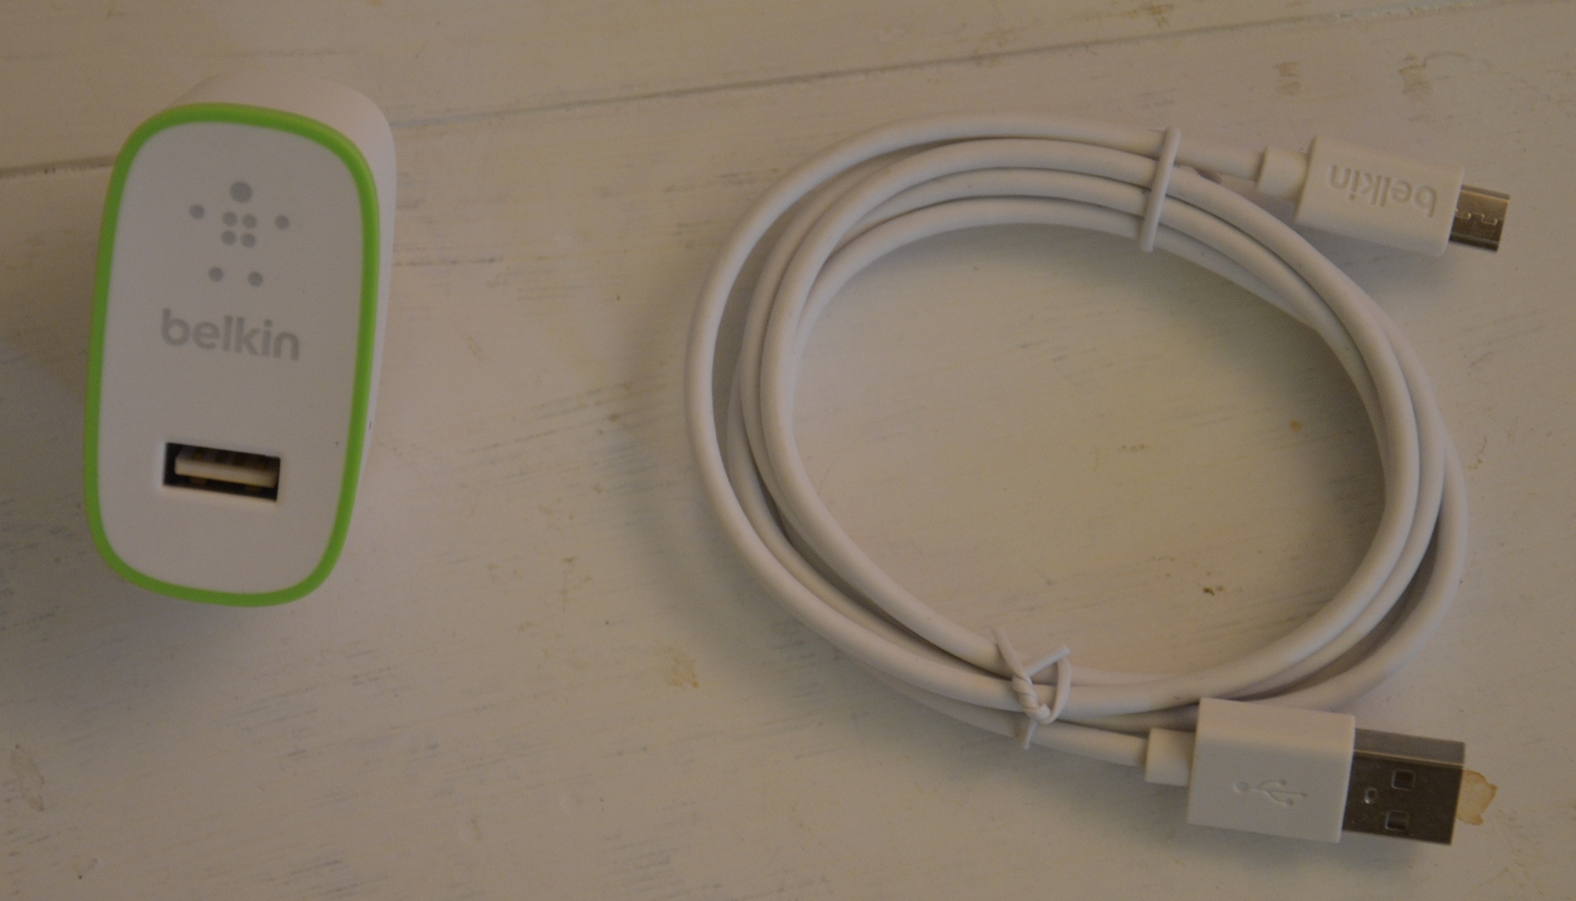

## Install Windows 10 to Raspberry Pi

### Download IoT Dashboard

<http://go.microsoft.com/fwlink/?LinkID=708576>

The IoT Dashboard is a tool that enables viewing and managing devices on your network significantly easier.

1. Download setup.exe from the link above.
2. Run the program.
3. Accept the defaults.
4. Run the IoT Dashboard

**If the IoT Dashboard is already installed** simply search in the Windows 10 Search area for “IoT”.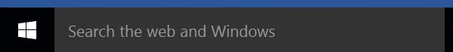

You will see the application: “Windows 10 IoT Core Dashboard” pop up. Run that application.

### Install Windows 10 to the SD Card.

1. Insert the miniature SD card (using the adapter if necessary) into your laptop.
2. From the IoT Dashboard, navigate to “Setup a new device.”
   1. 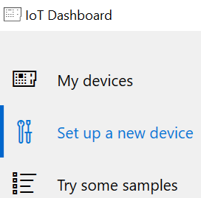
3. Select the options: “Raspberry Pi v2” , “Windows 10 IoT Core for Raspberry Pi v2” and the SD card you inserted. Also check the box for accepting the license agreement.
   1. 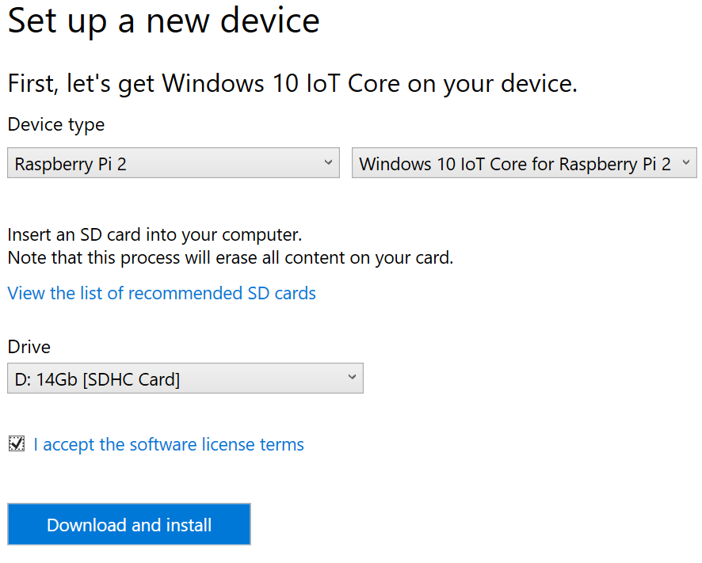
4. Click Download and install
5. Click Continue
   1. 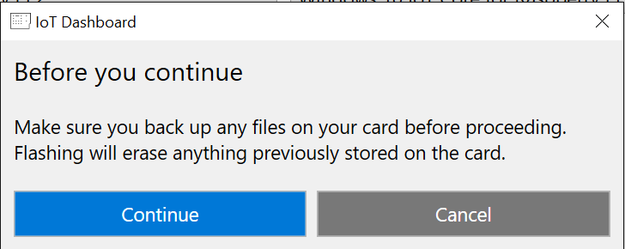
6. When access control asks for your permission to continue, Click “YES”.
7. 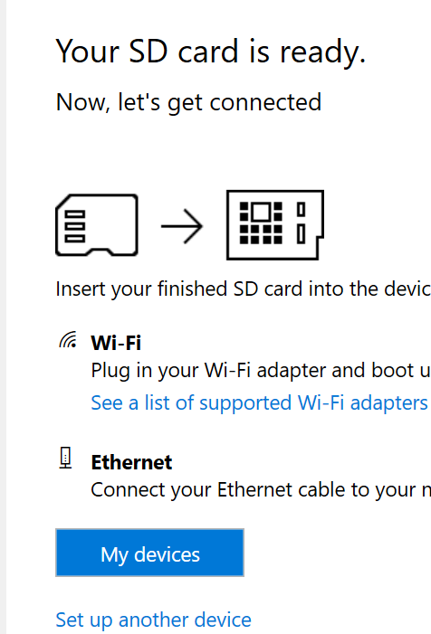
8. Remove the SD card from the laptop
9. Insert the SD card into the micro SD card reader on the back side of the Raspberry Pi
   1. 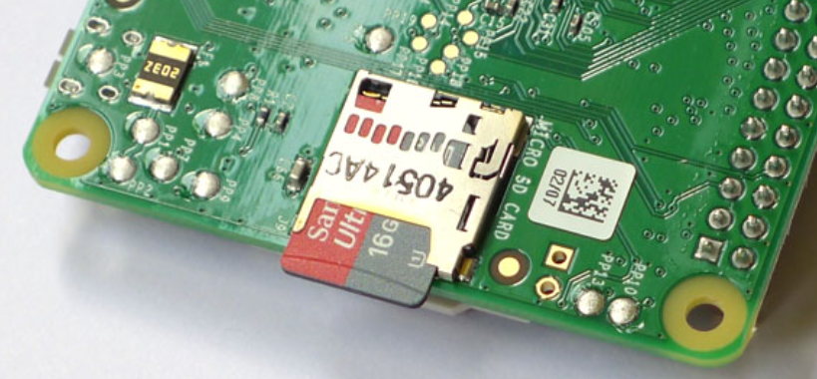
10. Power On the Raspberry Pi using the phone charger
    1. 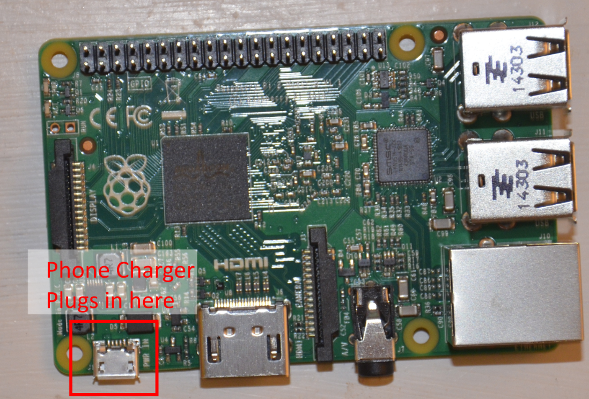

## Connect Raspberry PI

1. Connect Ethernet Cable to Ethernet USB adapter
2. Connect Ethernet Cable end into Raspberry Pi
3. Connect USB end into Computer
4. 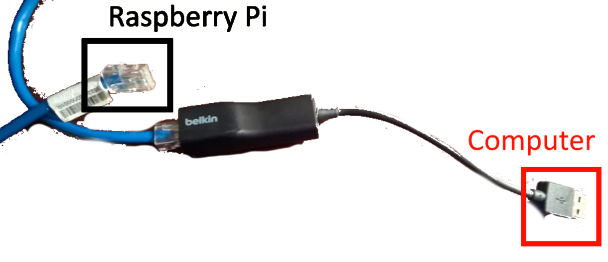
5. Notice from IoT Dashboard
   1. 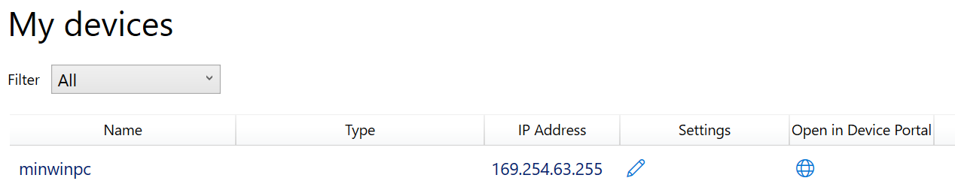
6. If the device does not appear within 60 seconds, try powering off and then powering on the device.

## Bridge Wifi Connection to Pi

The reason we are bridging a Wi-Fi connection is that we have connected the Pi to our laptop. In a production scenario the gateway device will be directly connected to a router and be provisioned its internet connections in that fashion.

1. From Windows 10 Search, Search for “Control Panel”
   1. Run it
2. Click on “Network and Internet”
   1. 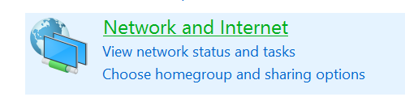
3. Navigate to Network and Sharing
   1. 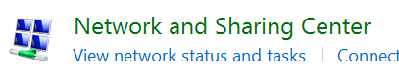
4. Find the network that has Internet Access
   1. Click on Wi-Fi link
   2. 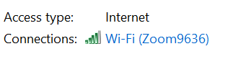
5. Click on Properties on the bottom left.
   1. 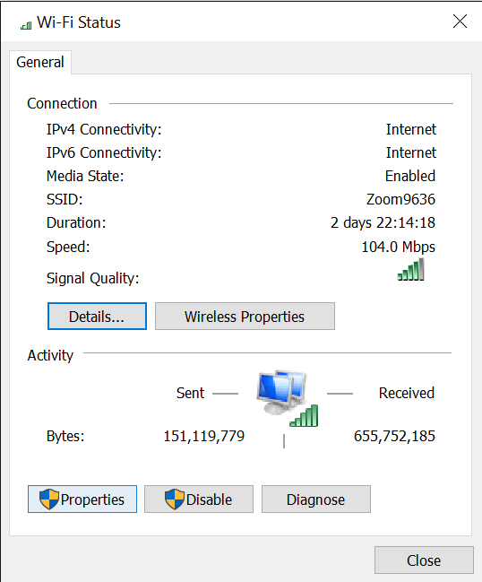
6. Click on the Sharing tab
   1. 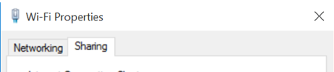
7. Click the checkbox next to “Allow other network users to connect”
   1. 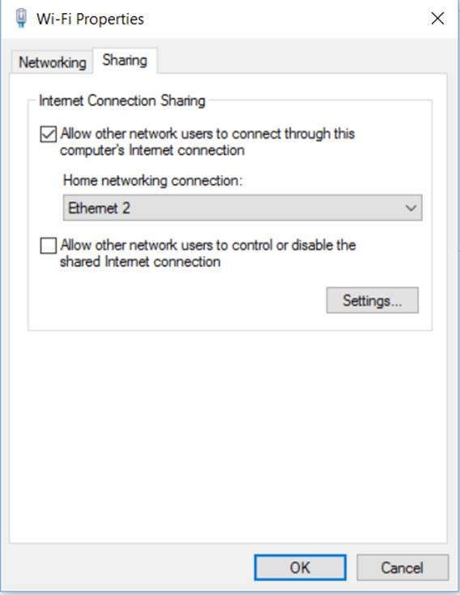
8. Click OK.

## Ensure Raspberry Pi DNS

As most resources change IP addresses dynamically, the Raspberry Pi needs to have the ability to find a resource by name such that it can communicate with it.

1. From Windows 10 Search, Search for “Services”
   1. Click
2. Find Windows Remote Management.
   1. If not started, start.
   2. 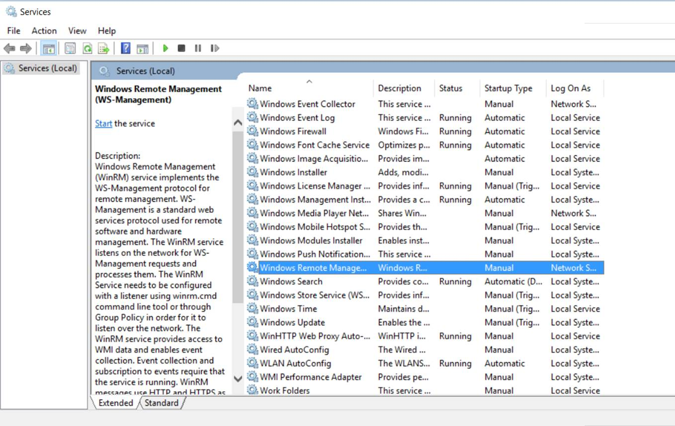
3. From Windows 10 Search, search for “cmd”
   1. Type the command “ipconfig”
   2. Look for your Ethernet adapter and write down the IPv4 Address.
   3. Here the address is 192.168.137.1
   4. 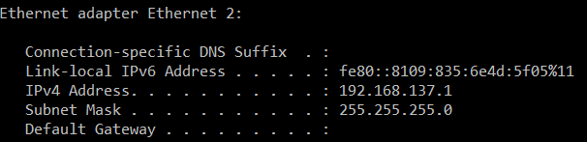
4. From Windows 10 Search, Search for “Powershell ISE”
   1. Right Click
   2. Run as Administrator
   3. Click “Yes”
5. Type the following commands
   1. 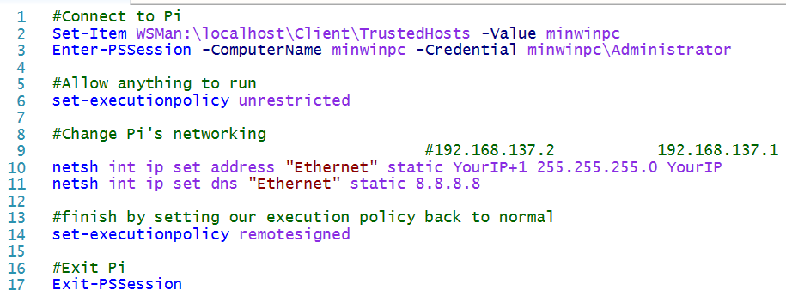
   2. Note the ip addresses in relation to what we got from ipconfig.
6. Run each command
   1. The highlighted icon runs each highlighted section of code
   2. Highlight each section one by one and press the button.
   3. Wait ~3 seconds between executing each line of code.
      1. You may receive a failure if you attempt to execute too fast
      2. Just try the failed line again.
   4. The password is: “p@ssw0rd”, where the 0 is the number zero.
   5. 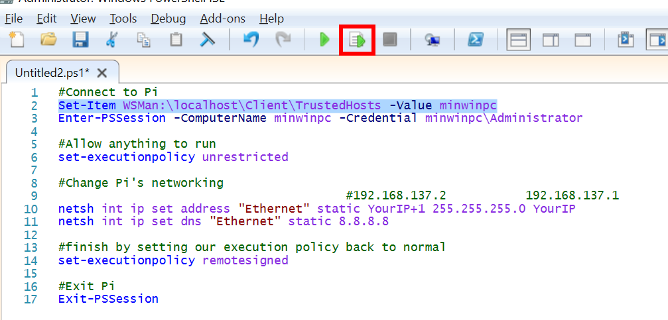

# Part 2: Hardware Prototyping

This section builds on part 1. You will need to have the components assembled installed and configured from part one to complete part 2.

## Identify and Collect Additional Necessary Parts

### Breadboard

A breadboard is a device used to connect wires together without soldering. An explanation on how to use a breadboard is later in this lab. 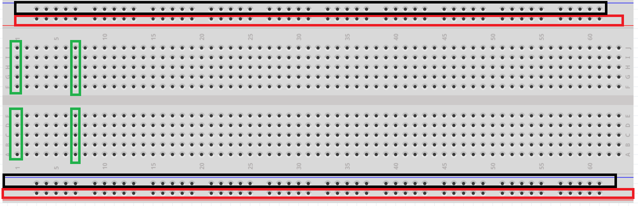

Each row of the breadboard corresponds to a “bus” or a connection. In the image above any component plugged into one of the green blocks will be connected to any other device in that green block equally. This is true for the black block and the red block. Each block is independent of the others. You can create connections between blocks by running a wire or component from one block to another. Notice how the rows are organized and laid out. Most breadboards operate in this manner.

### MCP 3008

The MCP 3008 is an Analog to Digital converter. It allows a variable voltage level to be converted into a digital signal that the Raspberry Pi can understand. Computers speak in 1’s and 0’s, while the natural and physical world does not, therefore a chip is necessary to translate between the two. This is what the MCP 3008 does. Note that in the kit, there are multiple chips that look very similar. Each one has words on it. The MCP 3008 has the letters: “MCP 3008” on it, though it is very difficult to see.

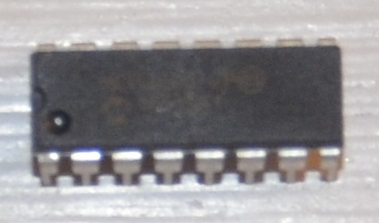

### Temperature Sensor

The temperature sensor is a variable resistor. Based on the temperature, it will reduce the incoming voltage to a lower voltage. The difference between the voltage levels can be used in a calculation to accurately determine the current temperature.

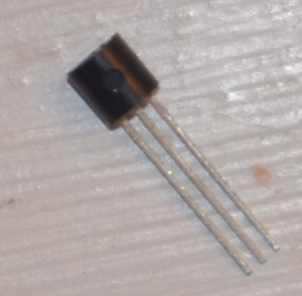

### Photo Resistor

The photo resistor is a variable resistor. Based on the quantity of light it will create a different output voltage than the input voltage level.

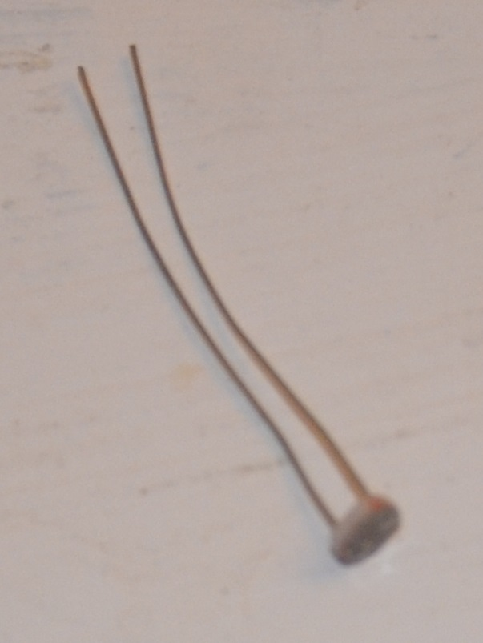

## Wiring

It is important to note in this section that one of the learning points is HOW a breadboard works and how to use it. Do not get caught up in a wire has to go into column 27, row a; but rather understand how the breadboard works and why the wires are connected in this manner. This will further your knowledge for how and why each electrical component actually works and is a key element to understanding rapid prototyping.

### Raspberry Pi v2 Pin Layout

This is just a reference image.

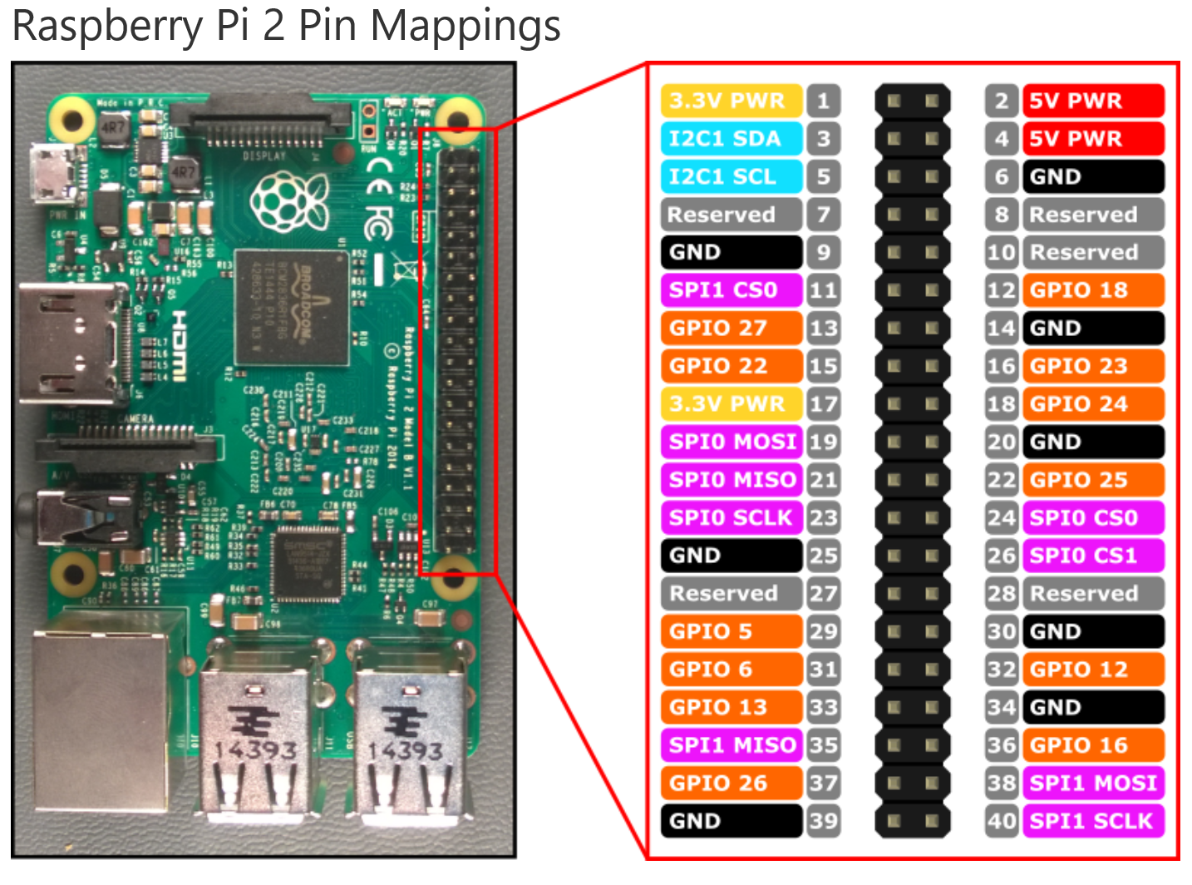

### MCP 3008 Pin Layout

This is just a reference image. The Raspberry Pi will communicate with this device over Serial Peripheral Interface number 0 (SPI0). This interface consists of pins: 19, 21, 23 and 24 on the Raspberry Pi and pins 10, 11, 12 and 13 on the MCP 3008. The other right hand side pins are for power, power reference and ground. The pins on the left hand side are channels that can convert analog to digital to be output back to the Raspberry Pi.

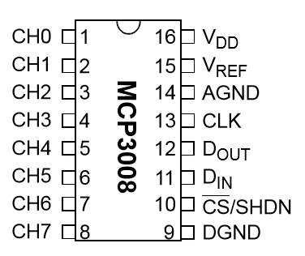

### Wire Raspberry Pi and MCP 3008

For this step, you will actually wire the Pi to the MCP 3008. Recall from the segment on how a breadboard works that you do not necessarily need to plug the wires into those exact pin holes. The important concept to realize here is that the two halves of the MCP 3008 (pins 1-8 and 9-16) are split on two different connection buses. Also note that the Pi supplies power to the power bus and ground to the ground bus. Also realize that for example pin 23 on the Raspberry Pi connects to pin 13 on the MCP 3008 and nothing else.

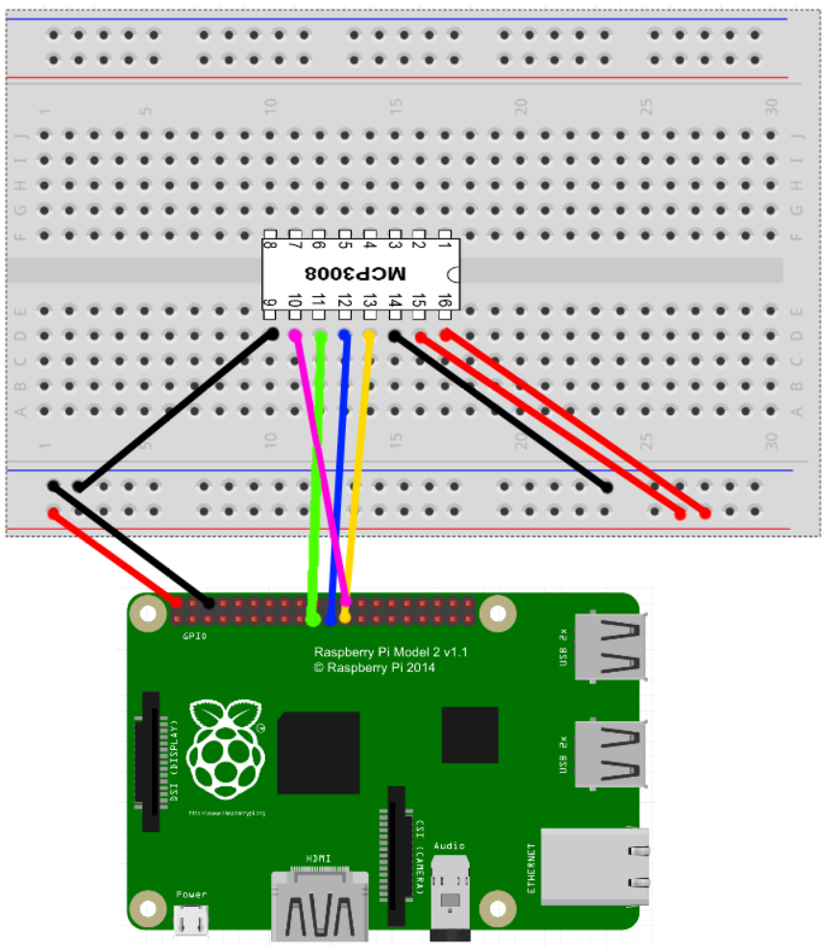

### Knowledge Check

1. On the MCP 3008, what is the difference between pins 16 and 15?
   1. Pin 16 supplies power to the board while pin 15 supplies the amount of voltage used as a reference point for the incoming voltages from the analog sensors. The difference between pin 15 and incoming channels is then converted to digital and provided back on the MISO line to the Pi.
2. How many pins are connected to the Raspberry Pi’s pin 6?
   1. 2, MCP 3008’s pins 9 and 14 which are the grounds for the digital and analog circuits.
3. How many analog sensors can you connect to the MCP 3008?
   1. 8
4. What does MOSI and MISO stand for?
   1. MOSI -> Master Out, Slave In
   2. MISO -> Master In, Slave Out
5. What type of power is being supplied to the MCP 3008?
   1. Parasitic power. It is called this, because the MCP 3008 is using the Raspberry Pi as its primary power source and is therefore drawing additional amps across the Pi that would not ordinarily be moving through the device.
6. How many volts are being supplied to the device?
   1. 5V

### Temperature Sensor Pin Layout

Take important note of the *orientation and shape* of the temperature sensor. Reverse wiring the temperature sensor will cause it to *overheat, melt and potentially catch fire*. **Supply ground prior to power.**

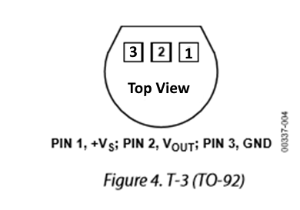

### Wire Temperature Sensor and MCP 3008

Notice that the current wiring has been removed from the diagram. This is to showcase a completely separate circuit. You should keep the current wiring in place and add this wiring to it.

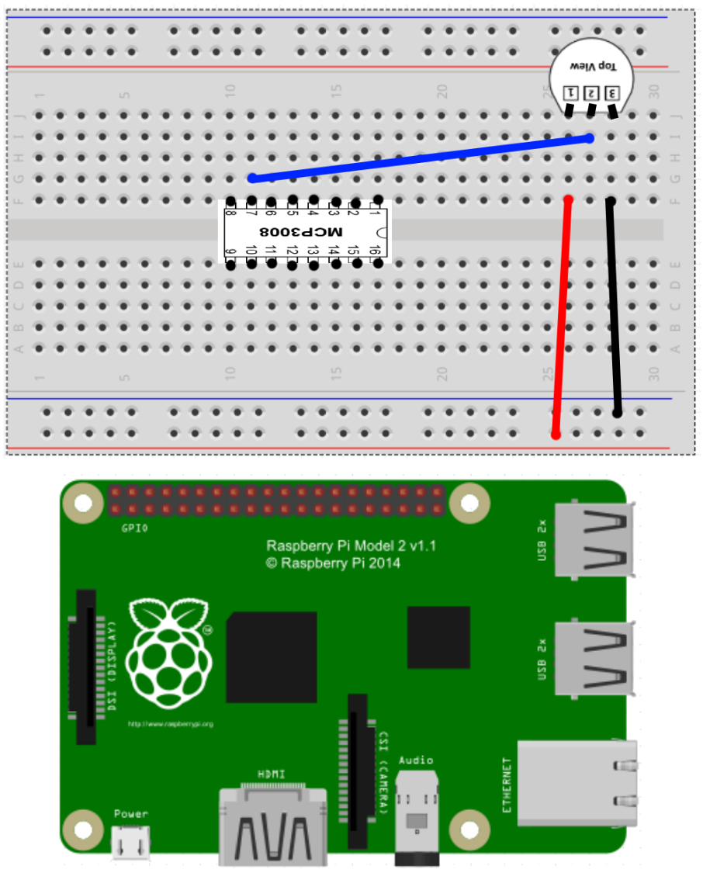

### Wire Photo-Resistor and MCP 3008

A photo resistor is a very simple device and no wiring diagram is required for it. It is basically a simple series based inline resistor that changes impedance based on quantity of light. It has no direction and therefor is treated simply like an inline resistor. The resistance decreases with light intensity, therefor the closer to 5V, the higher the amount of light is being sensed.

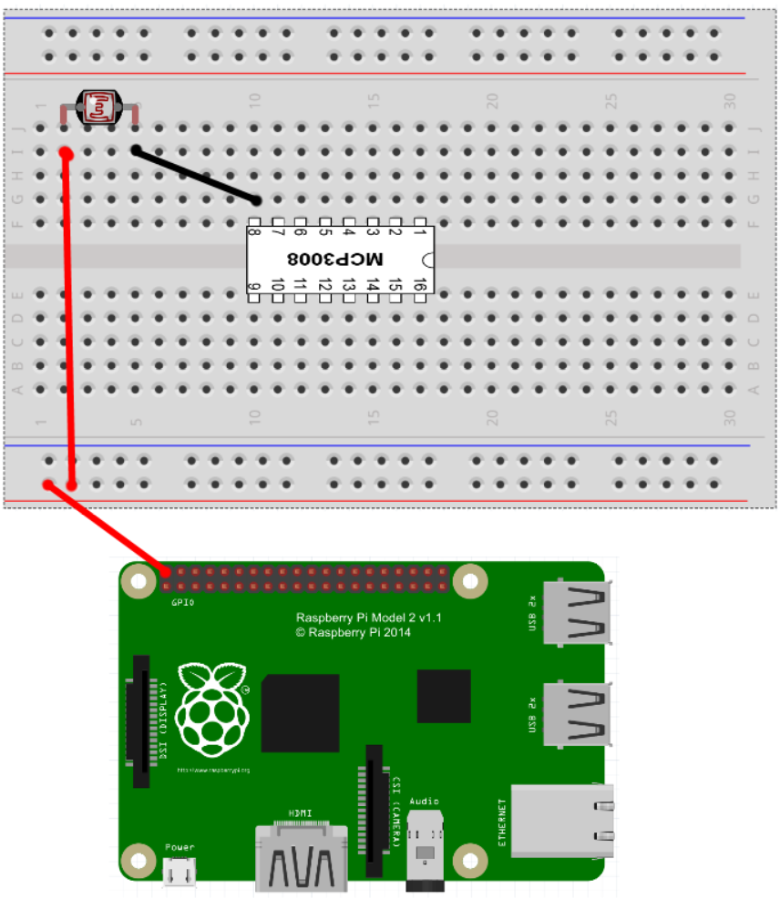

### The Complete Diagram

Below is a complete wiring diagram for the circuit with the Raspberry Pi, Photo Resistor, Temperature Sensor and MCP 3008 all connected. Remember that yours may not necessarily look like this as you should have focused on HOW a breadboard works and not necessarily using the exact holes as used in this diagram.

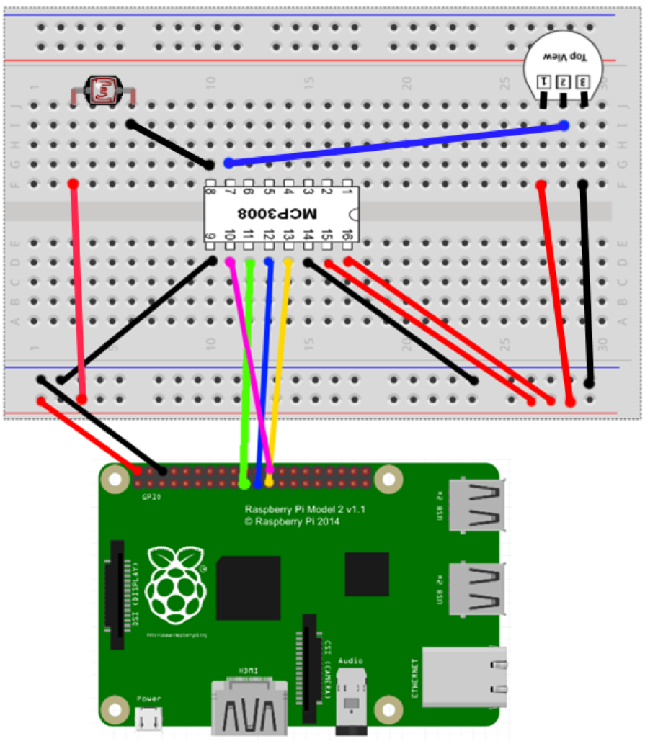

# Part 3-A: Data Streaming – Resource Provisioning

Part 3 is all about getting the data being detected by the electrical components from the device into the cloud. Part A will be provisioning the cloud based resources while Part B will be writing code to integrate with those resources from the device.

## Accessing Azure

Azure is the Microsoft public cloud offering. Beyond simple virtual machines, Azure has several PaaS offerings which are ideal for IoT scenarios and greatly reduce time to market, development complexity and can scale to support enterprise scenarios while still allowing you to pay only for what you use. For these reasons and more beyond the scope of this lab, PaaS and Azure have been my go to abstraction level for any product development.

1. From your computer browser, navigate to [www.Azure.com](http://www.Azure.com)
2. Login with your Microsoft Account.
   1. 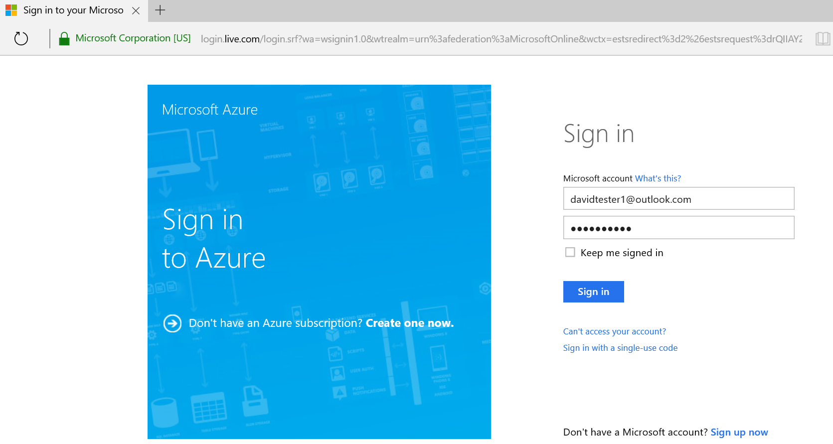
   2. If you do not have one, click the “Sign up now” link.
   3. You can connect a Microsoft account to any already existing email address. It is just simply a way to recognize you as a unique user.
3. You will then see the view below:
   1. 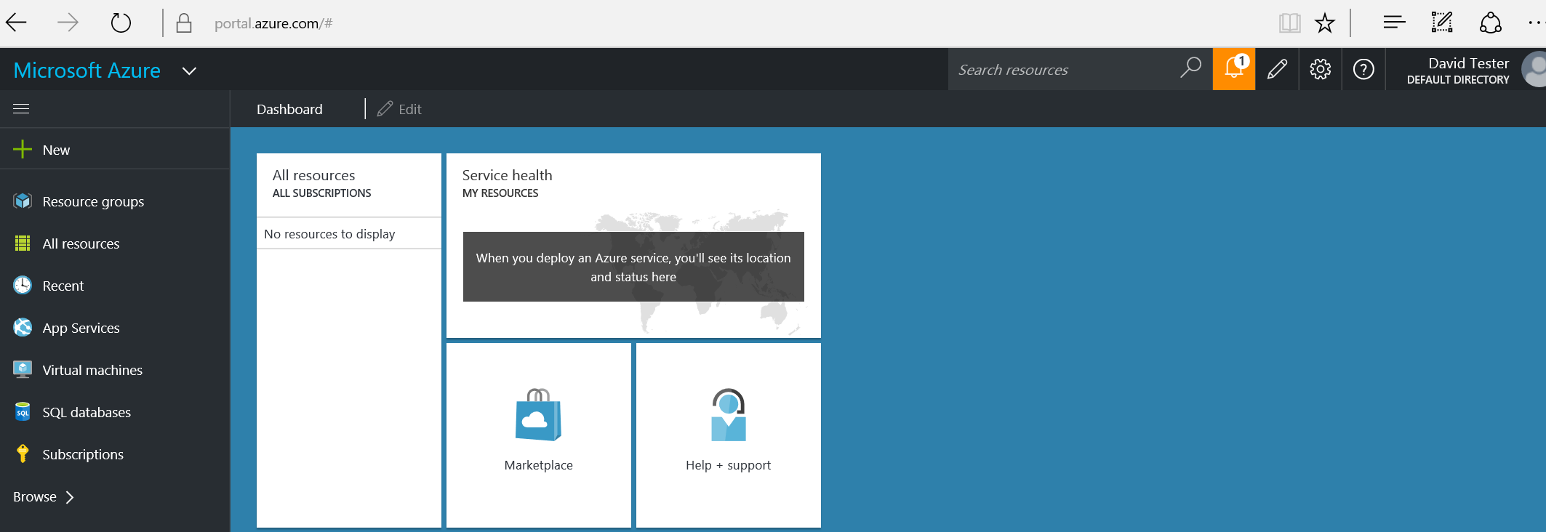
4. Click on the “New” Button in the top left.
   1. Type “IoT Hub” followed by pressing the enter key
   2. 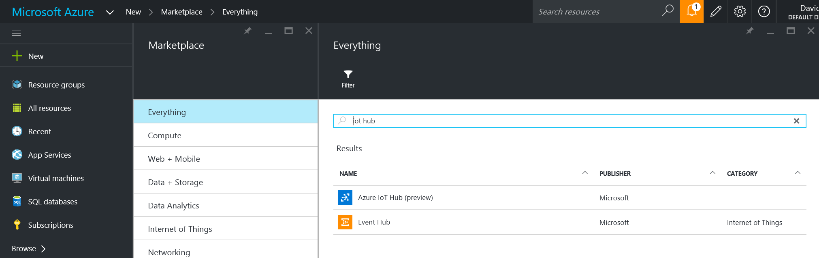
5. Select “Azure IoT Hub” (it may or may not be in preview at the time of taking this course).
   1. 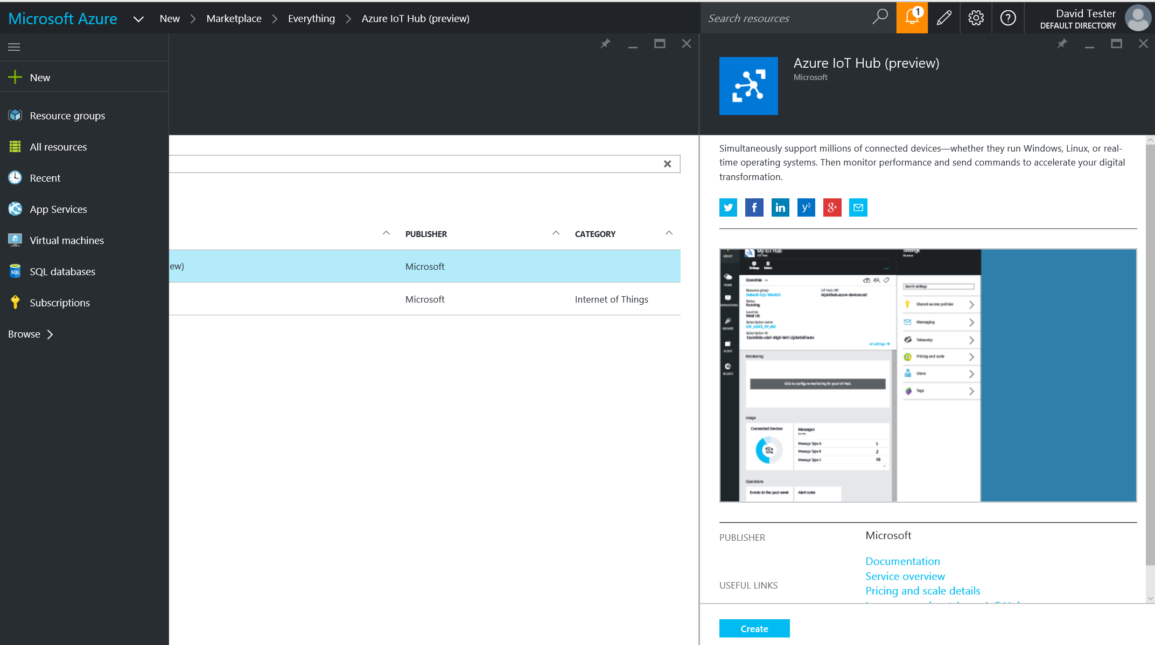
6. Click the create button on the new pane that opened up.
7. A new pane will appear asking you to sign up.
   1. 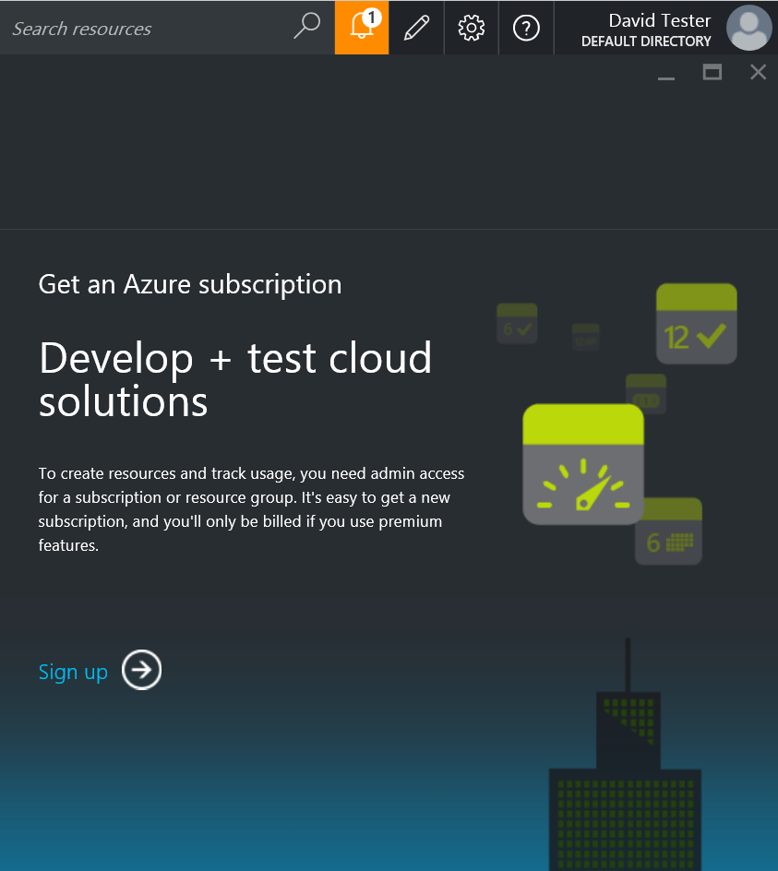
   2. Click Sign up
8. Select Free-Trial
   1. 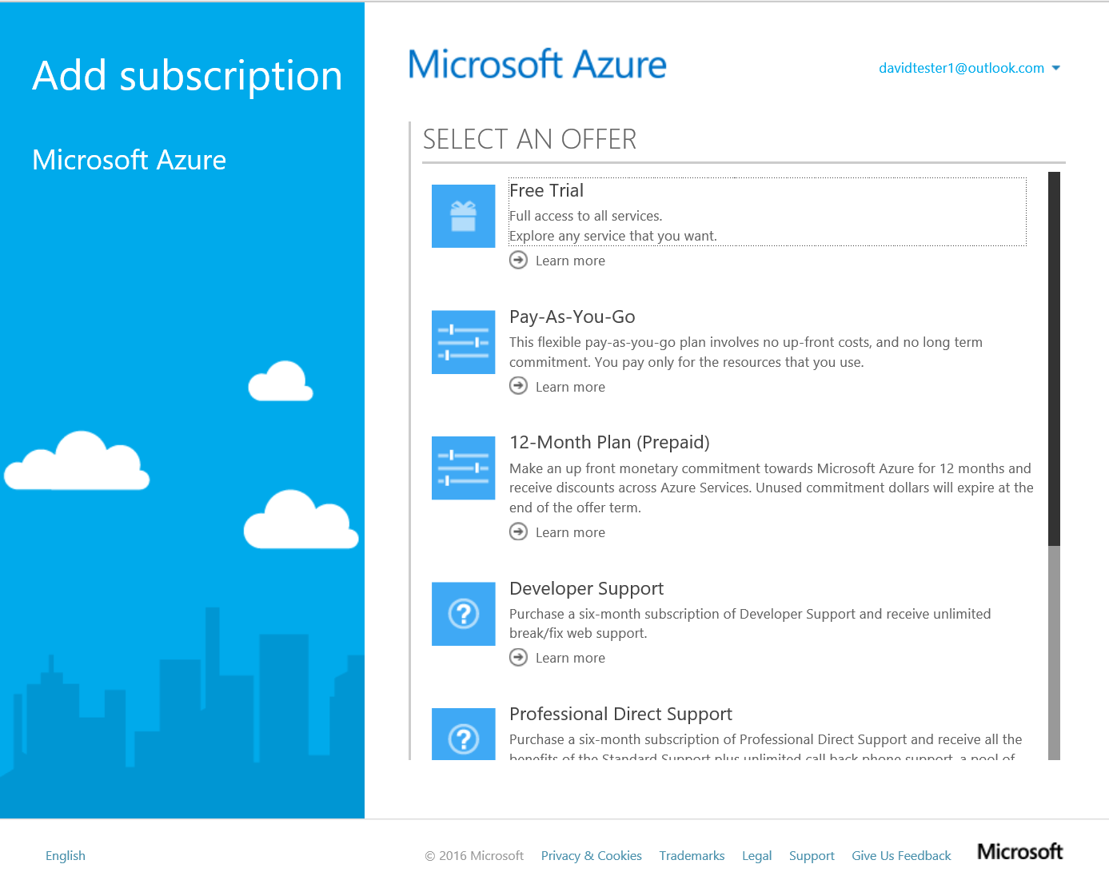
   2. **Pro-Tip:** If your current free trial has expired, simply create a new email address at outlook.com ([somebody@outlook.com](mailto:somebody@outlook.com) for example), this will automatically be associated as a Microsoft account and you can begin a whole new trial period with this account.
9. Complete the form
   1. 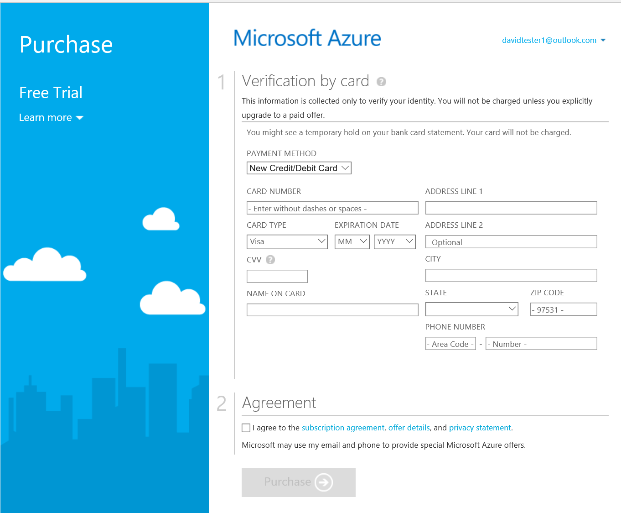
10. Return to Azure.com and enter your credentials if requested.

## Provision Azure IoT Hub

IoT Hub is a high throughput message passing solution, which has time to live, built in redundancies, bi-directional communication, device management and multiple other facets built into it. It is an abstraction layer above the Event Hub geared specifically towards IoT based scenarios. The power of this will be more apparent in the coding section.

1. Click on “New” in the top left corner.
   1. Type “IoT Hub” followed by pressing enter in the search bar.
   2. 
2. Select “Azure IoT Hub” (it may or may not be in preview at the time of taking this course).
   1. 
3. Click the “Create” button on the bottom of the pane.
4. This time, a new pane will open with configuration options
   1. 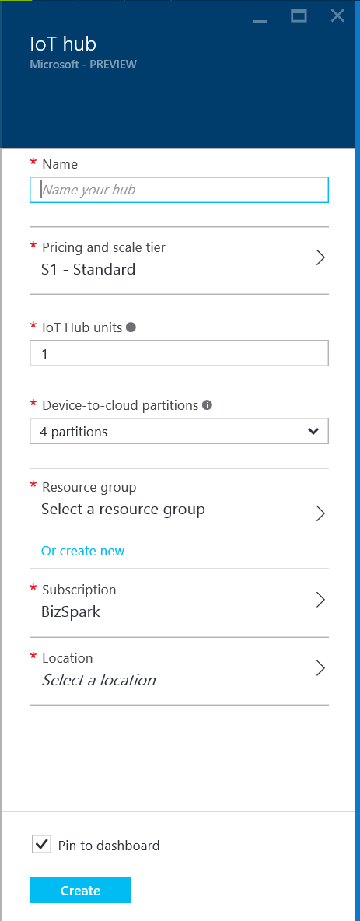
5. Under name, use your initials – mtp
   1. Mine would be “drc-mtp”
   2. If the name is already taken, try adding random numbers on the end.
6. Click on Pricing, Click Free
   1. 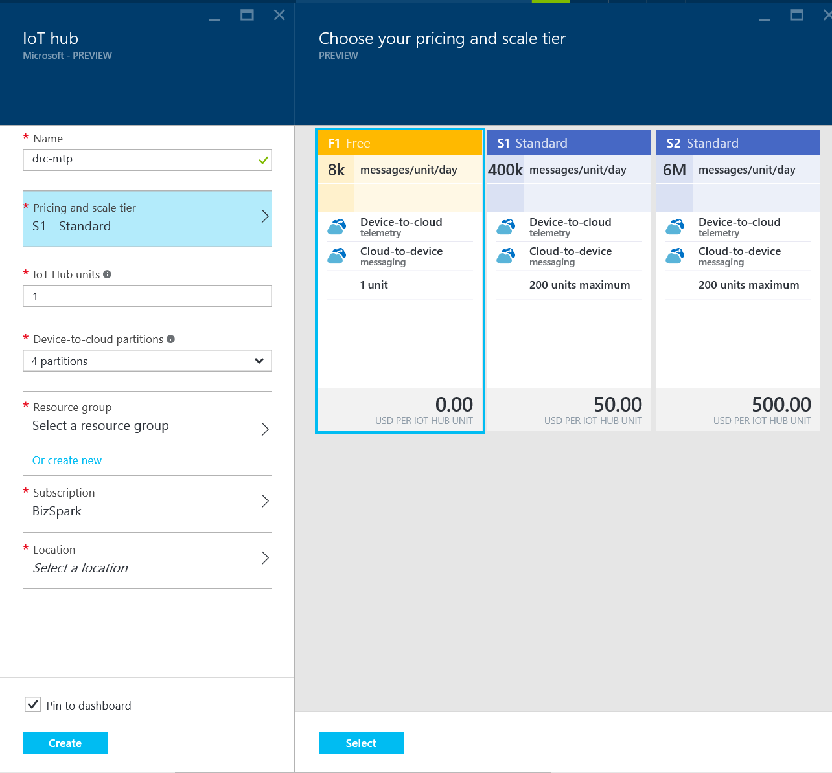
   2. Click the select button at the bottom
   3. Notice that units and partitions grey out.
   4. These are options for scaling.
7. Click on the “Or create new” link under Resource Groups
   1. Name it: “MTP-HOL”
8. Click on Location
   1. Select the location closest to you geographically.
9. Review your configurations
   1. 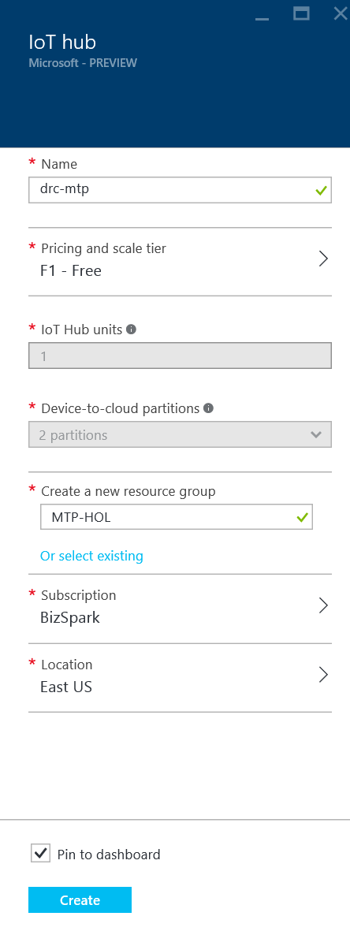
10. Click the “Create” button
    1. 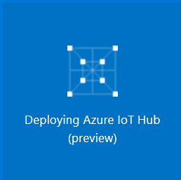
11. When it is done provisioning a new pane will appear
    1. 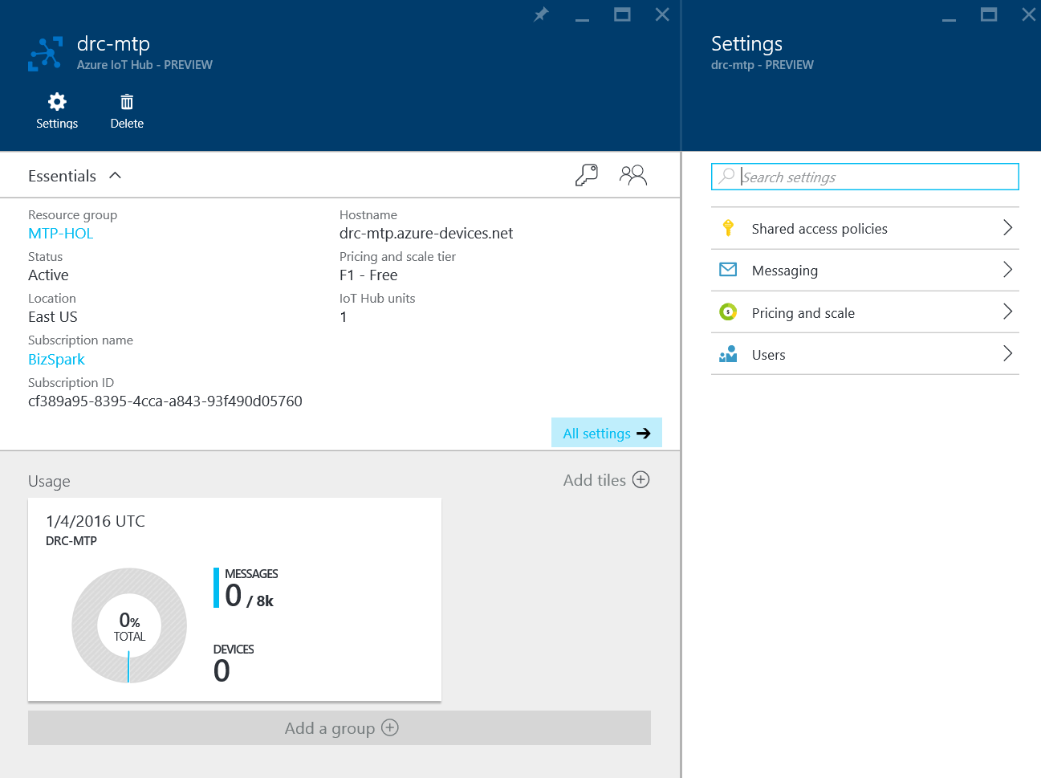

## Provision Azure Stream Analytics

Stream Analytics is a high throughput message analysis and re-routing system. It allows the user to query incoming messages from IoT Hub for example, do some analysis and put out another message to another system be it storage, messaging, queues etc.

1. Click the New button in the top left.
   1. 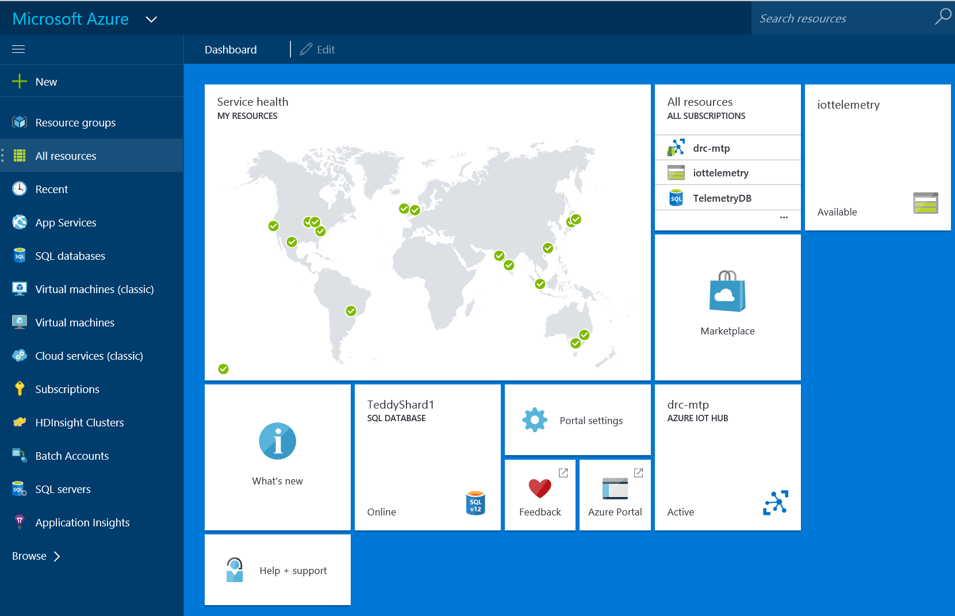
   2. Note: if you are stuck in the IoT Hub Panes, you can click “Microsoft Azure” in the top left to return to the view you see above.
2. In the search area, type “stream analytics” followed by pressing enter
   1. 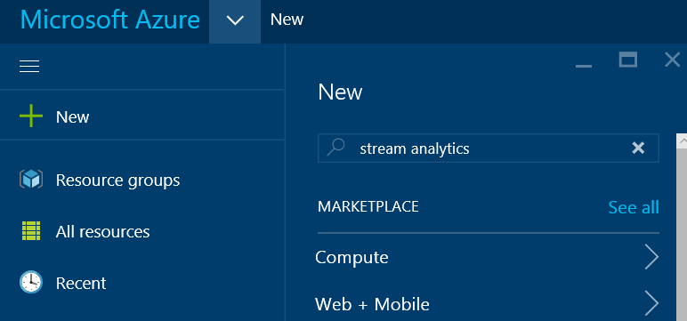
3. Click on “Stream Analytics Job”
   1. 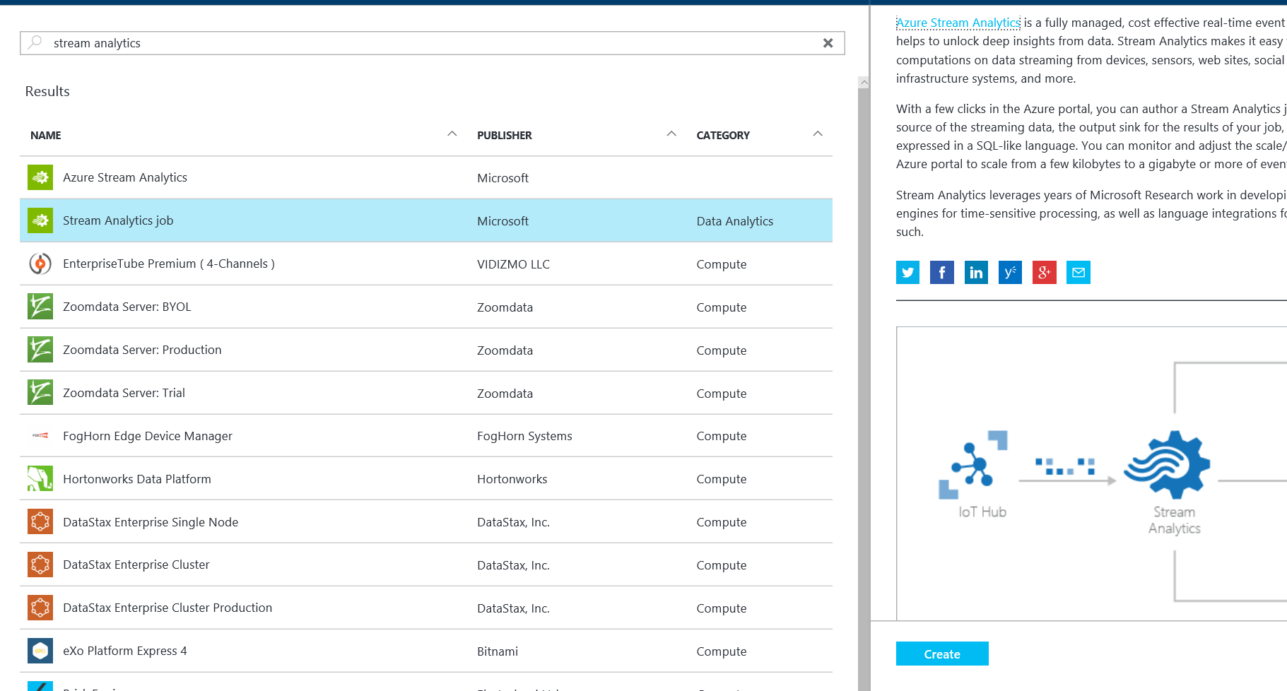
   2. “Azure Stream Analytics” and “Stream Analytics Job” are the same, just “Azure Stream Analytics” will navigate you to the old provisioning process.
4. Click the “Create” button
   1. This will open a new pane
   2. 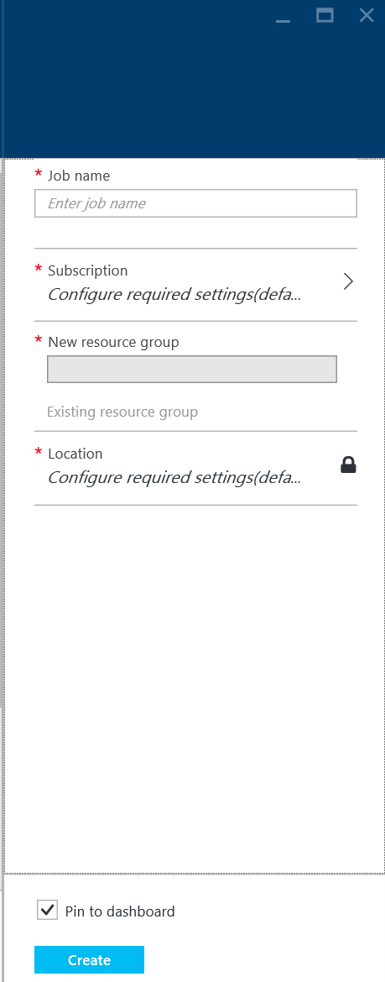
5. Name the job your initials-mtp
   1. For example, mine is drc-mtp
6. Click on Subscription
   1. 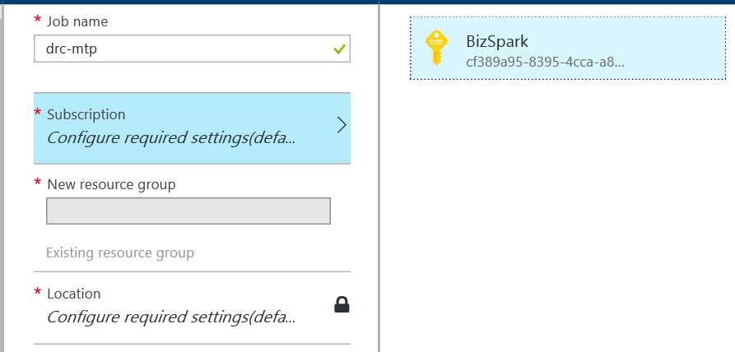
   2. Select your active subscription
7. Click on the “Existing Resource Group” link in the Resource Group’s section
   1. 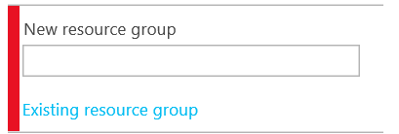
   2. 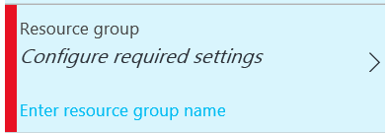
   3. Click on the whole button now.
   4. Search for MTP-HOL
      1. We created this earlier
8. Click on Location
   1. Select the location closest to you geographically
9. Review your settings
   1. 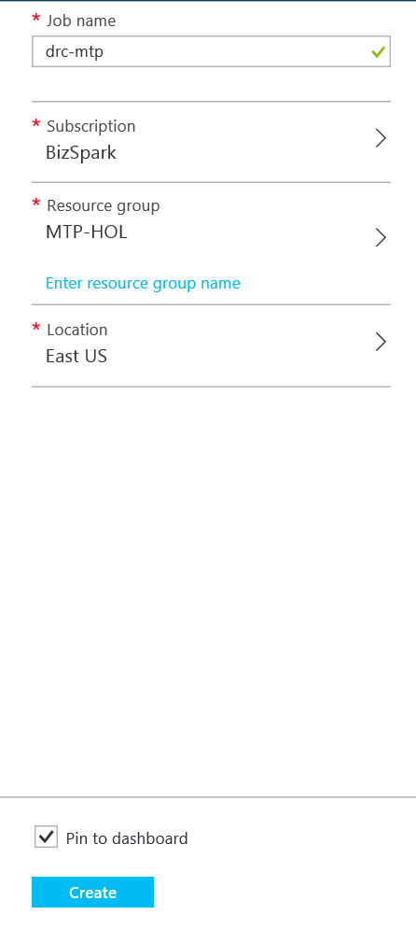
10. Click the “Create” button.
    1. 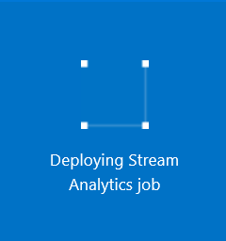
11. Once provisioning is complete, a new settings pane will open
    1. 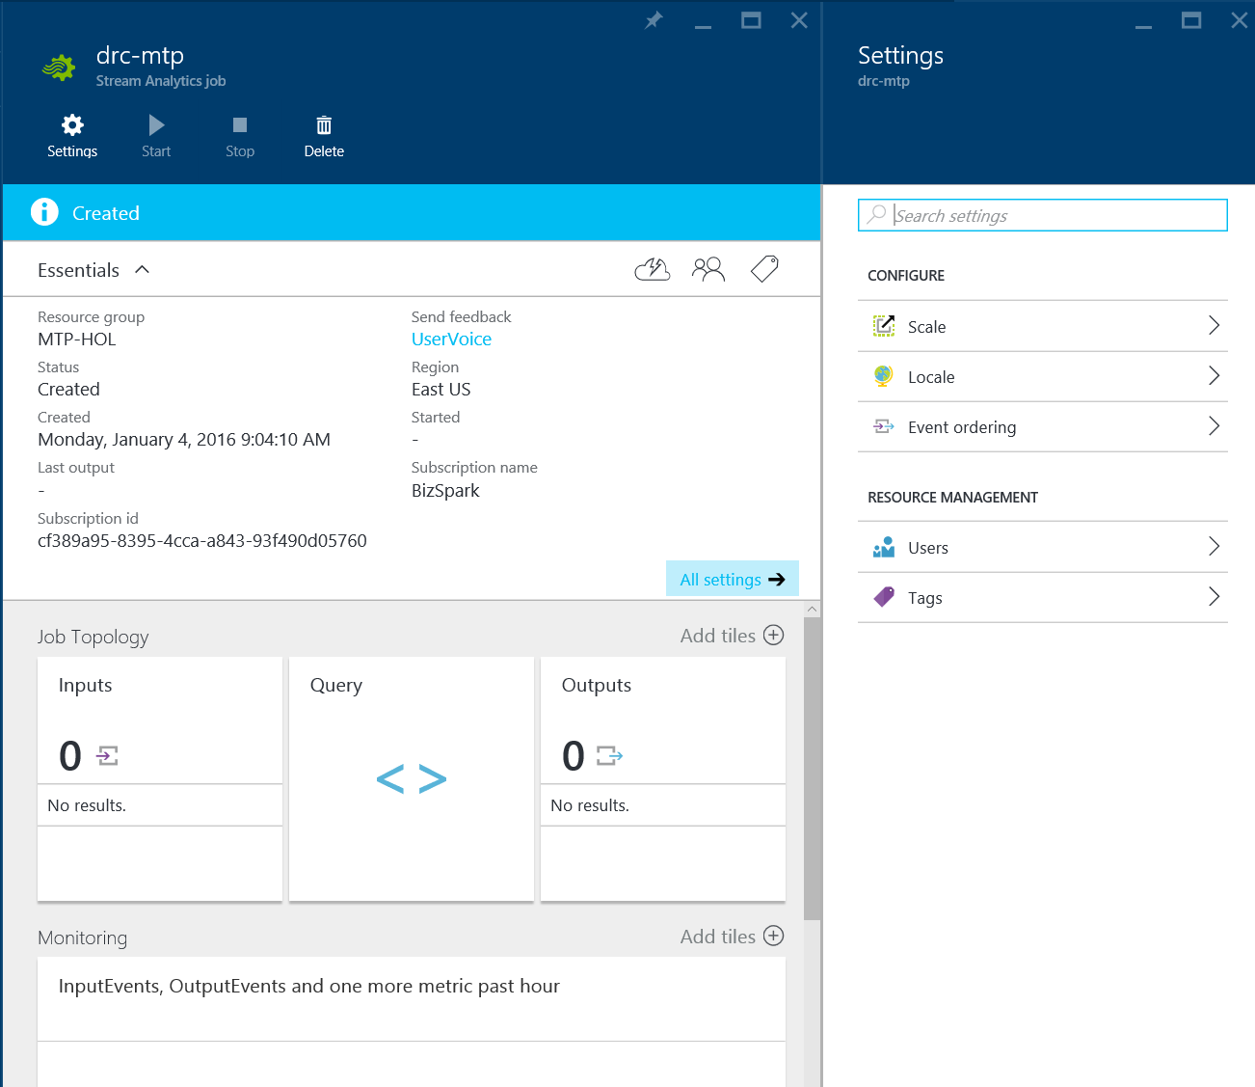

## Provision SQL Azure

SQL Azure is a fully managed SQL Server database. SQL is a high performance relational database ideal for storing and querying data with very high speed and performance. It is also as of 2015 the most secure database according to National Institute of Standards and Technology Comprehensive Vulnerability Database update 10/2015

1. Click on “New” in the top left.
2. In the search Area, search for “SQL”
3. Click on SQL Database
   1. 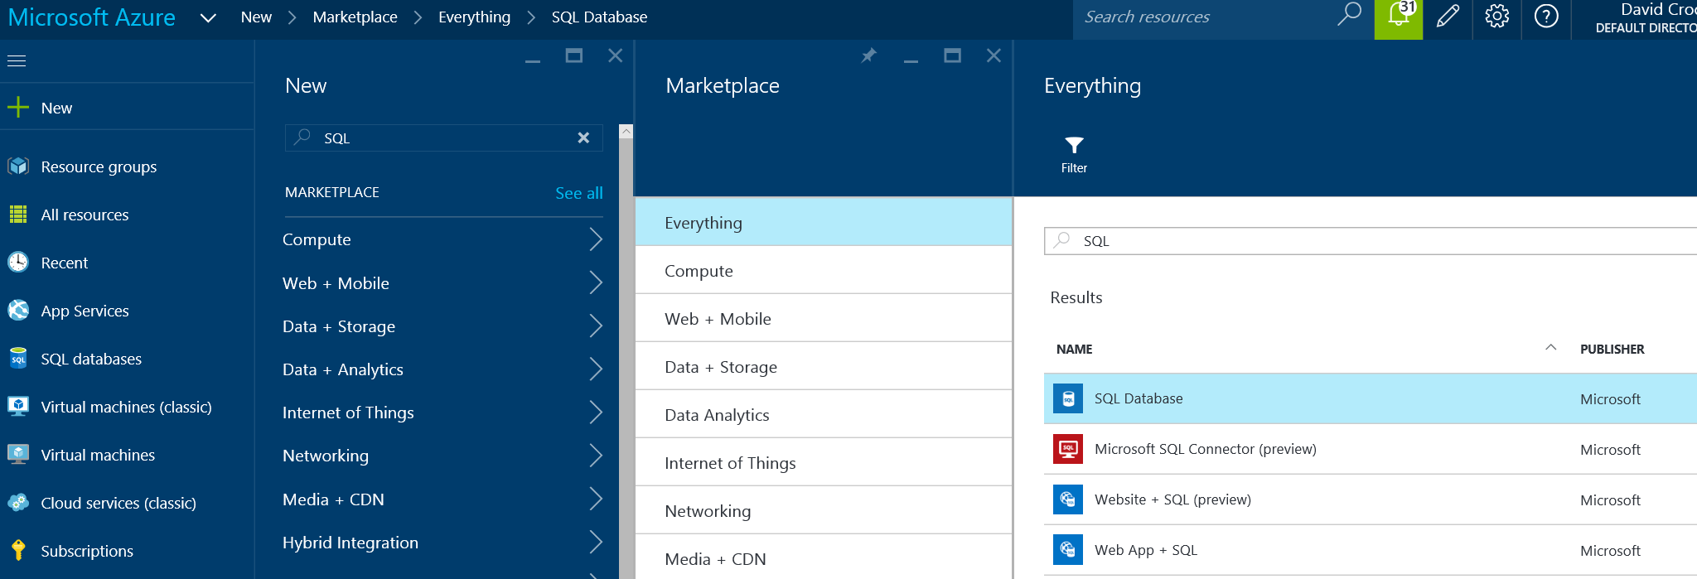
4. Click the “Create” button on the bottom
   1. 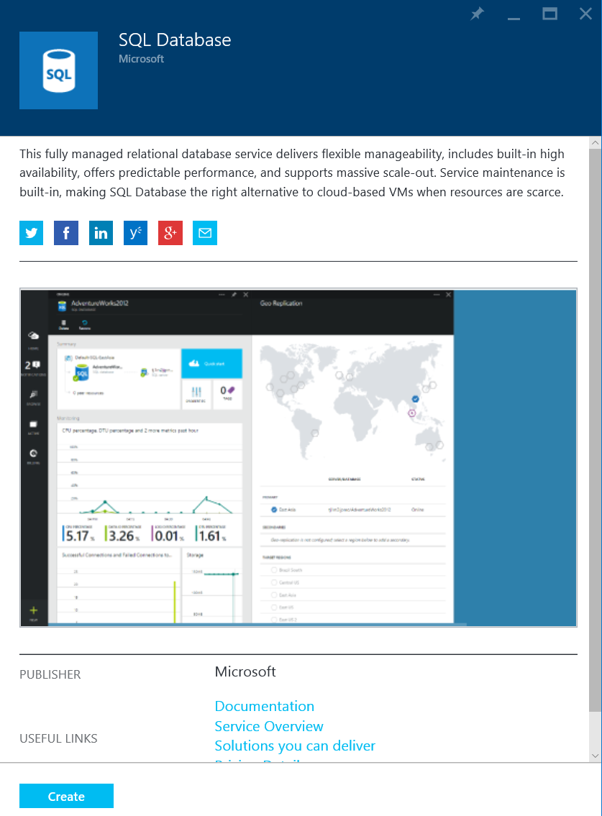
   2. 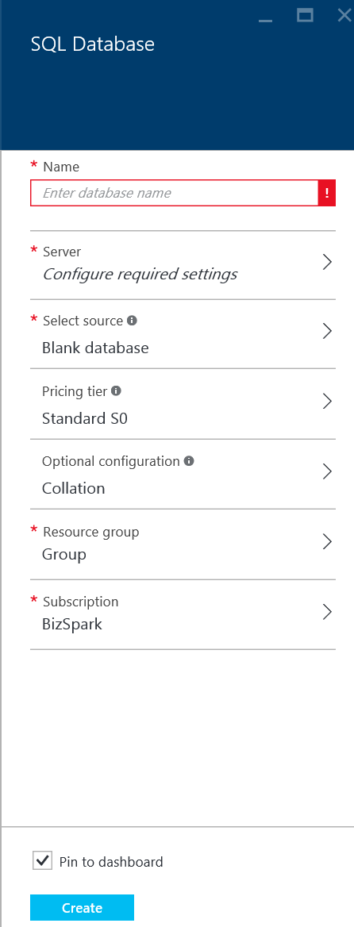
5. Use your initialsmtp for the database name
   1. For example, mine is “drcmtp”
6. Click on Server
   1. 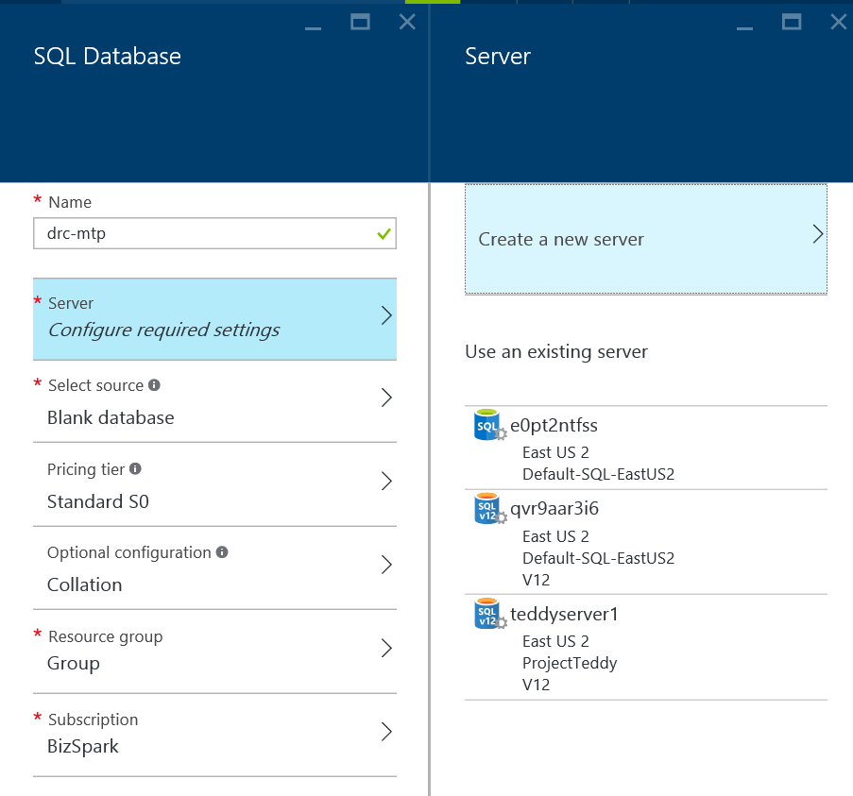
7. Click Create a new server
   1. 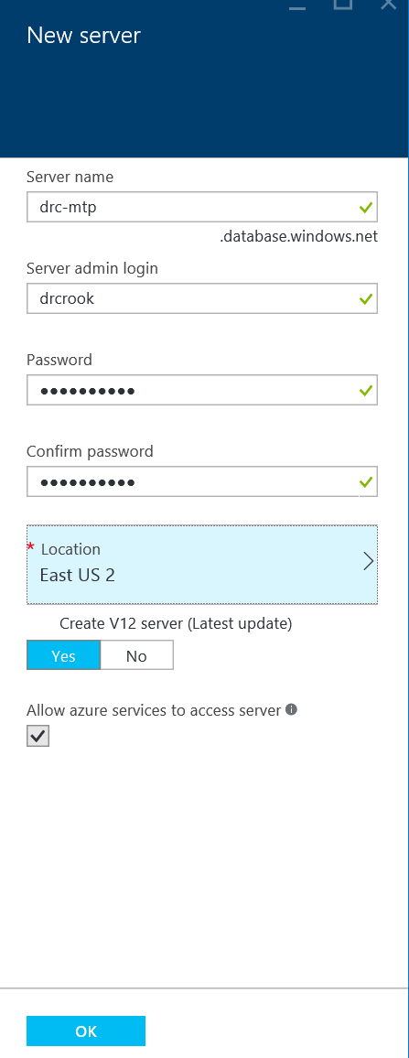
   2. For Name, use your initials-mtp
      1. For example, mine is “drc-mtp”
   3. For Server admin login, use “drcrook”
   4. For Password, use “David!2345”
   5. For location, use the closest one geographically to you.
   6. Use the latest server version.
   7. Ensure the Allow Services checkbox is checked.
   8. Click “OK”
8. Click Pricing Tier
   1. Select “Basic”
   2. 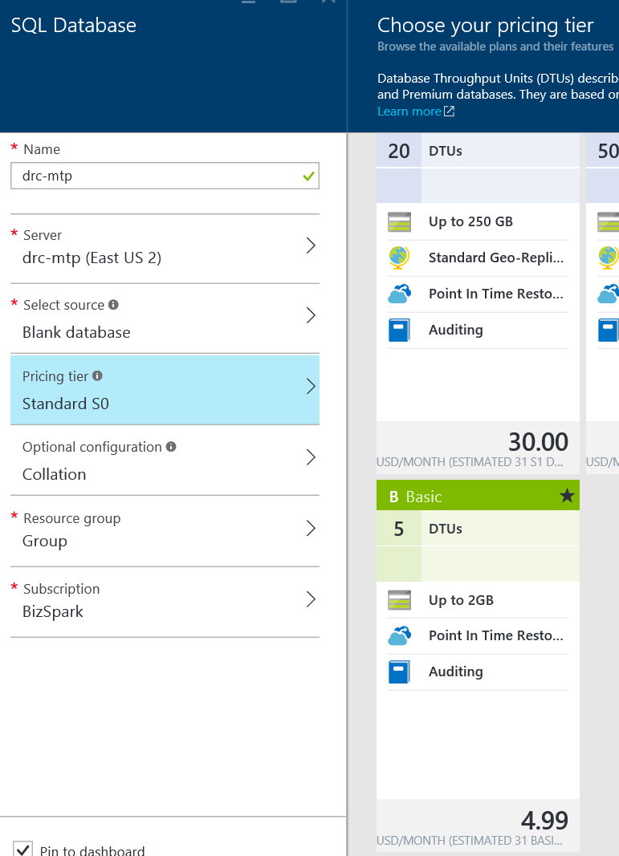
   3. Click Select
9. Click Resource Group
   1. 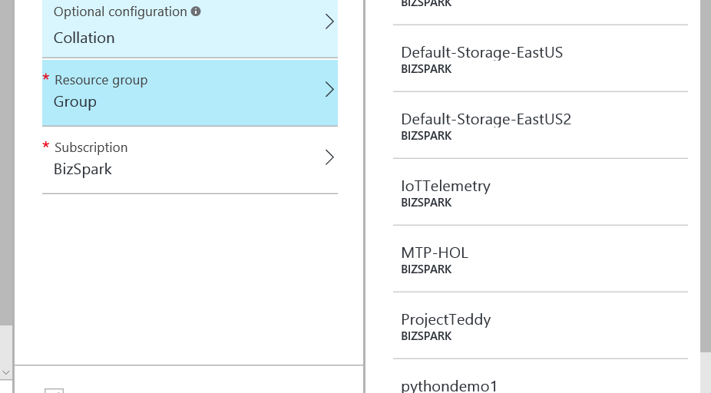
10. Locate MTP-HOL (created earlier)
11. Select MTP-HOL
12. Review your configurations
    1. Ensure your SQL DB name has only letters and numbers. Special characters will create issues later as of the writing of this document
    2. 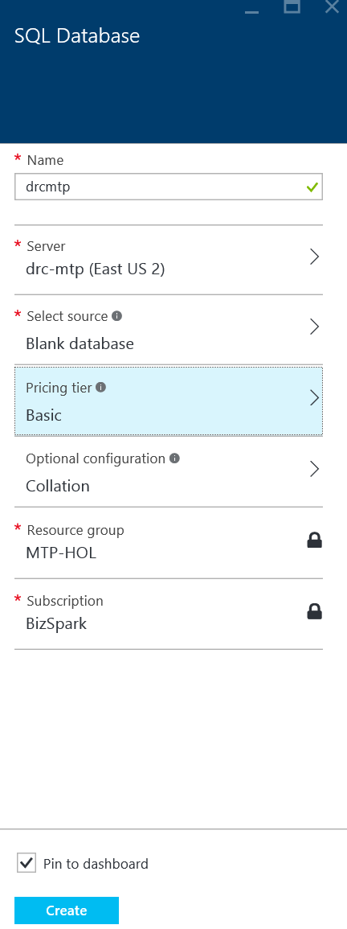
13. Click “Create”
    1. 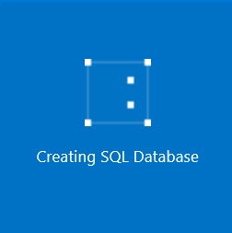
    2. 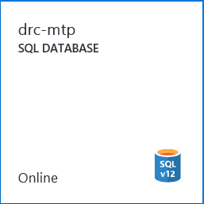

## Provisioning Summary

We have deployed IoT Hub, Stream Analytics and SQL Azure. Typically Azure Blob would also be deployed, however to reduce complexity of the lab, we are dropping Blob storage and only doing SQL Azure.

### Knowledge Check

1. What is the flow of data between the provisioned cloud resources?
   1. Data will flow from the device to IoT Hub, into Stream Analytics and then finally reside in SQL Azure.
2. What is the purpose of Stream Analytics?
   1. Stream Analytics in this instance is simply receiving and storing the data, however it is typically used for short time window analysis for events such that it can output important information into the appropriate channels.
3. What is an Azure Resource Group?
   1. Azure resource groups are logical groupings of cloud based resources for aggregated management and costing.

# Part 3-B: Data Streaming – Coding

In this section we will write the code necessary to connect the device to the cloud and stream data. Beyond just writing the code, we will deploy the code and verify it works.

## Create Solution Structure

A good solution structure is key to every project. In this project for the Data Streaming portion, we will have a single solution with a database project and an IoT background application.

1. In the Windows 10 Search area, type “Visual Studio”
   1. 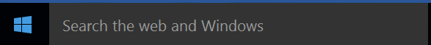
   2. Located in the bottom left.
2. In the top left, click File, New, Project
3. Find Background Application (IoT)
   1. 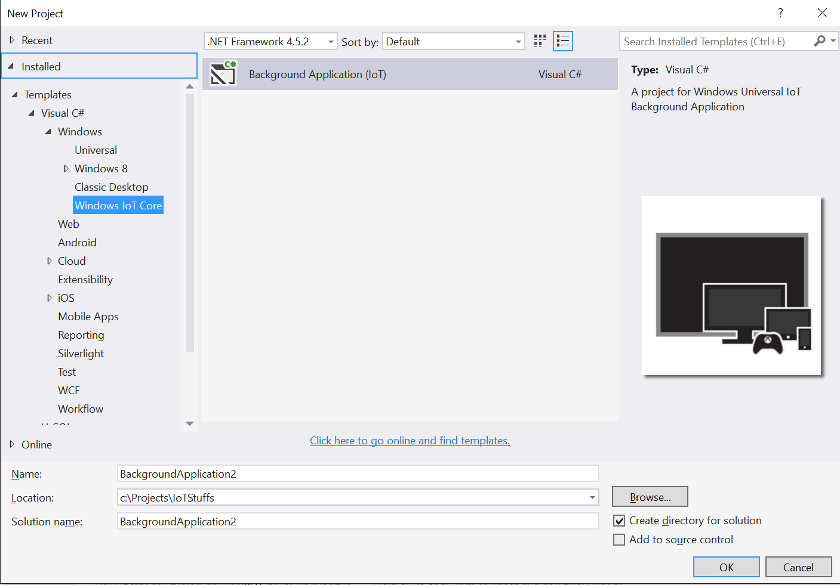
4. Name your project “MTP.PiApp”
5. Modify the location of your project to be C:\Projects\MTP
6. Name your solution “MTP”
   1. 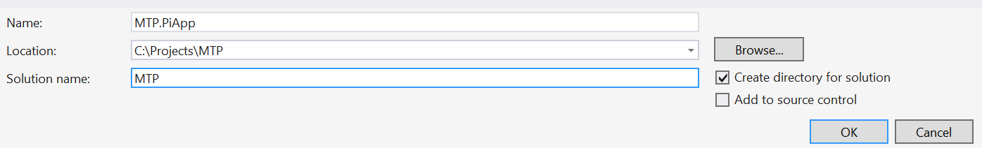
7. Click “OK”
   1. 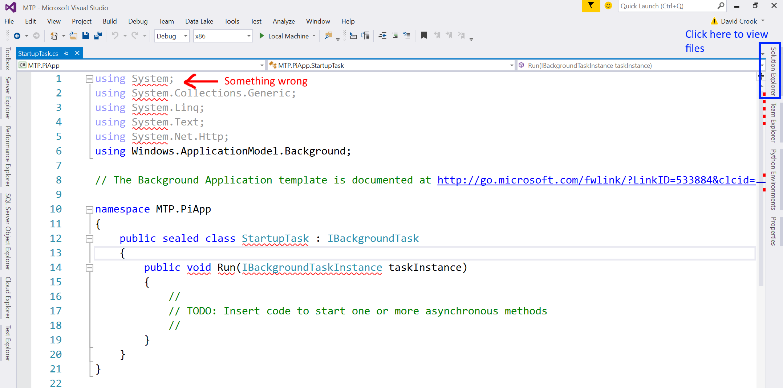
8. Click on solution explorer
   1. In the blue rectangle in the image above.
   2. 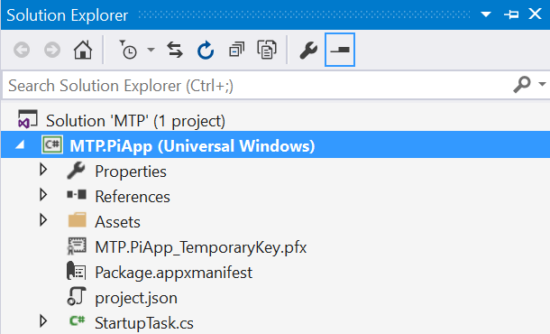
9. Right click the highlighted Project (MTP.PiApp (Universal Windows))
   1. Select Rebuild
10. 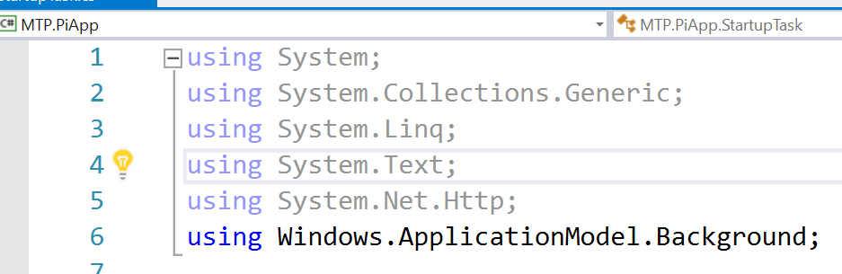
    1. The red squiggles are gone, because rebuilding forced required packages to be downloaded and installed into the solution.
11. Open the solution explorer again.
12. Right click Solution ‘MTP’ (1Project)
    1. 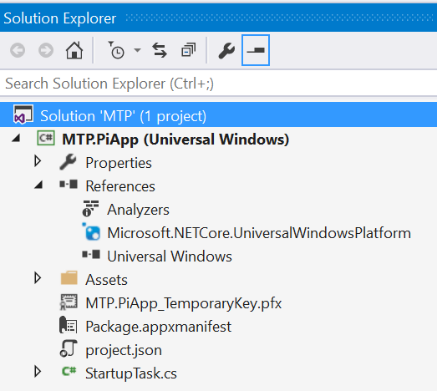
13. Highlight “Add”
14. Click New Project.
15. Under “Other Projects”, find SQL Server
    1. 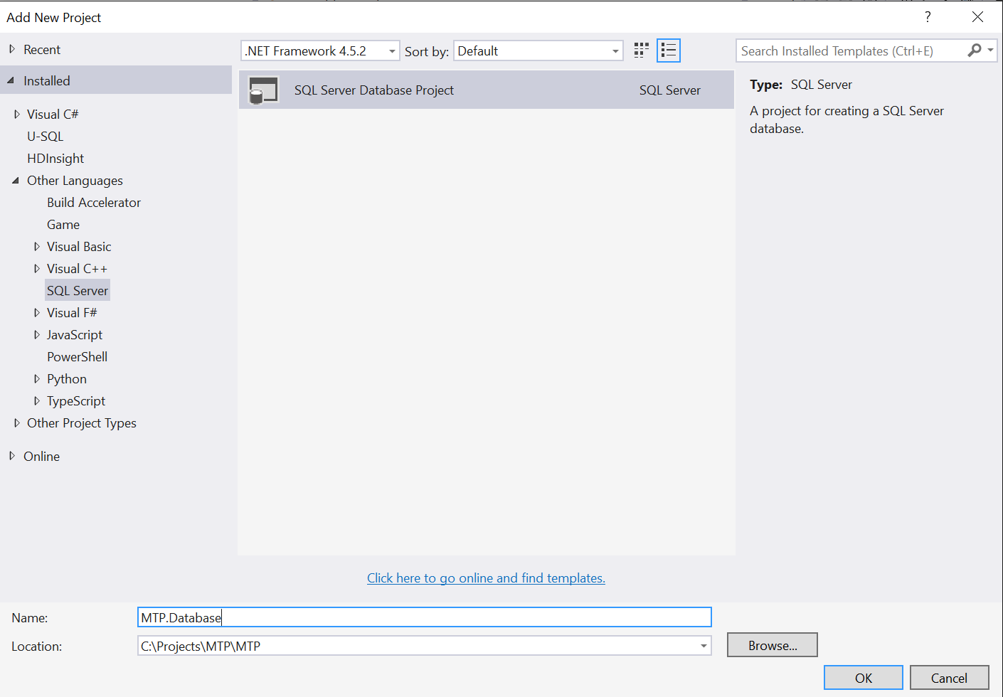
16. Name the project MTP.Database
17. Click OK

## Create and Deploy SQL Schema

This section is the hard how to for creating and deploying the simple data schema we will be using for the project.

1. Right click the MTP.Database Project
   1. Select “Properties”
2. Change “Target Platform” to be “Microsoft Azure SQL Database V12”
   1. 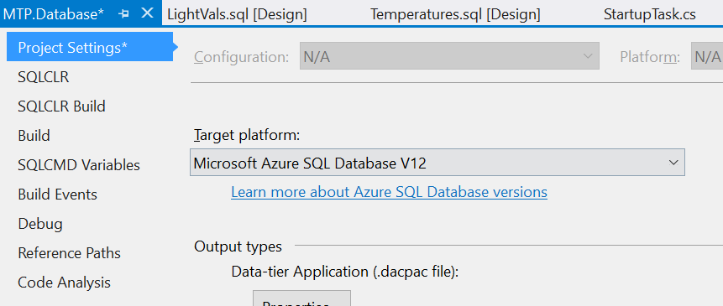
3. Save the file
   1. Ctrl-S
   2. Or the save floppy disk in the top left.
4. Right Click the MTP.Database Project
   1. Add -> New Folder
   2. Name the folder “tables”
   3. 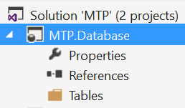
5. Right Click the new Tables folder
6. Select Add -> Table
7. Name the table “Temperatures”
   1. Note the s
   2. 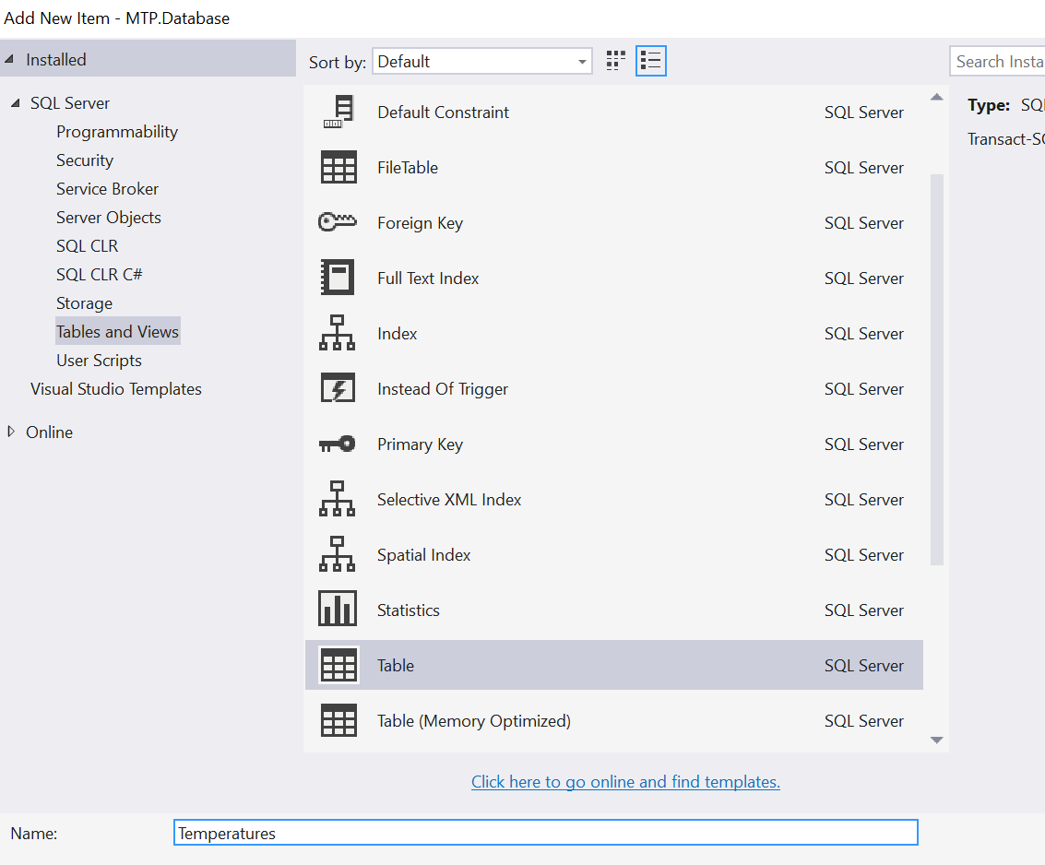
   3. 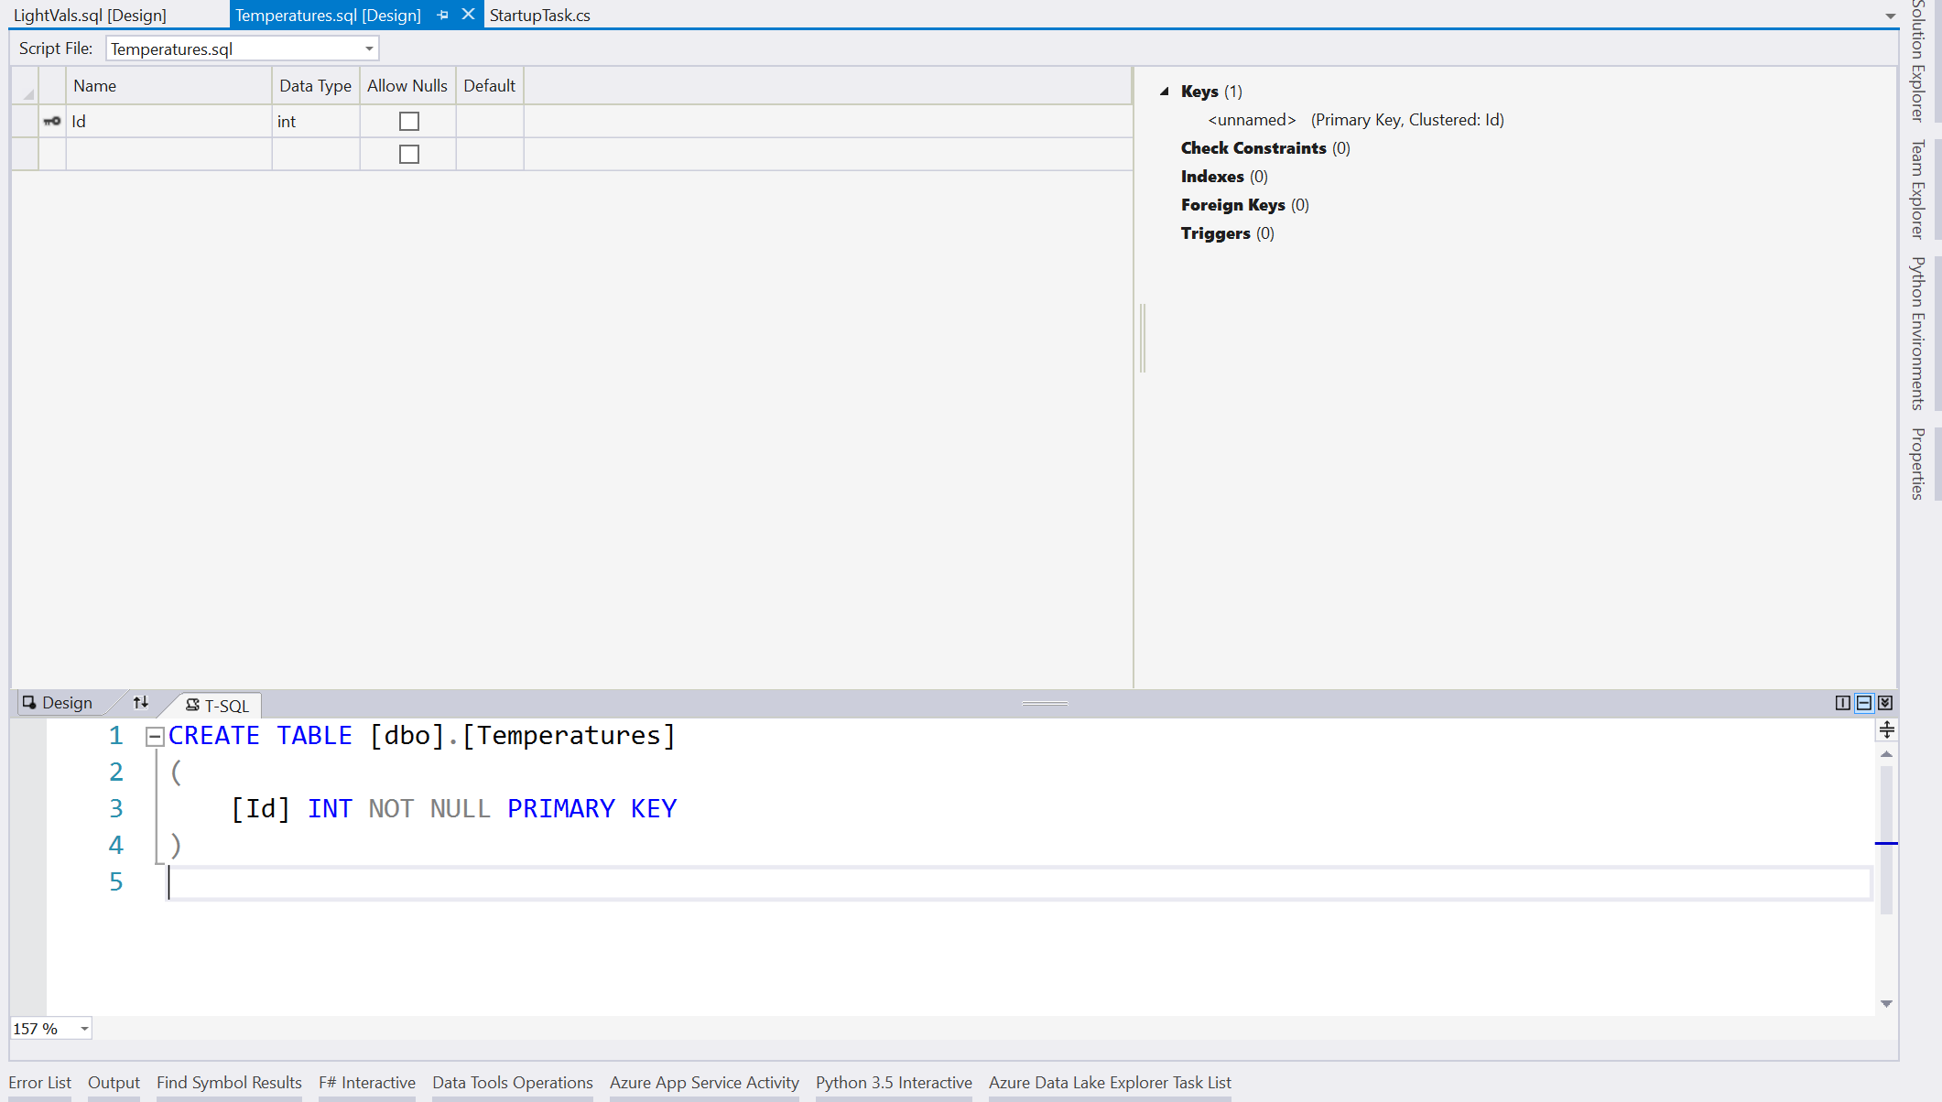
8. Right Click the tables folder
9. Select Add -> Table
10. Name the Table “LightVals”
11. In the T-SQL Section of the LightVals file, type the following code:
    1. 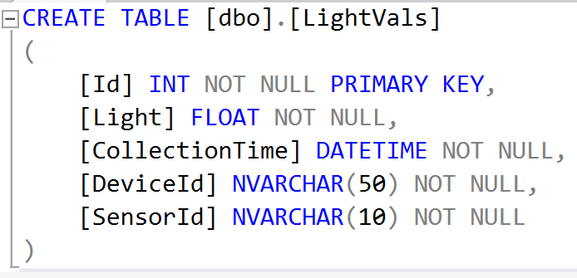
12. In the T-SQL Section of the Temperatures table, type the following code:
    1. 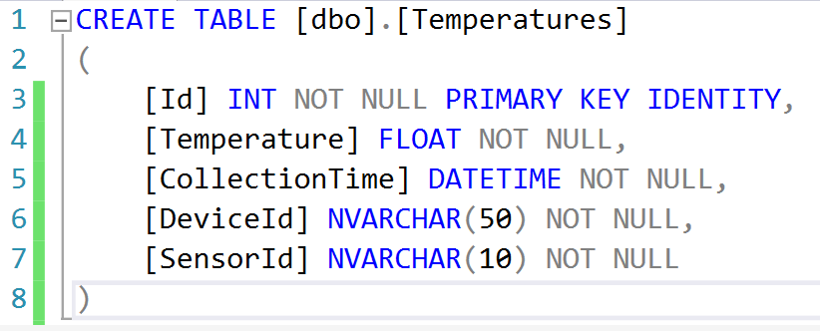
13. Right Click the Database Project
    1. Click “Publish”
    2. 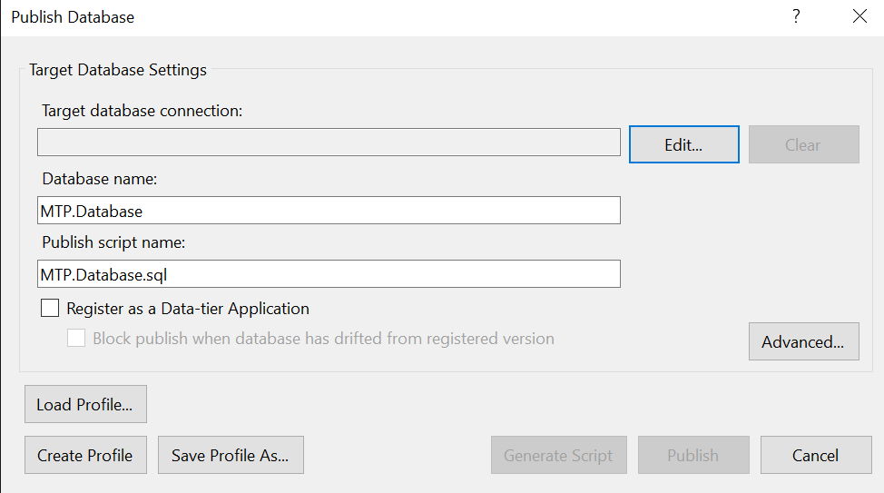
14. Click Edit
    1. 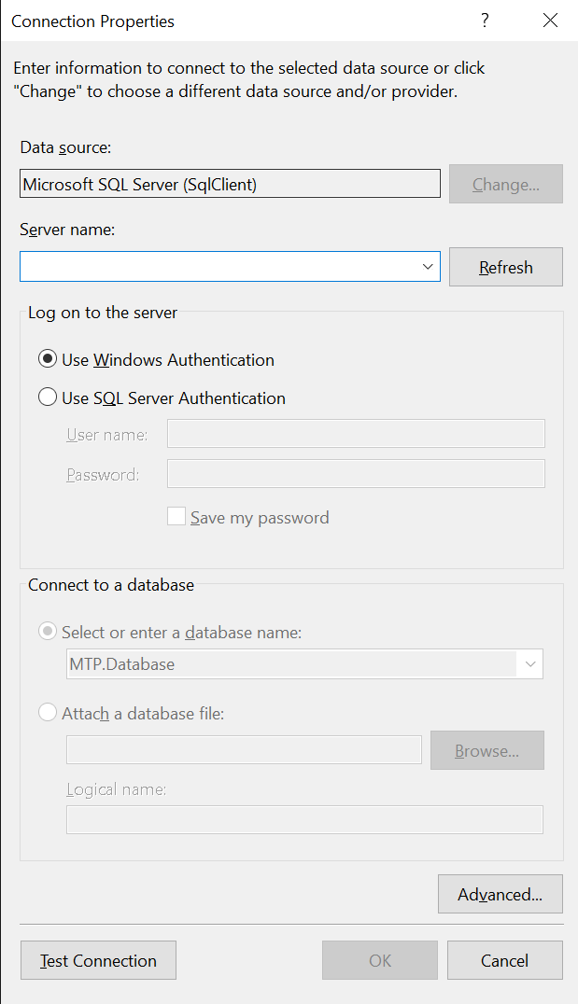
15. From your Azure Portal, find your SQL Database and click on it
    1. 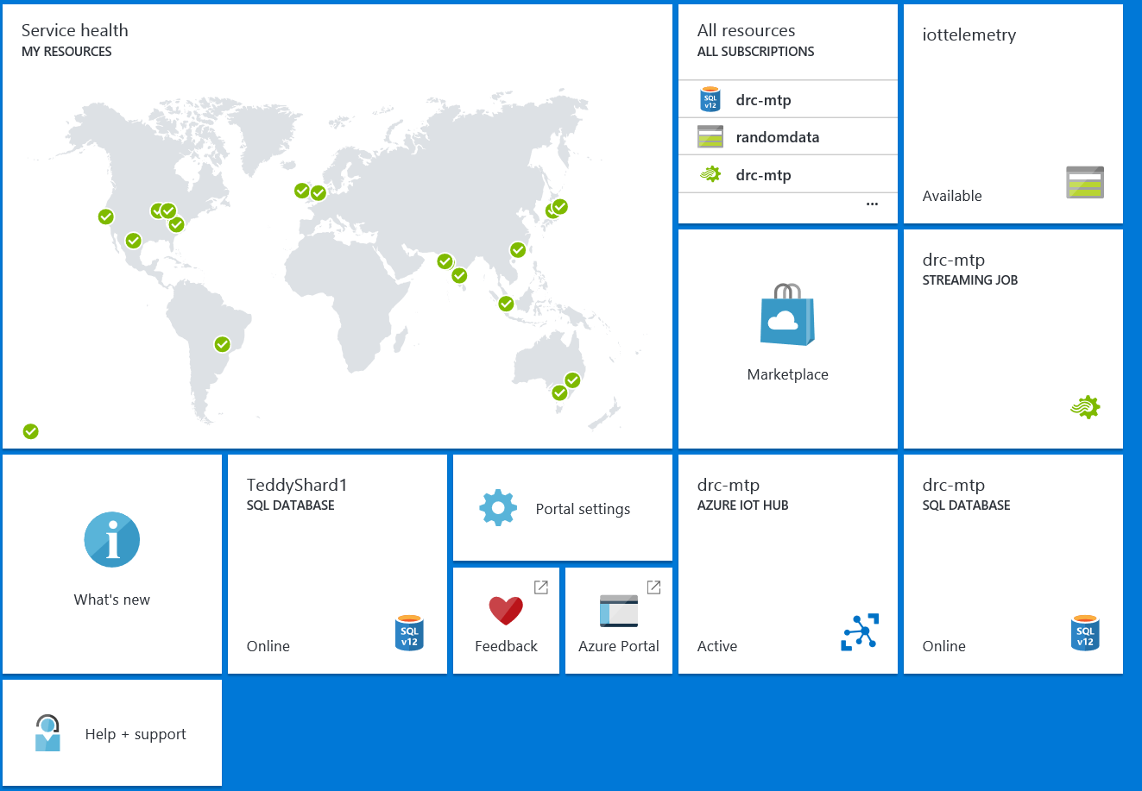
16. Locate your server name and copy it
17. Click on the server name to open the server blade
    1. 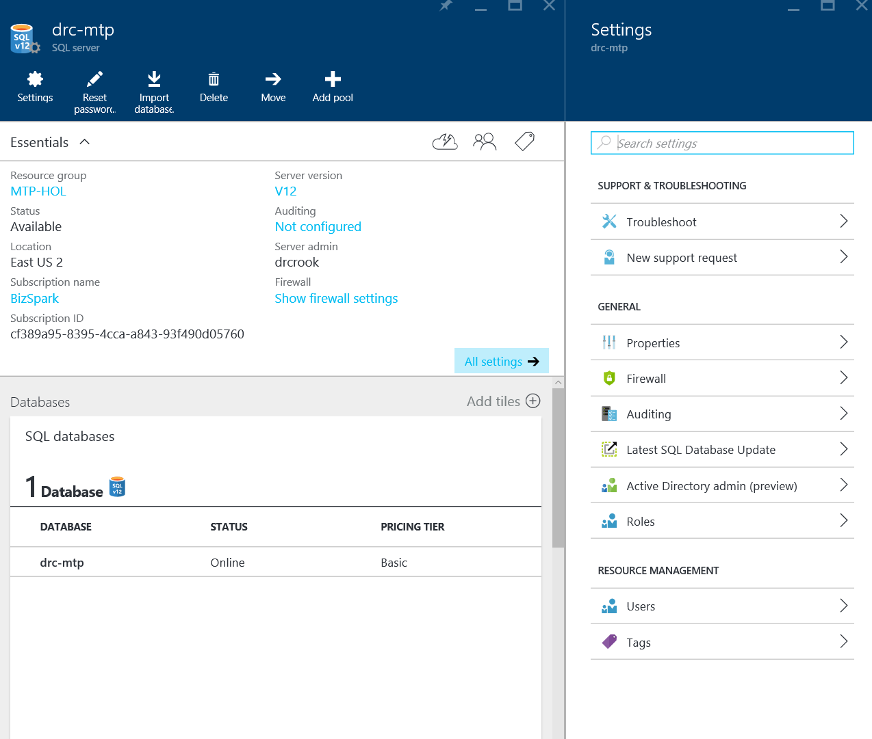
18. Click on “Show firewall settings”
    1. 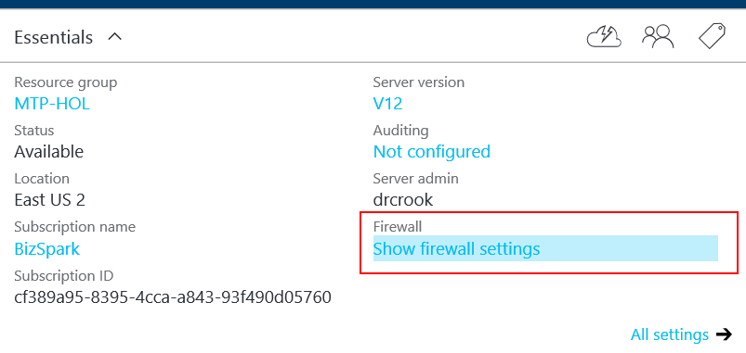
19. Click “Add Client IP”
    1. 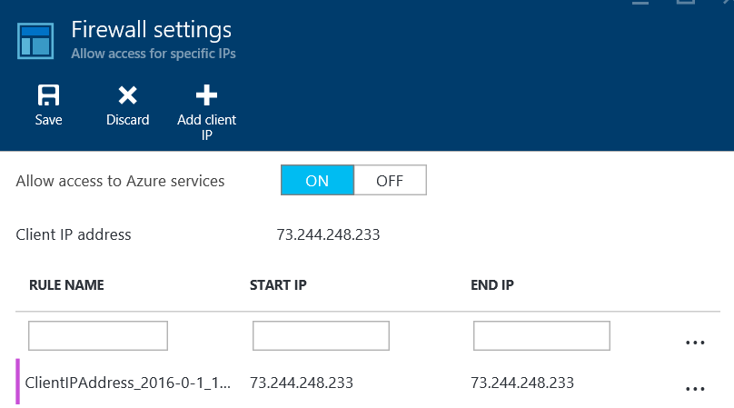
20. Click “Save”
    1. 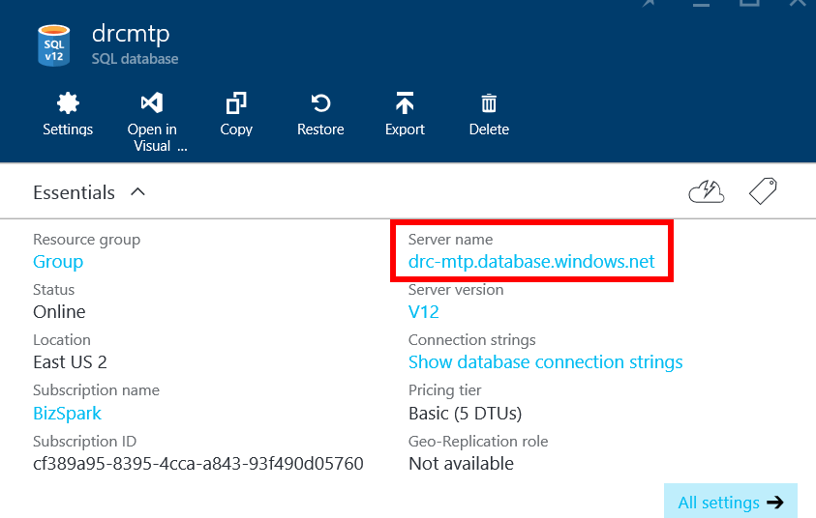
21. Paste the server name you copied earlier into the Server Name Section of the connection pop up
    1. 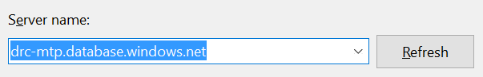
22. For the Log on section…
    1. SQL Authentication
    2. Username: drcrook
    3. Password: David!2345
    4. 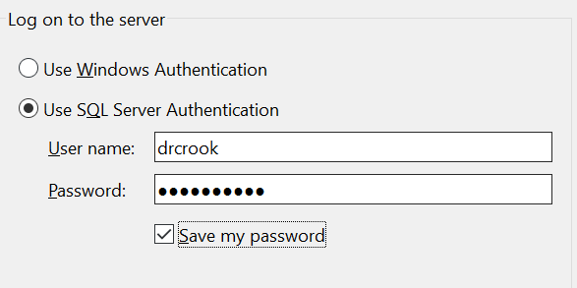
23. In the database name section, type your database name, for example, mine was “drc-mtp”
    1. 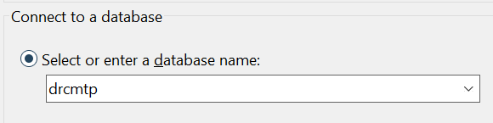
24. Finally in the bottom left corner of the dialogue, click “Test Connection” to ensure you have a solid connection.
25. Click OK.
    1. 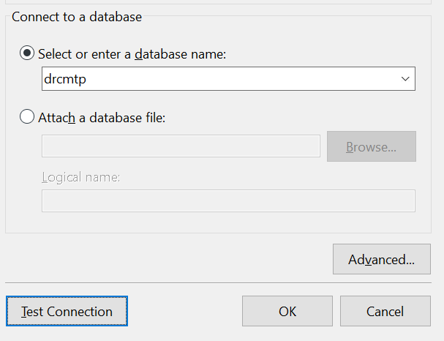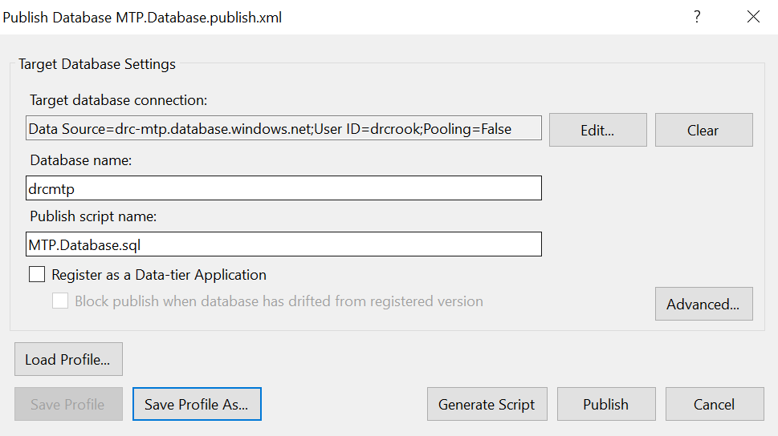
26. Click “Save Profile As…”
    1. Keep the default and save
    2. 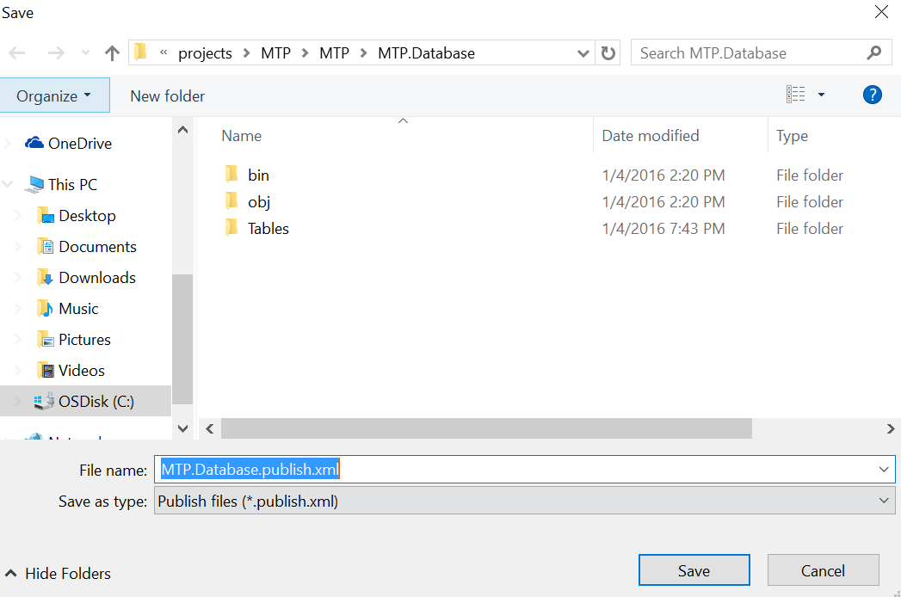
27. Click the Publish Button.
    1. 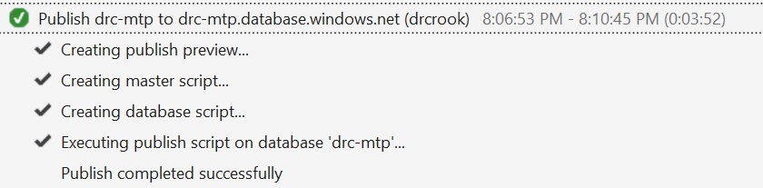

## Device Application Code

In this section we will create code that sends dummy values up to IoT Hub to ensure that portion of the code base works prior to integrating with our circuitry.

### Install Necessary Packages

1. Right Click the MTP.PiApp
   1. Select “Manage Nuget Packages”
2. Ensure “Include prerelease” is checked
3. Type into the search box “Microsoft Azure Devices Client”
4. Verify the author of the package is “Microsoft Corp”
5. Install the exact package “Microsoft.Azure.Devices.Client”
   1. 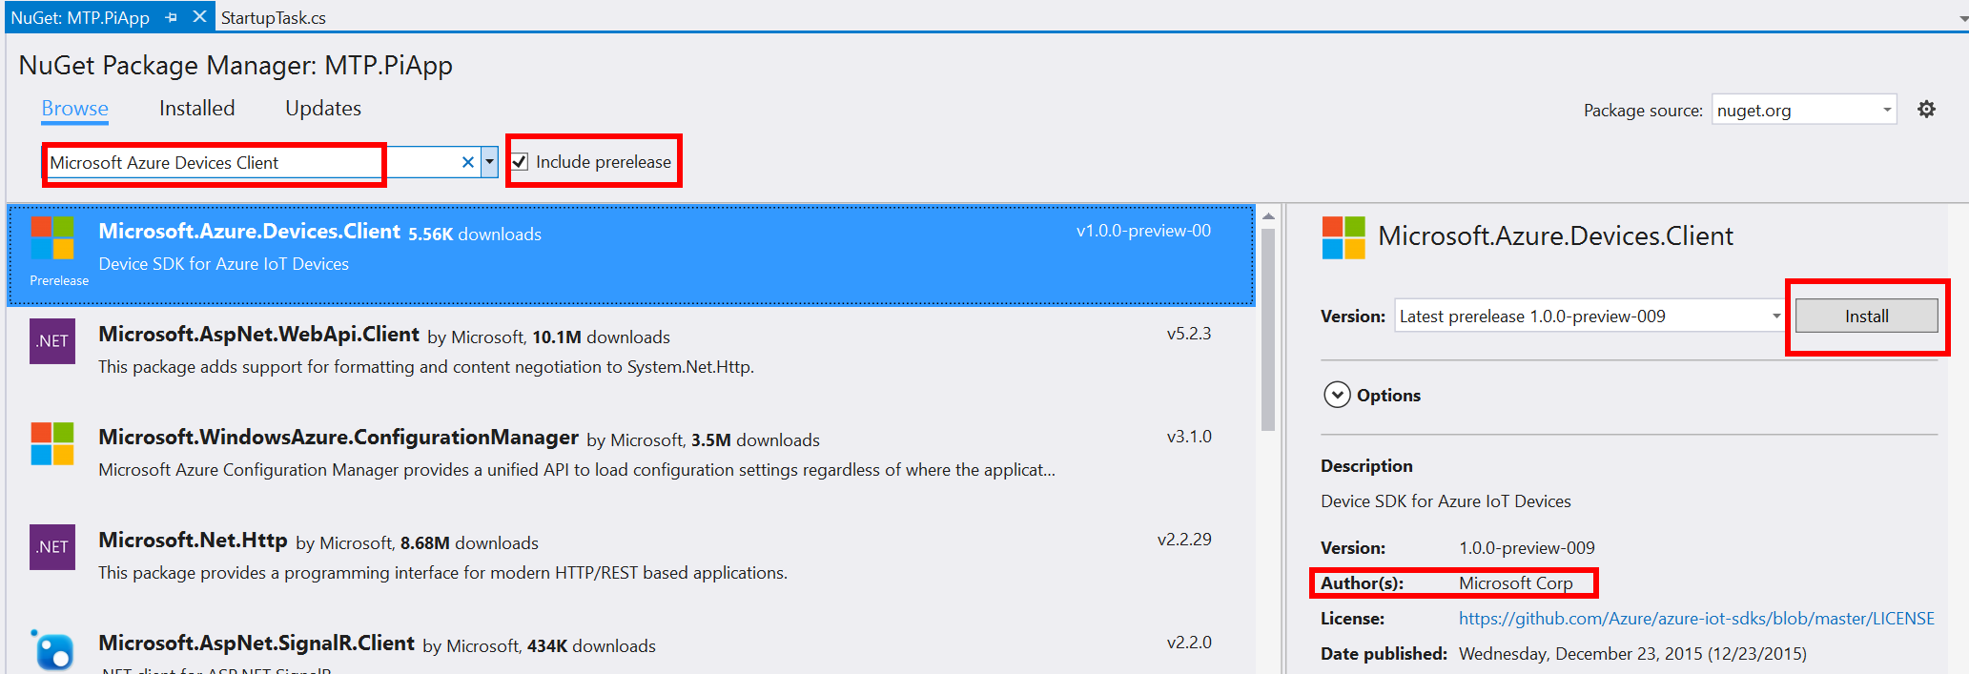
6. Read and accept the License Terms
   1. 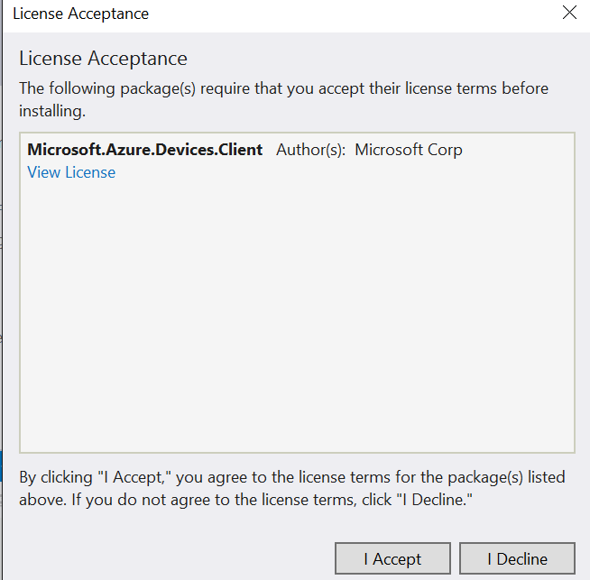
7. Search for “Newtonsoft”
   1. Install Newtonsoft.Json
   2. Ensure author is: James Newton-King
   3. 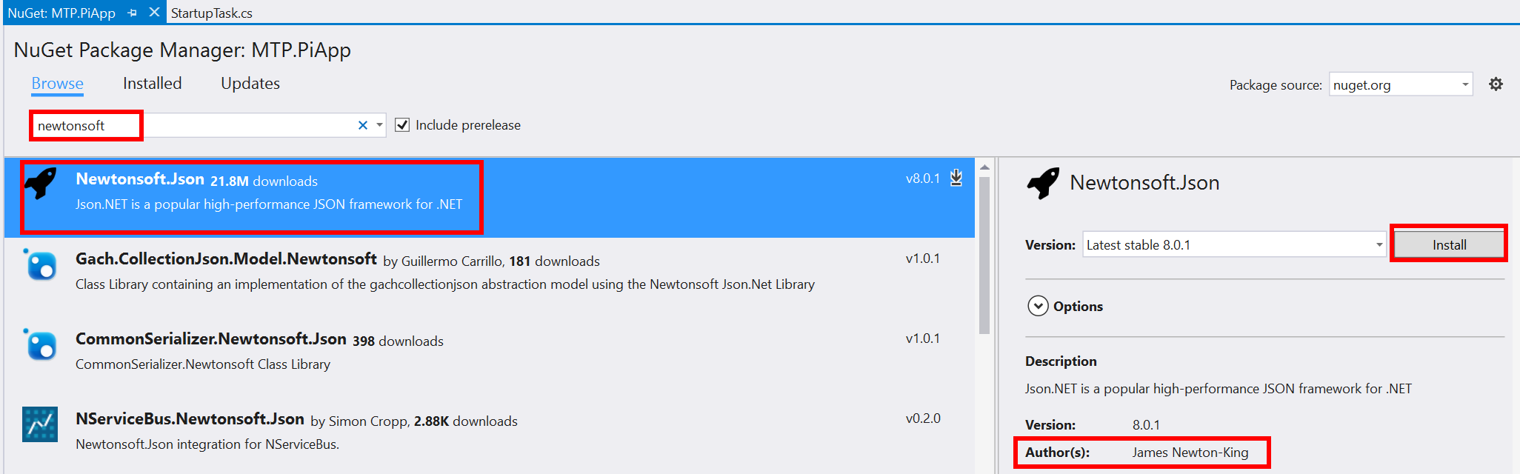
8. Search for “windows iot devices”
   1. Install Microsoft.IoT.Devices
   2. Ensure author is: jbienzms
   3. 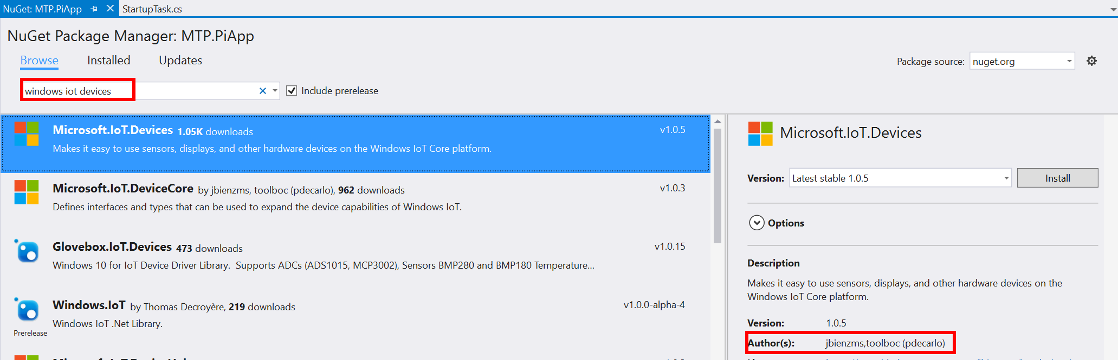

### Create Domain Types

1. Right click the “MTP.PiApp” Project
   1. Add -> New Folder
   2. Name the folder “DomainTypes”
2. Right click the new DomainTypes folder
   1. Add -> New Class
   2. Name the class “Temperature.cs”
   3. Click Add
   4. 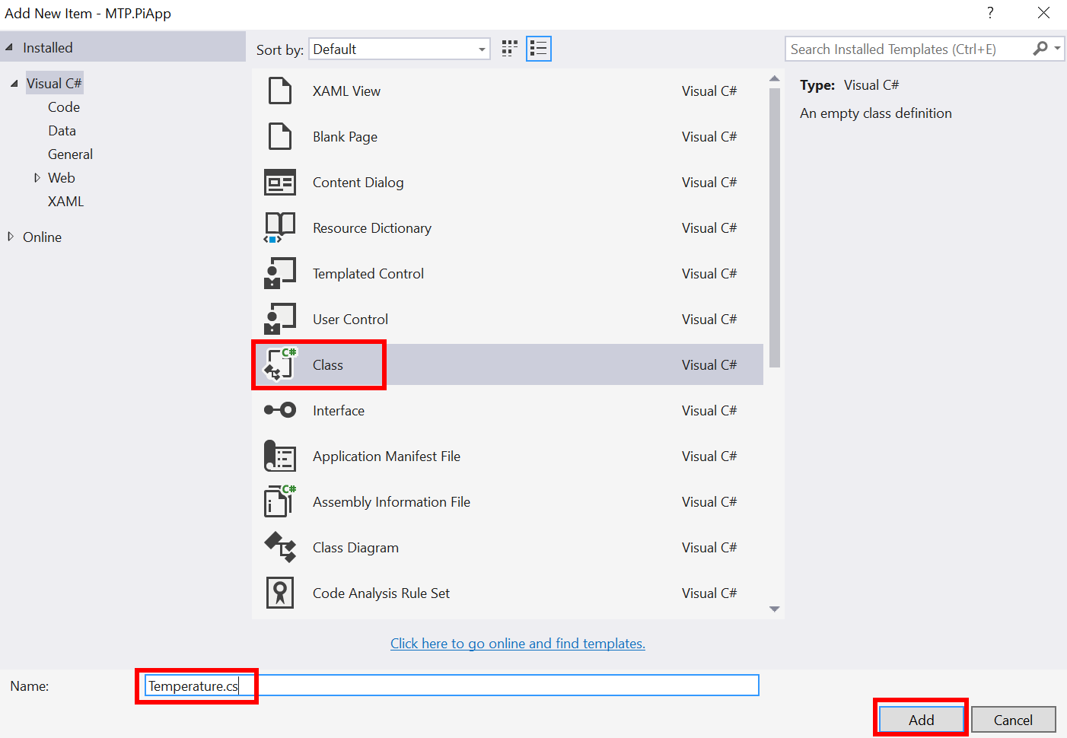
3. Replace the entirety of the Temperature.cs code file with the following code:
   1. 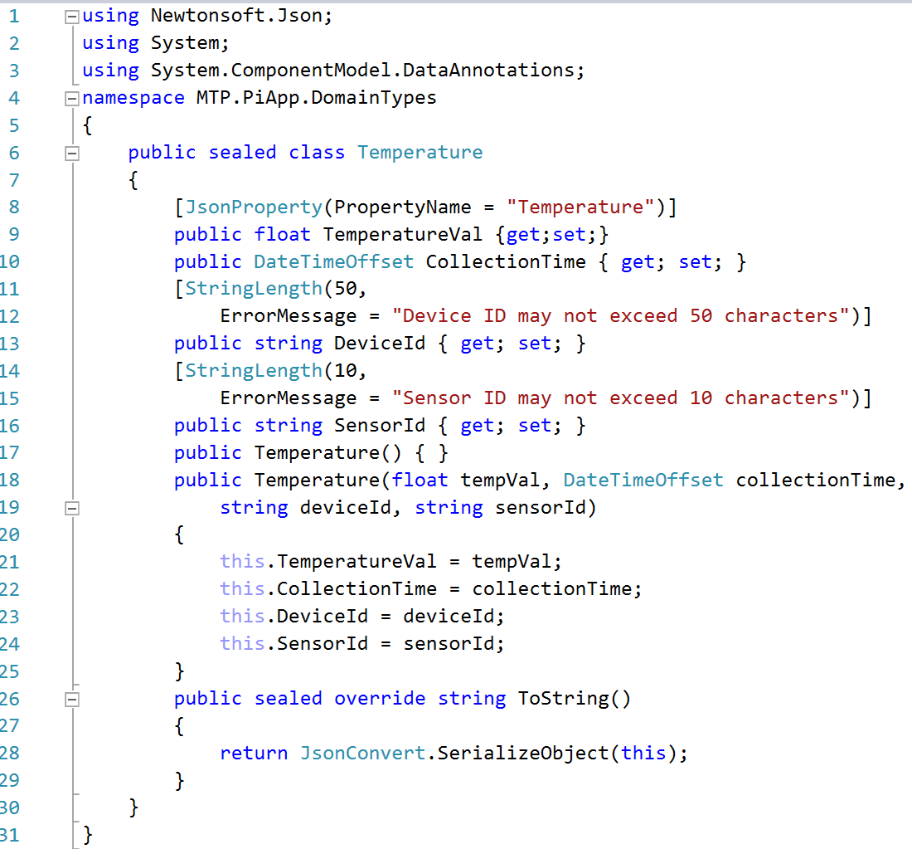
4. Right Click the Domain Types folder
   1. Add -> New Class
   2. Name the class “Light.cs”
   3. Click Add
   4. 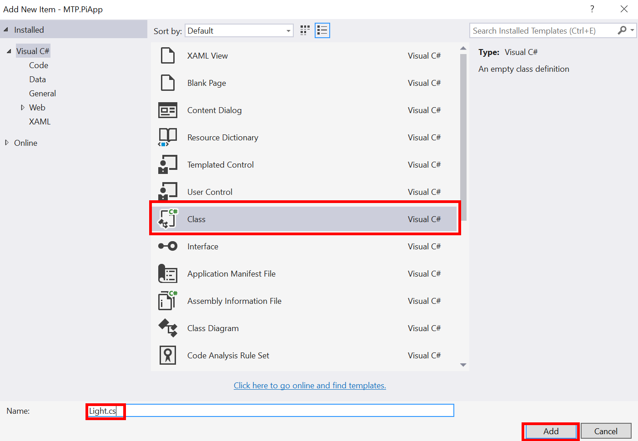
5. Replace the entirety of the Light.cs code with the following code
   1. 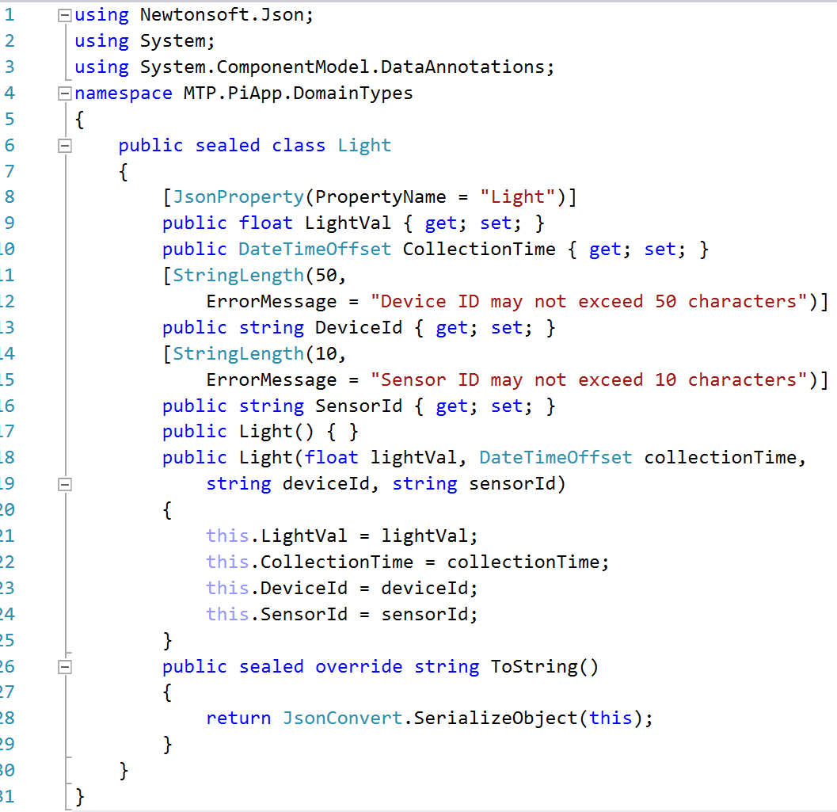
6. Right Click the Domain Types Folder
   1. Add -> New Class
   2. Name the class “Telemetry.cs”
   3. Click Add
   4. 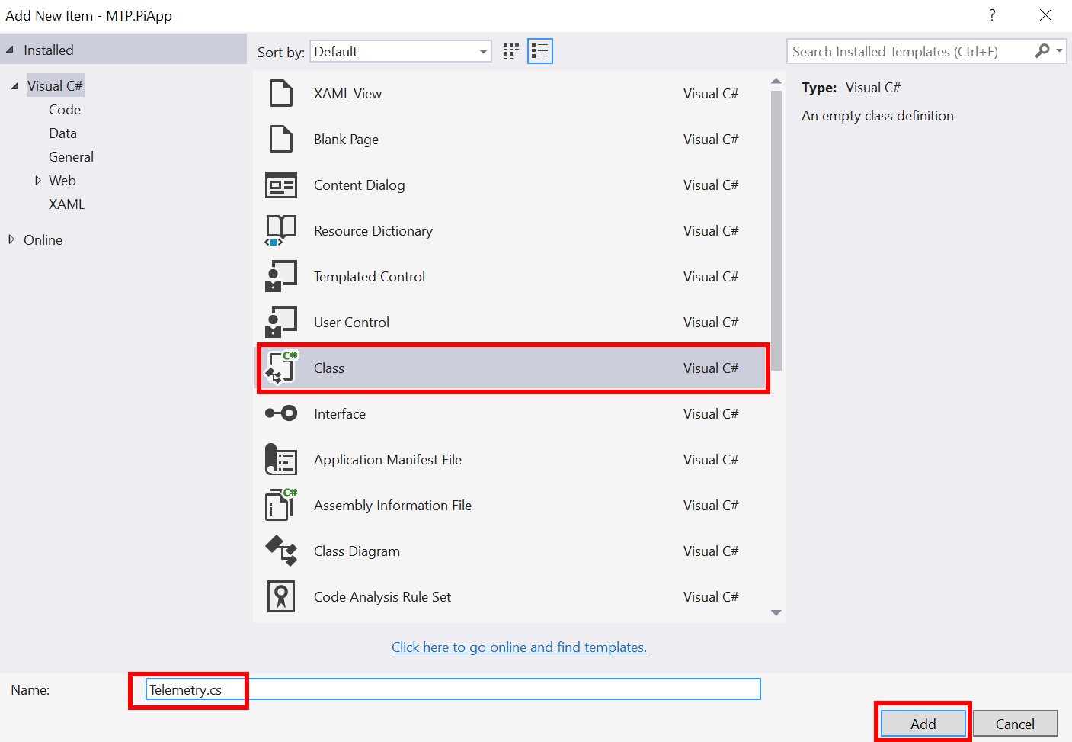
7. Replace the Telemetry.cs code file with the following code
   1. 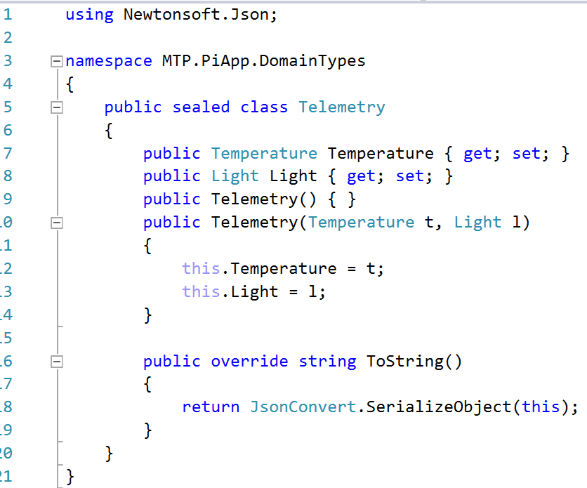

### Create Application Code

The entirety of the original StartupTask.cs file will be replaced, you can begin by just deleting its entire contents.

1. Create these using statements
   1. 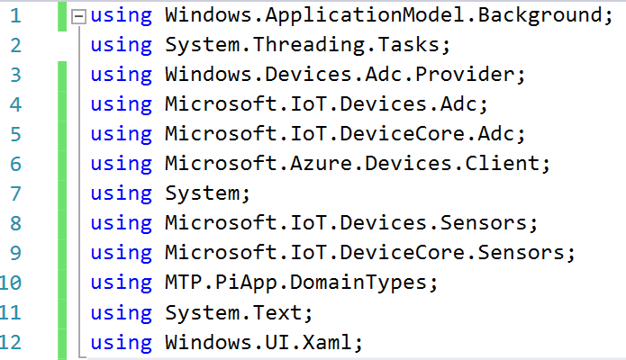
2. Create the Class and Variables
   1. 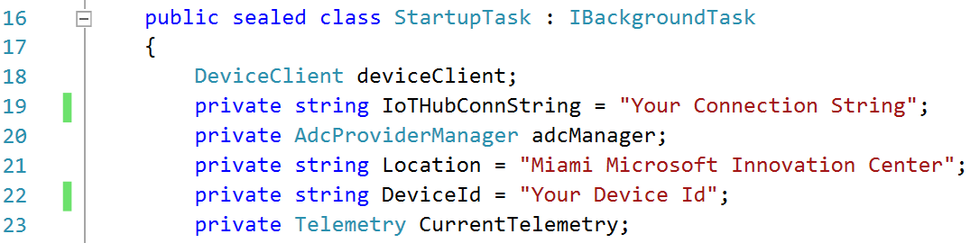
3. Create the Run Function
   1. 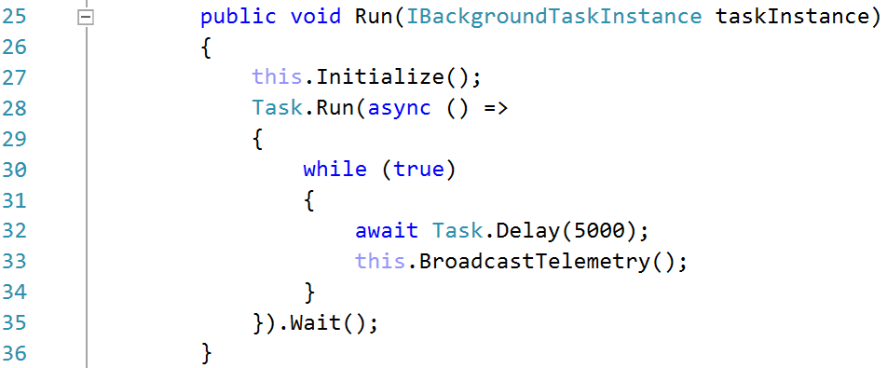
4. Create the Initialize Function
   1. 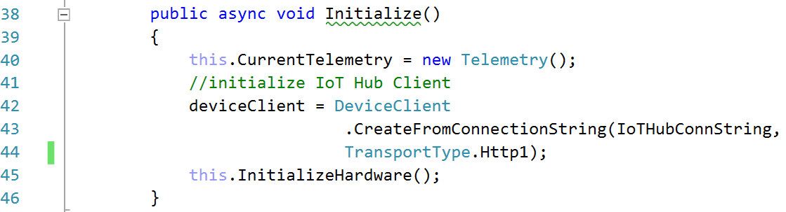
5. Create the InitializeHardware Function
   1. 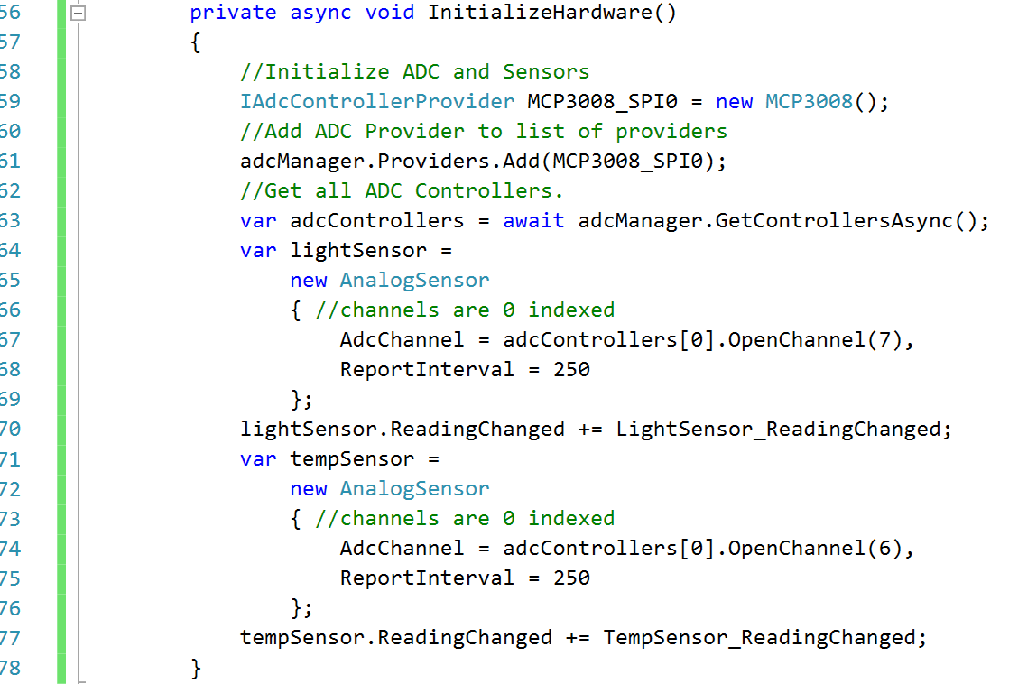
6. Create the TempSensor_ReadingChanged Function
   1. 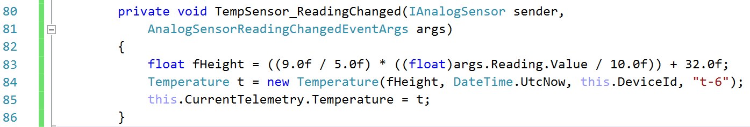
7. Create the LightSensor_ReadingChanged Function
   1. 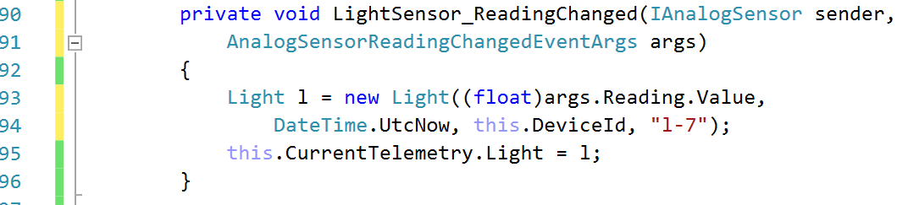
8. Create the BroadcastTelemetry Function
   1. 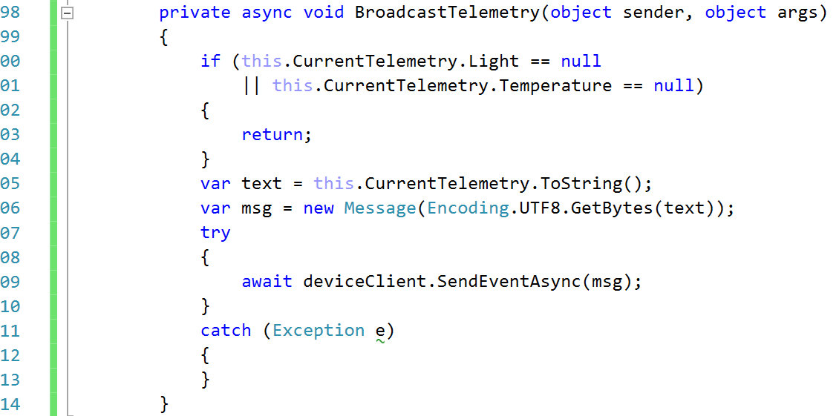
9. Validate Program Structure
   1. Pressing ctrl + m + o will collapse all functions.
   2. 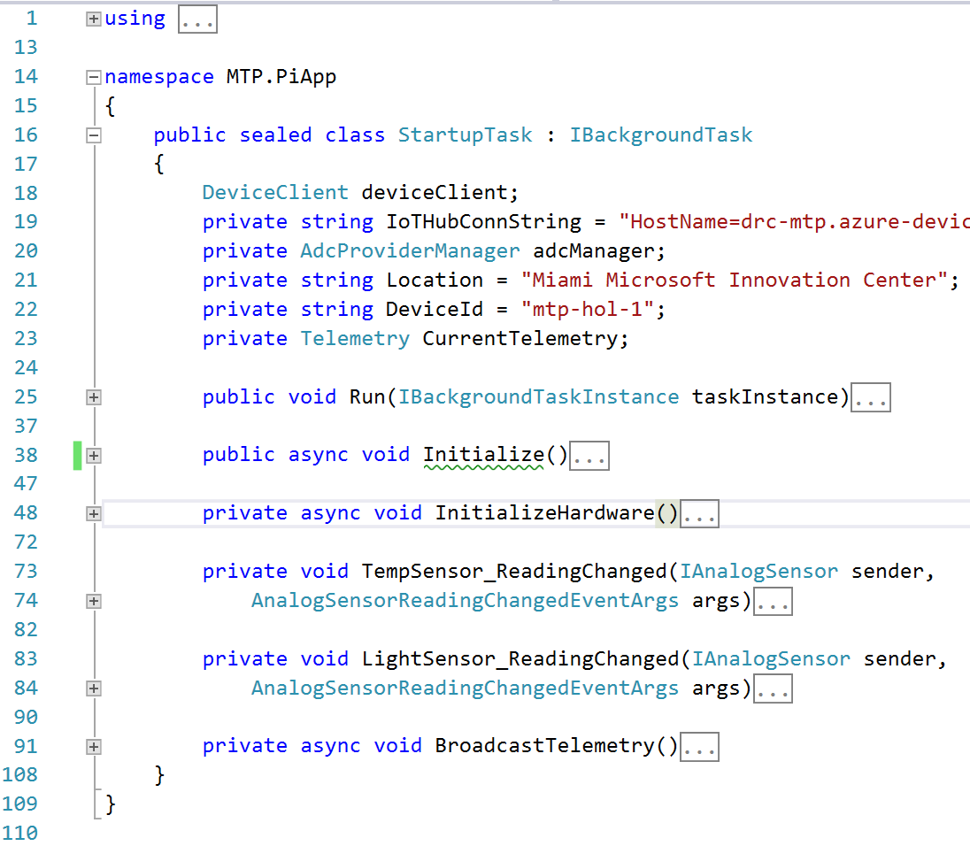

### Register Device with IoT Hub

You likely noticed that the IoT Hub connection string was blank as was the device id. That is because we need to download the application to register the device with IoT Hub.

1. Install the IoT Device Monitor.
   1. Navigate to this page: <https://github.com/Azure/azure-iot-sdks/releases/>
      1. 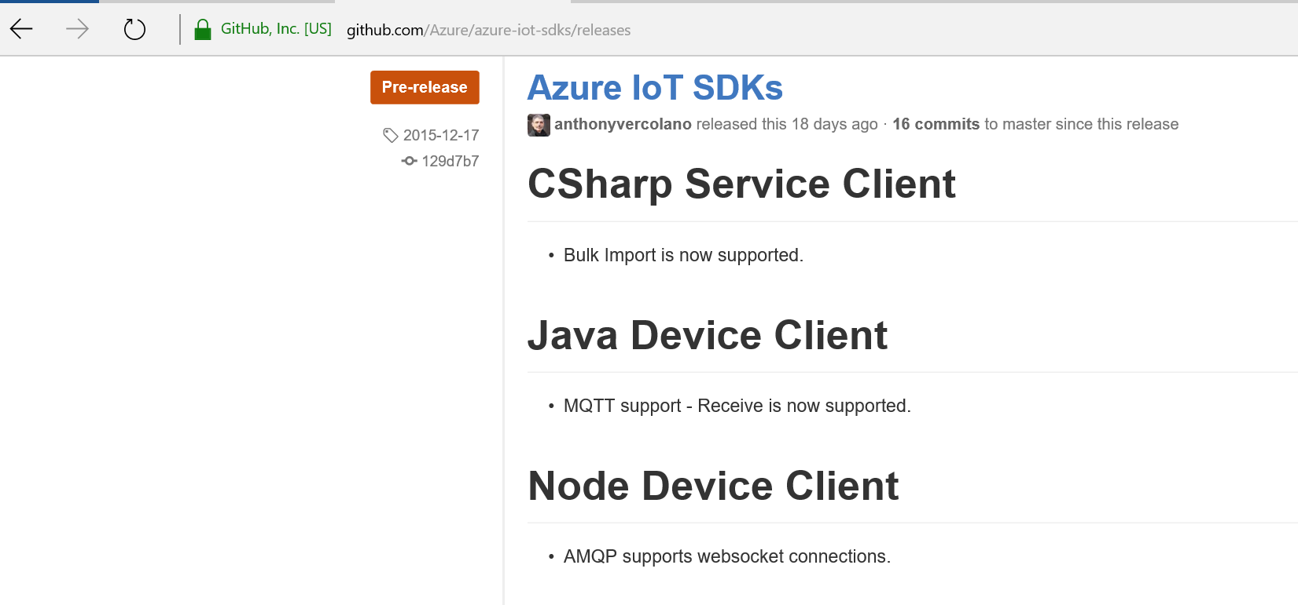
   2. Scroll down to the most recent release’s downloads section
      1. 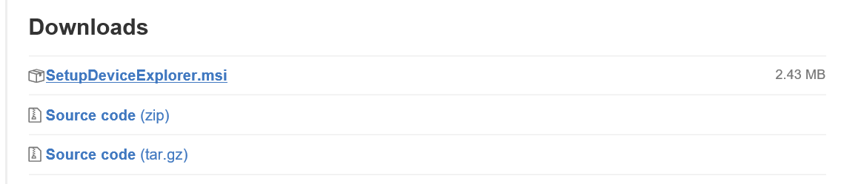
   3. Download and Run the “SetupDeviceExplorer.msi”
      1. 
      2. Click Run
      3. Click Next through all the notifications
      4. Click “Yes” when it asks if you would like to have it installed.
   4. From the Windows 10 Search area, search for “Device Explorer” and run the application.
      1. 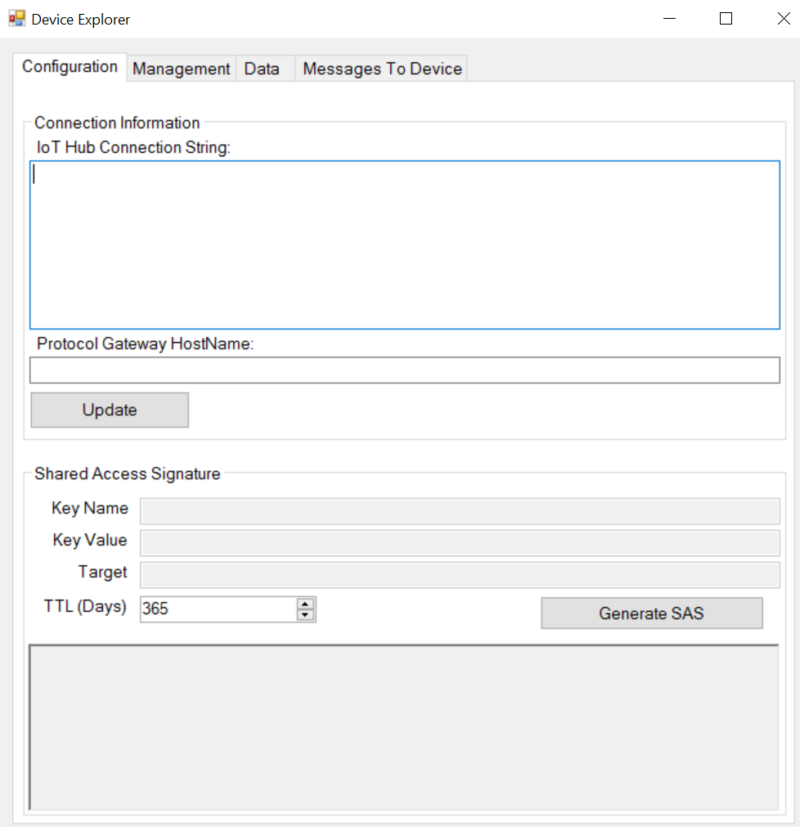
2. Navigate to the Azure Portal and login.
   1. 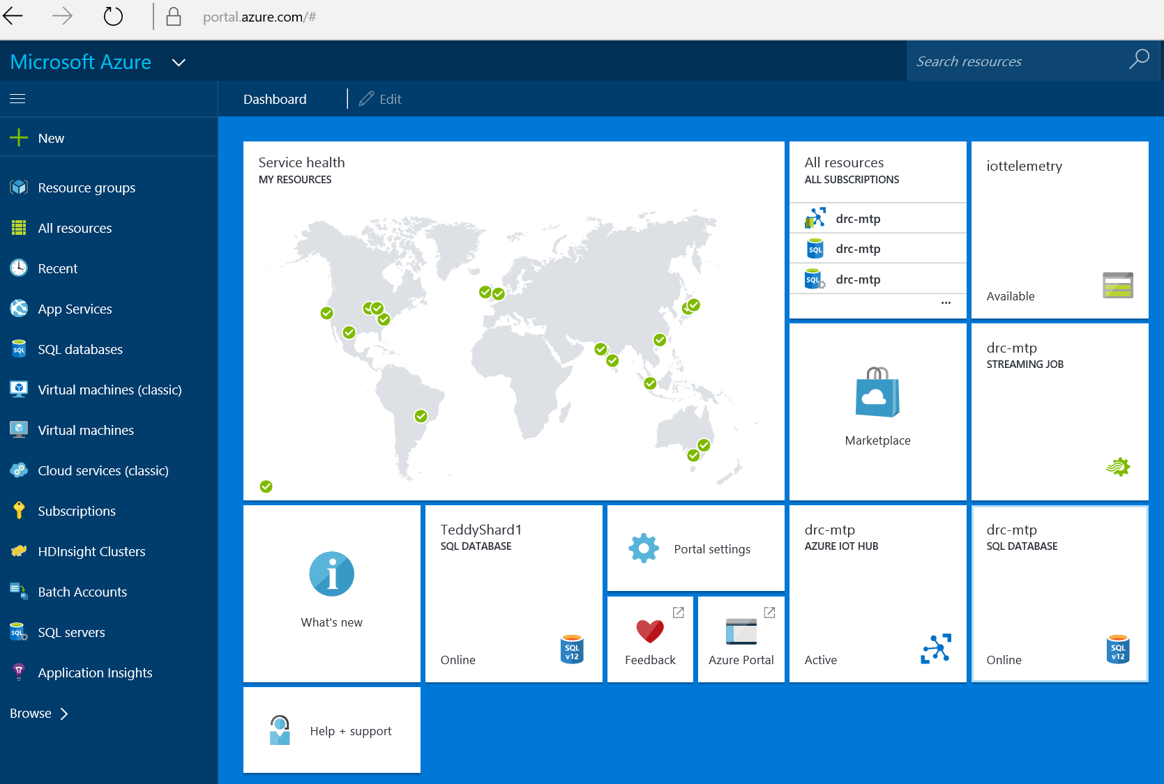
3. Click on your provisioned IoT Hub (in my case it is drc-mtp)
   1. 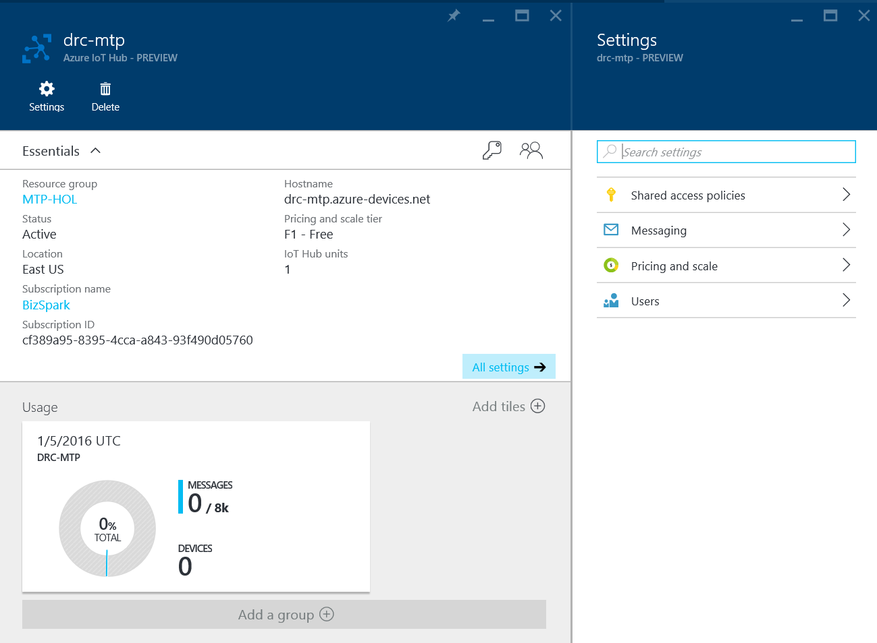
4. On the right blade, click on “Shared access policies”
   1. Then click on “iothubowner”
   2. Copy your Secondary Key Connection String
   3. 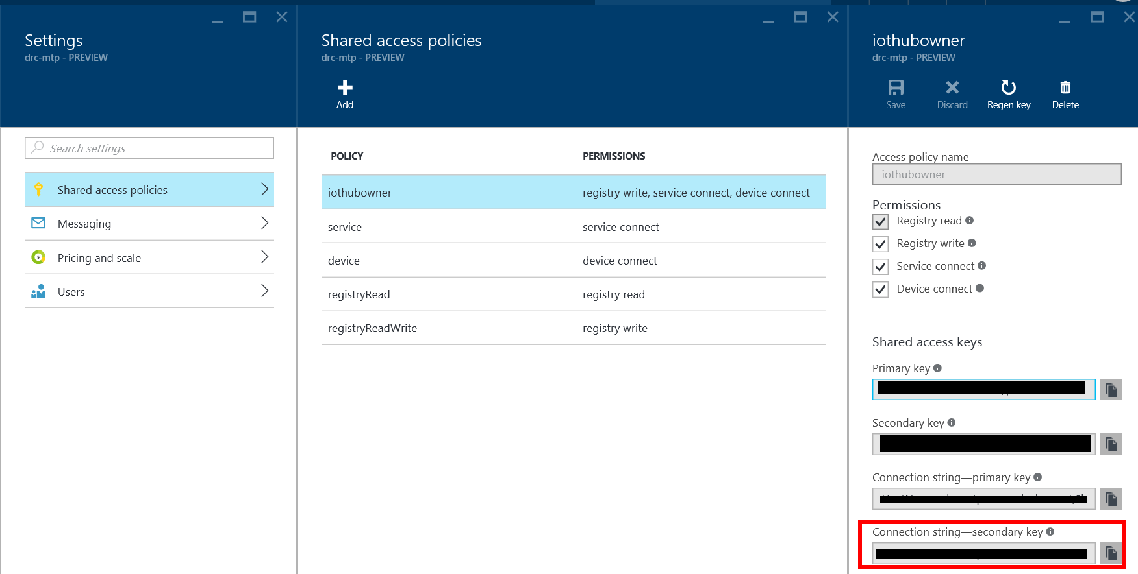
5. Paste the connection string into the connection string section of the Devices Explorer
   1. Push “Update”
   2. 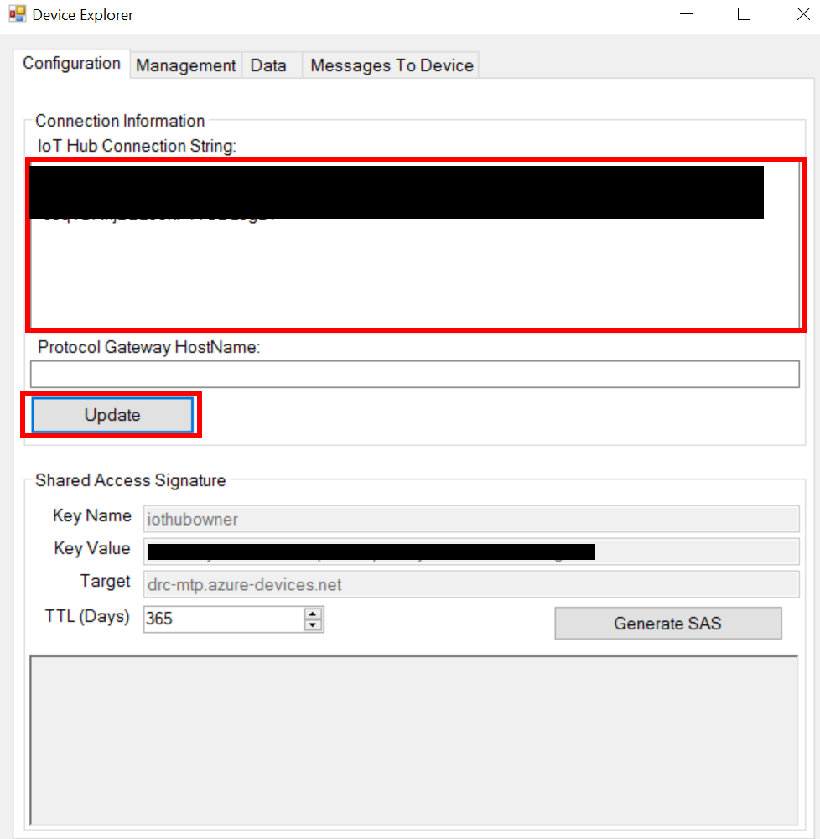
6. You should get a pop up indicating success.
7. Click on the Management Tab
   1. Click on the “Create” Button
   2. 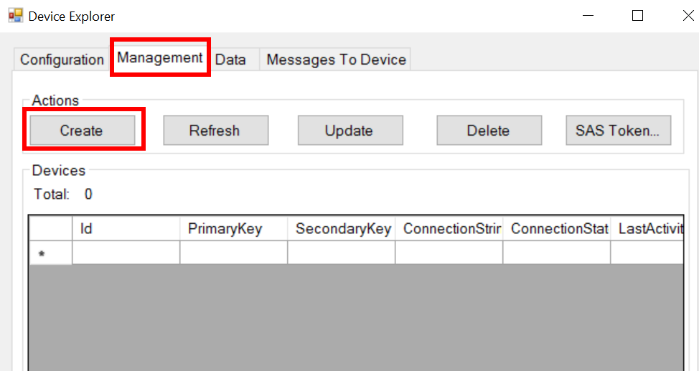
8. Create your device
   1. Ensure Auto Generate ID is not checked
   2. Ensure Auto Generate Keys is checked
   3. Pick an ID.
      1. I find it helpful to have a device id taxonomy for ease of adding new devices in a way that makes snse.
   4. 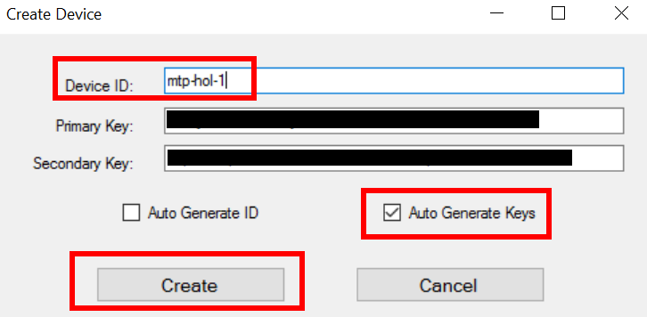
   5. You will see a popup indicating completion
      1. 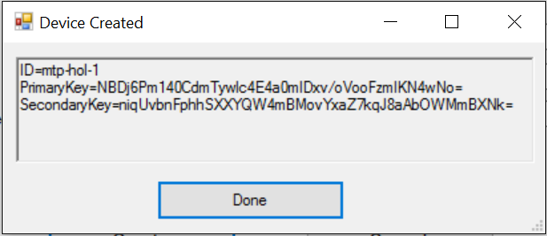
      2. Click Done
9. Right Click the new device’s row.
   1. 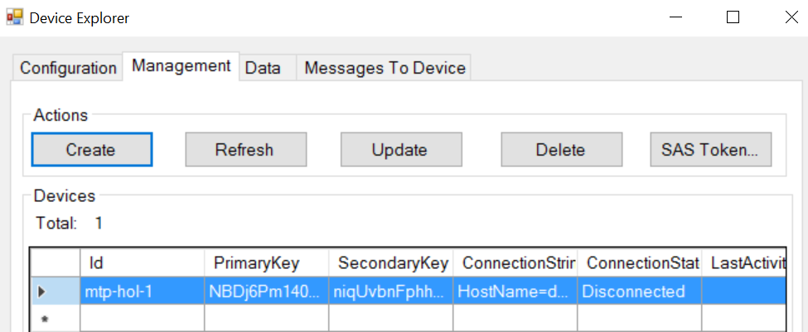
   2. Select the option “Copy Connection String for Device”
10. In the StartupTask.cs file (back in Visual Studio)
    1. Replace the variable “IoTHubConnString”’s value with the copied connection string.
       1. 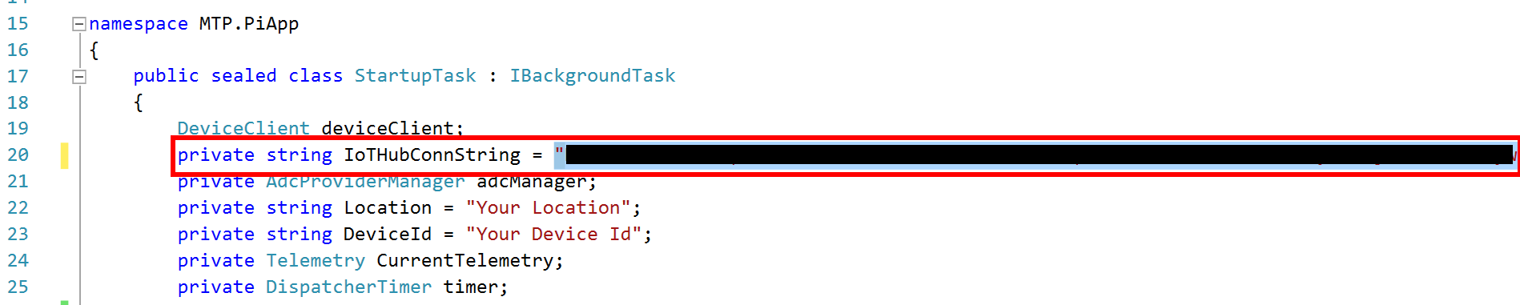
    2. Replace the variable “DeviceId” with your named id
       1. 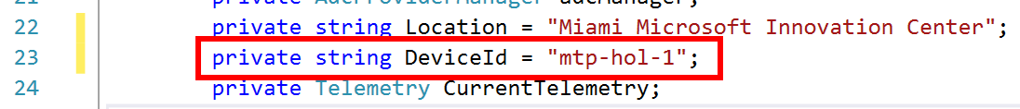
    3. Replace the variable “Location” with your location.
       1. 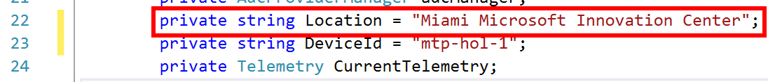

### Build and Deploy Debug

As the Raspberry Pi is an ARM based processing system, we need to change the build configuration to target ARM. We also need to set the deployment target to be the remote machine, our Raspberry Pi and deploy the test version of our application.

1. Right Click the “MTP.PiApp” Project
   1. 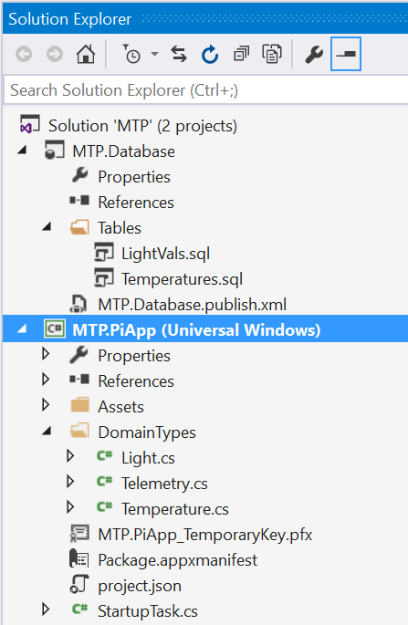
   2. Select Properties and click “Debug”
      1. 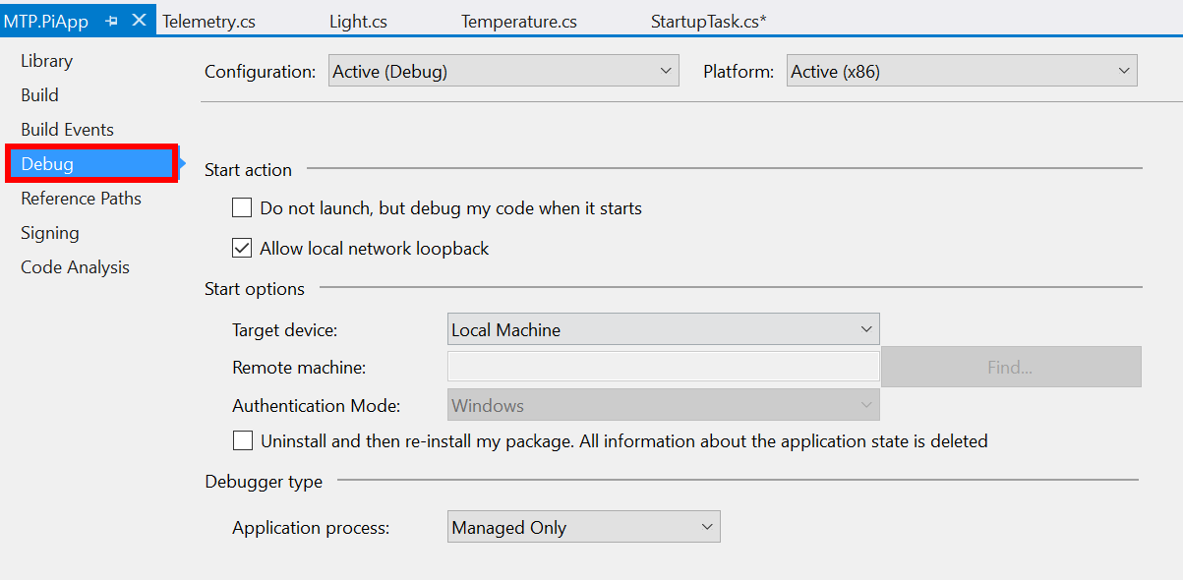
2. Switch the Platform to “ARM”
   1. 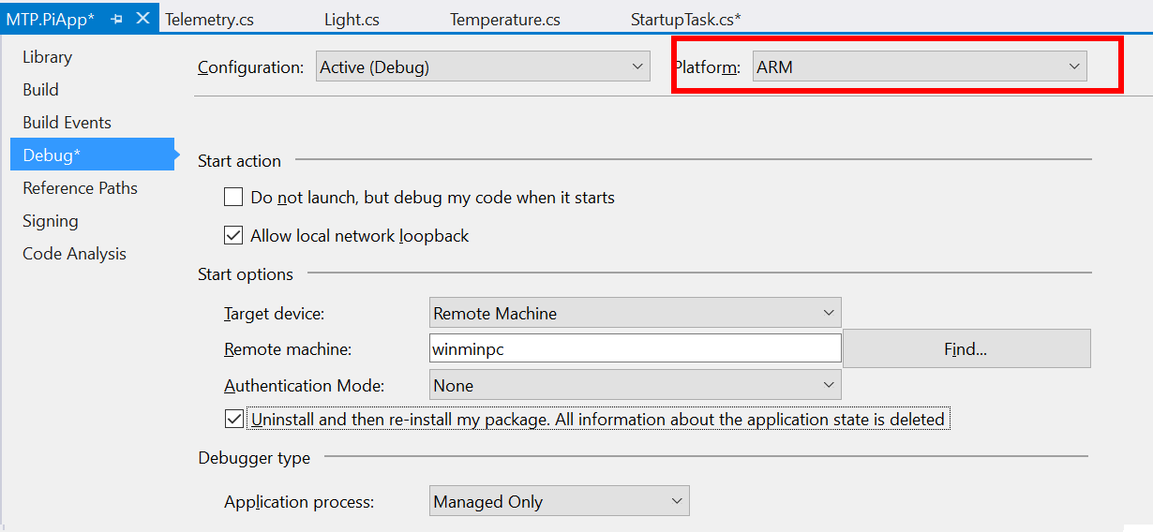
3. Change Target Device to “Remote Machine”
4. In the Remote Machine text box, type “winminpc”
5. Set Authentication Mode to “Universal (Unencrypted Protocol)”
6. Ensure the checkbox for “Uninstall and Reinstall my package” is checked.
   1. 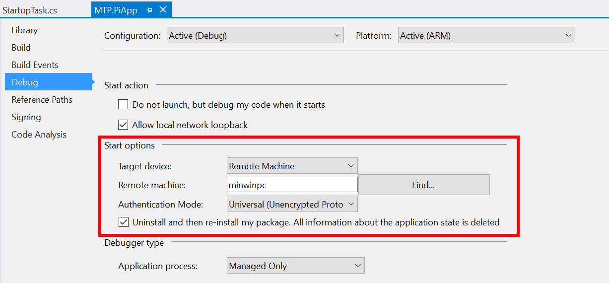
      1. Misconfiguration here will result in failure to deploy
7. Save the configuration
   1. Ctrl + S
   2. The little save button in the top left.
8. Ensure the Debug Execution Configuration
9. Build, Deploy, Debug
   1. Push the Remote Machine button with the green arrow next to it.
      1. This is the debug button
   2. 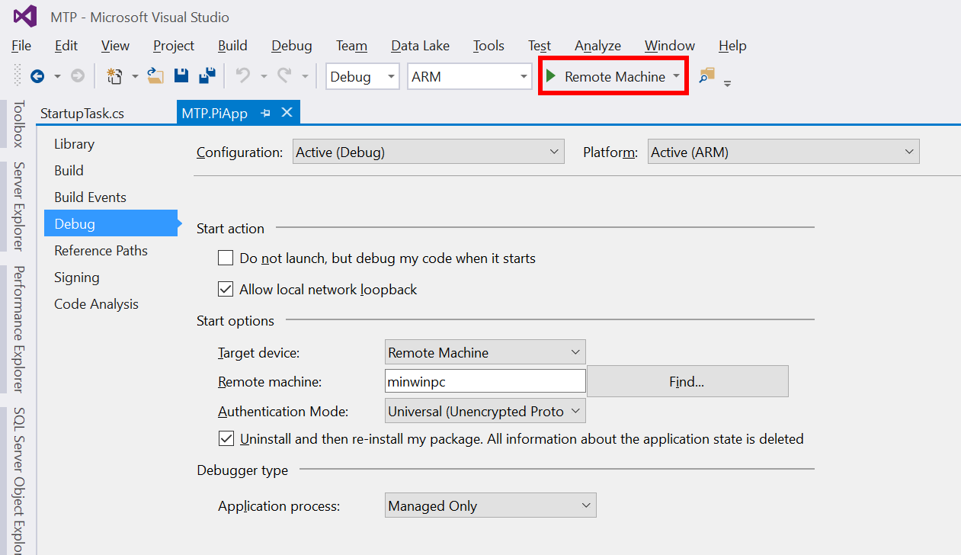
   3. The code will begin running.

## Verify Data Stream

Ensure the code is running still in debug mode from the previous section (Device Application Code). The device explorer has a listening that watches the cloud based data stream. We can verify telemetry has reached the cloud by ensuring messages make it here.

1. Open the Device Explorer
2. Navigate to the Data Tab
   1. 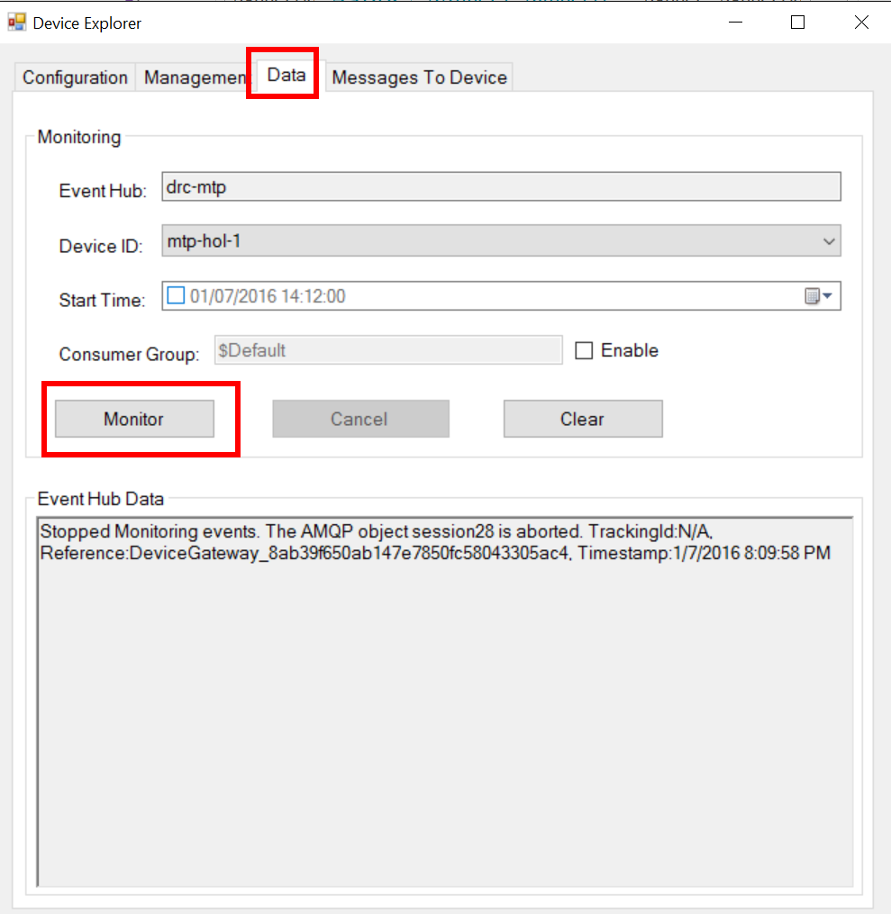
   2. Click “Monitor”
3. 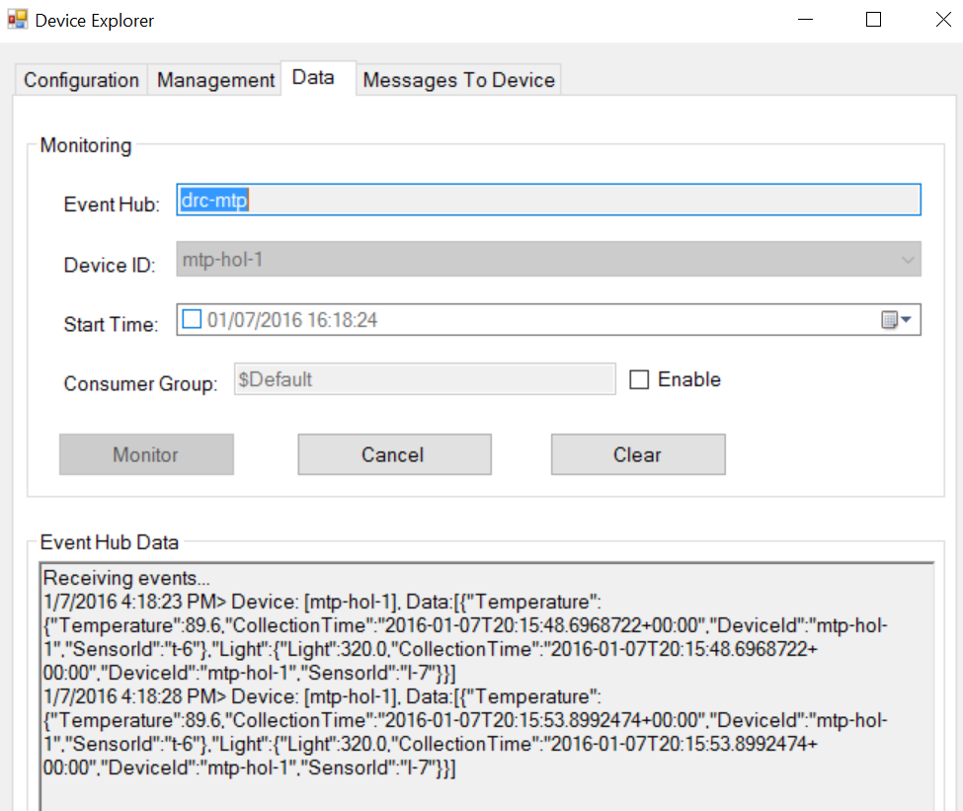
   1. You should see events beginning to come across like so.
   2. If you do not, try restarting the device explorer.
   3. Other common problems include:
      1. SAS token that has gone invalid.
      2. Message overload.
      3. Poor connectivity.
      4. Failed DNS configuration.
4. You can alternatively verify messages by first navigating to the Azure Portal.
   1. 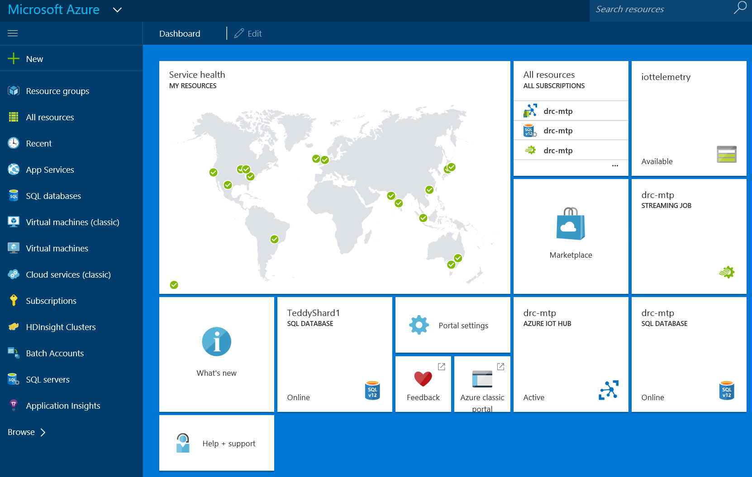
5. Click on your IoT Hub
   1. Notice the number of messages sent
   2. 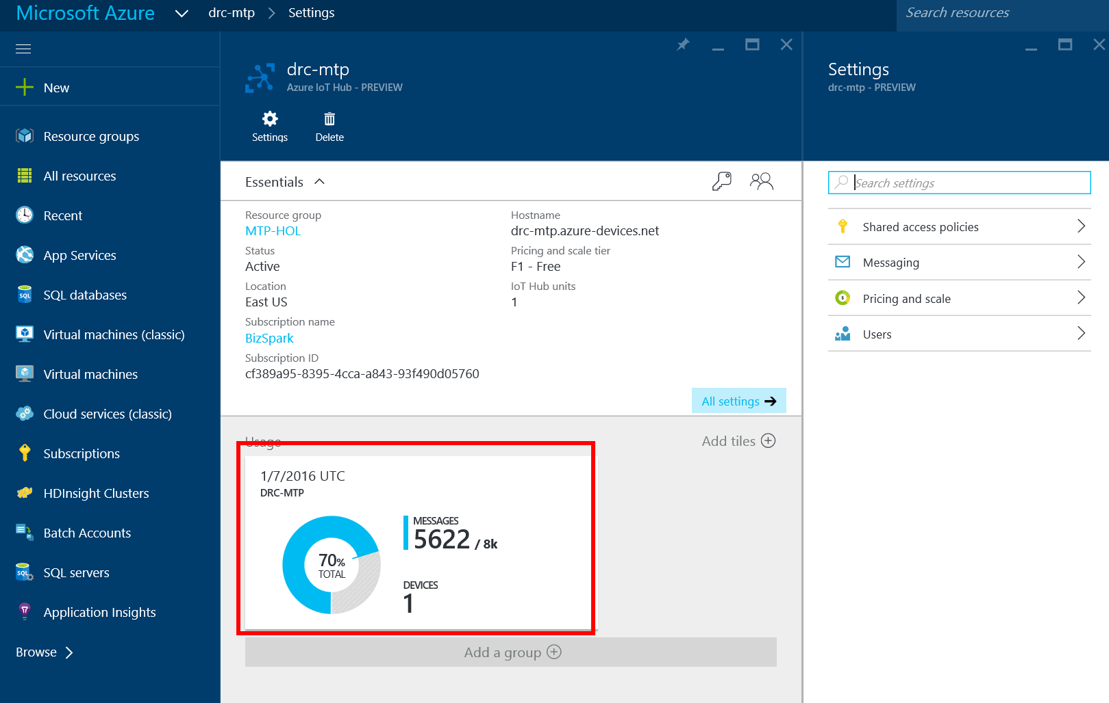

## Stream Query and Routing

This is a continuation from the previous parts. A live stream must exist for this section to work. As the free tier is only 8,000 messages/day, feel free to increase the task delay to reduce the quantity of messages sent.

1. For this portion, it helps to have two tabs open on Azure.com
2. Navigate (both tabs) to Azure.com
   1. 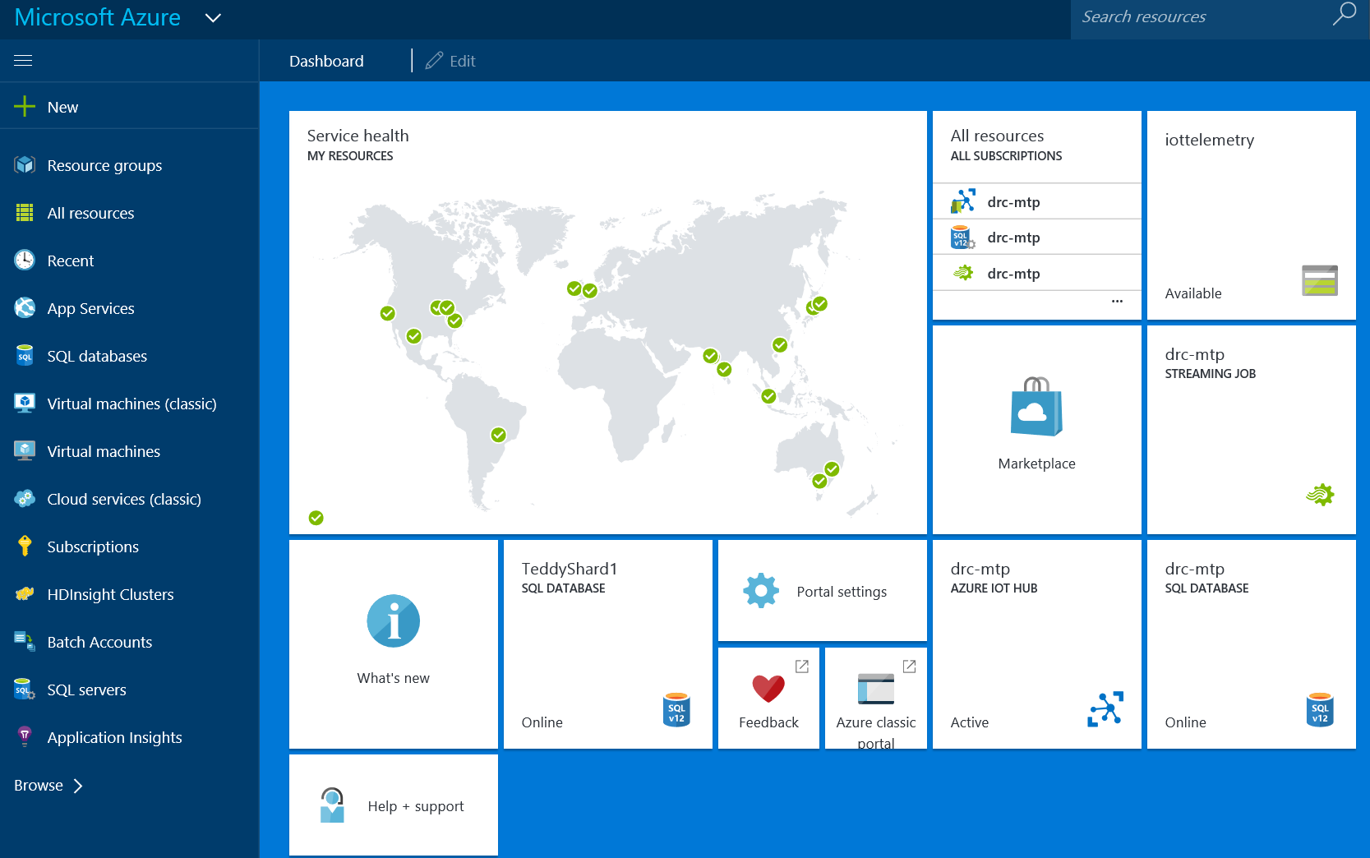
3. Click on your Streaming Job
   1. 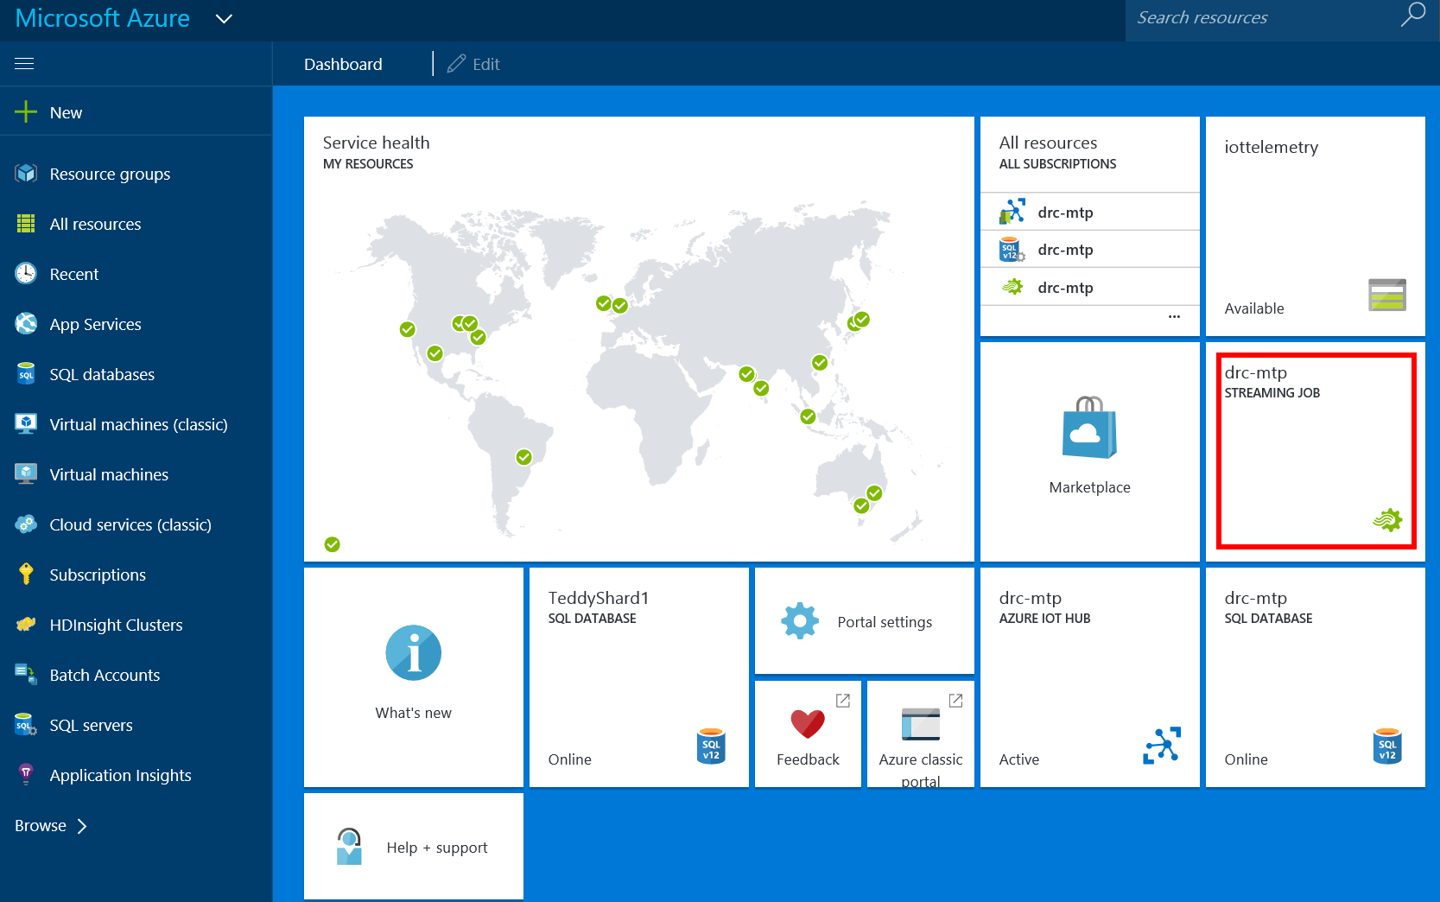
4. Click on Inputs
   1. 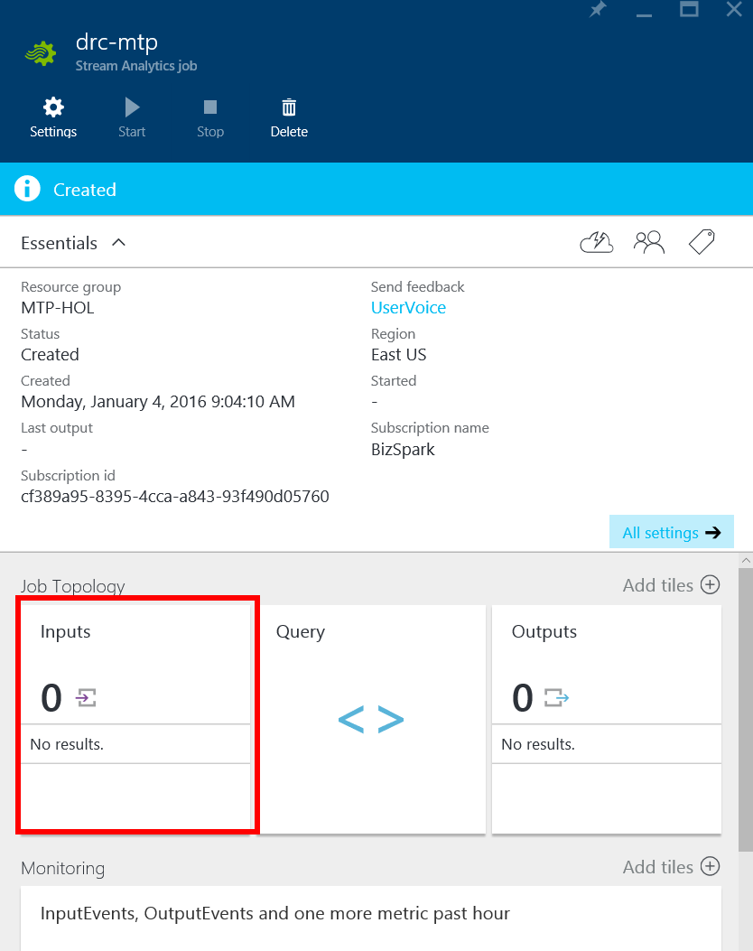
5. Click “Add”
   1. 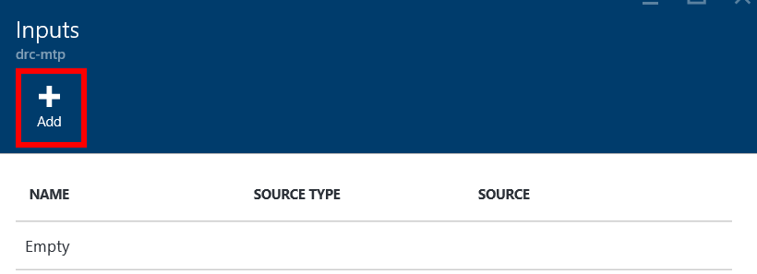
6. You will see a series of configurations
   1. 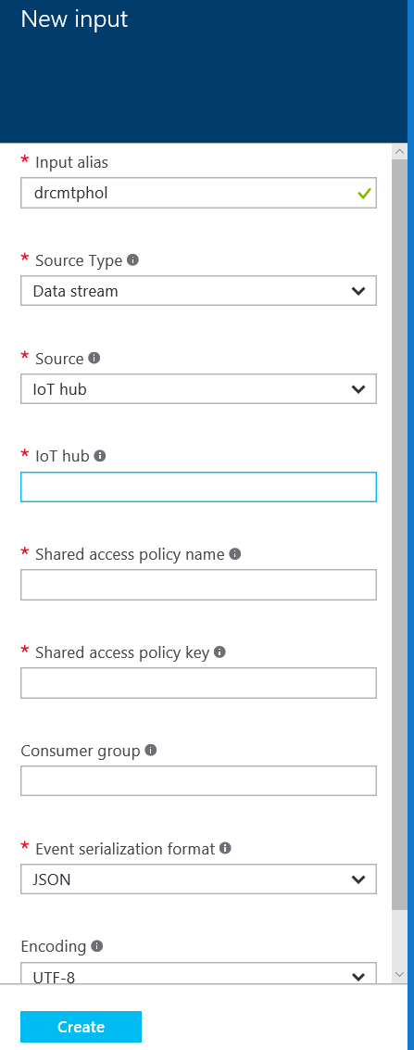
7. From your other tab, navigate to your IoT Hub
   1. It will be easier to copy many of these settings form the tab with IoT Hub open into the tab with the Streaming Job open.
   2. 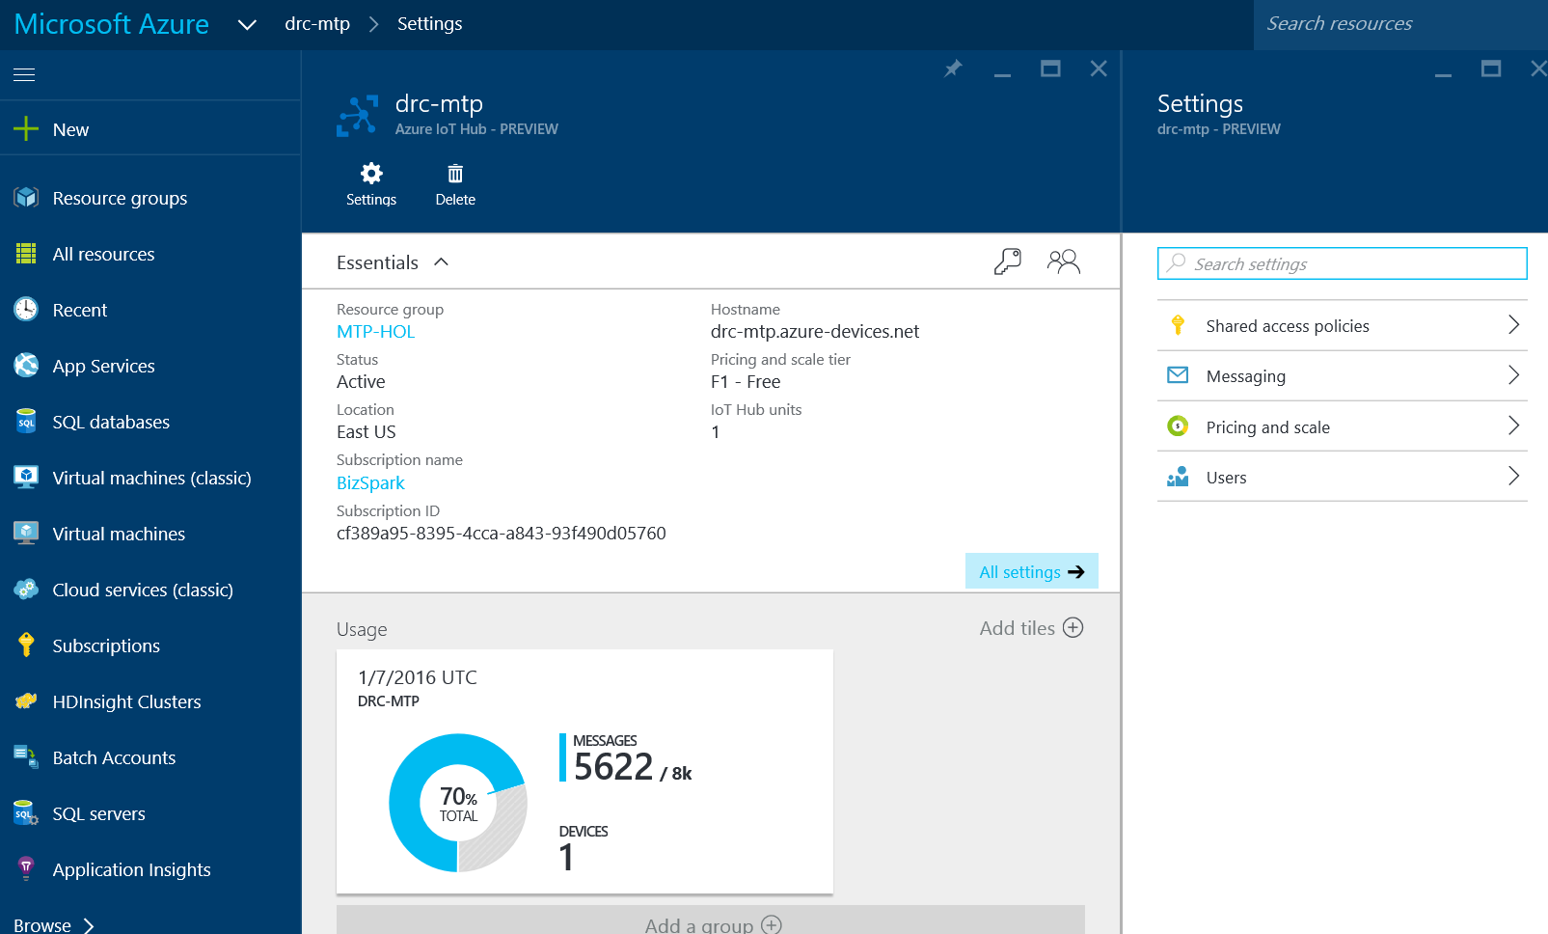
   3. Copy the IoT Hub name into the Streaming Job’s IoT Hub section
      1. 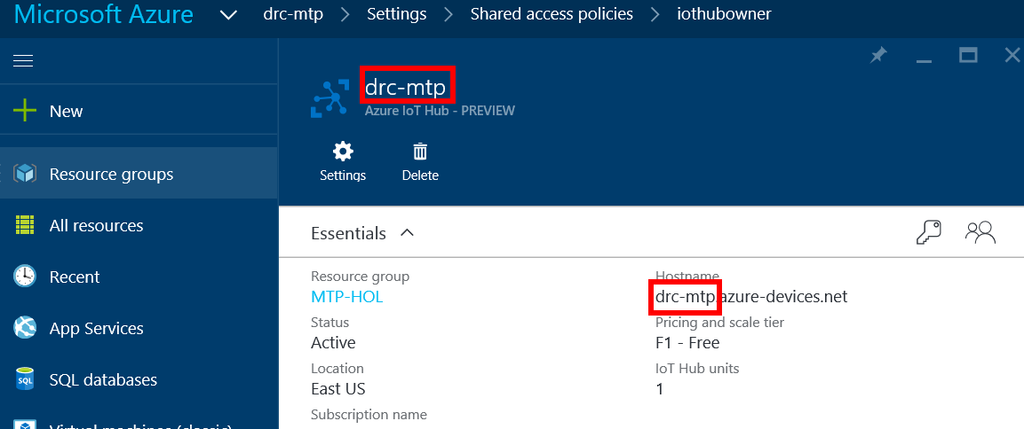
      2. 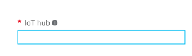
   4. Type “iothubowner” into the shared access policy name area
      1. 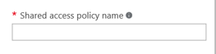
   5. Copy the “iothubowner” shared access policy key from the iothubowner settings
      1. 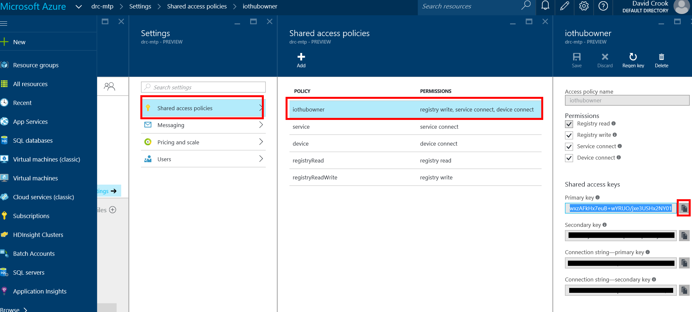
      2. 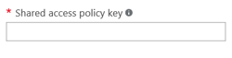
   6. The rest of the settings can be left at their defaults for this scenario.
8. When Complete, Click Create
   1. 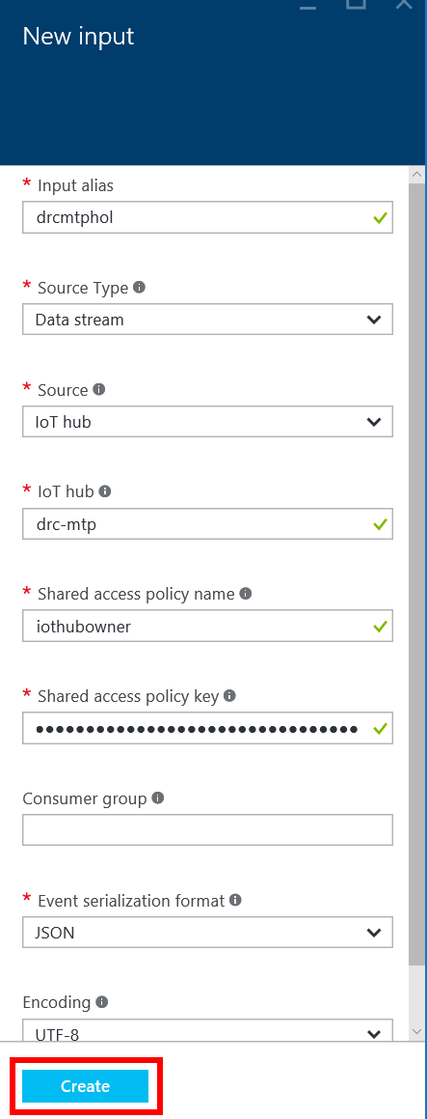
9. Click on Outputs
   1. 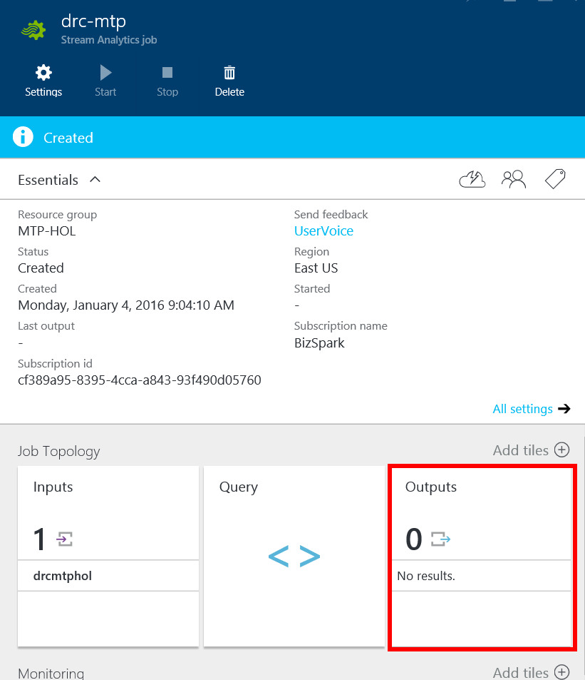
10. Click on “Add”
    1. 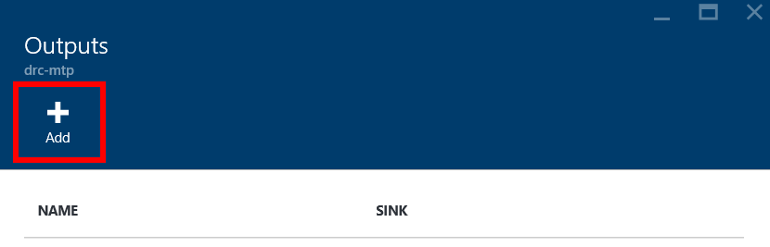
11. You will see a series of configurations
    1. Set output alias to “sqlTemperatures”
    2. Sink is “SQL database”
    3. 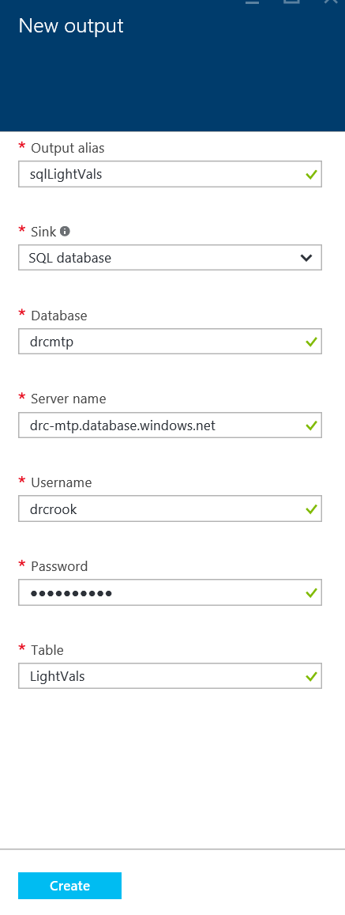
12. From your second tab, navigate to your SQL DB
    1. 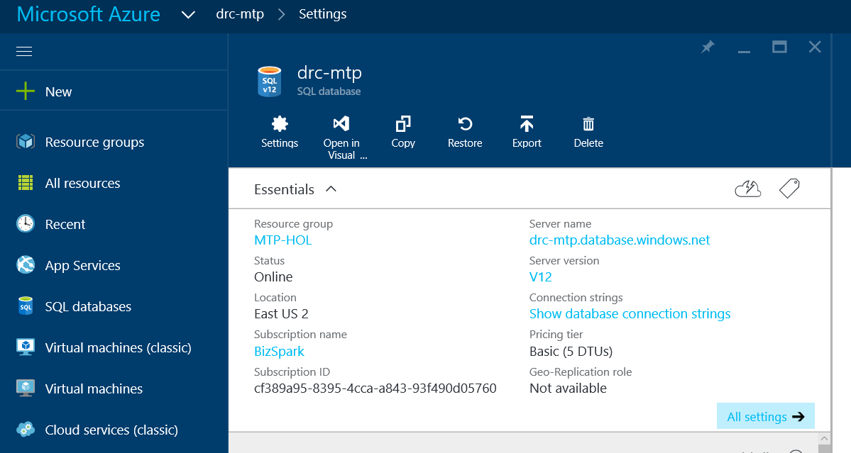
    2. Copy your DB name and Server Name into the configuration
       1. 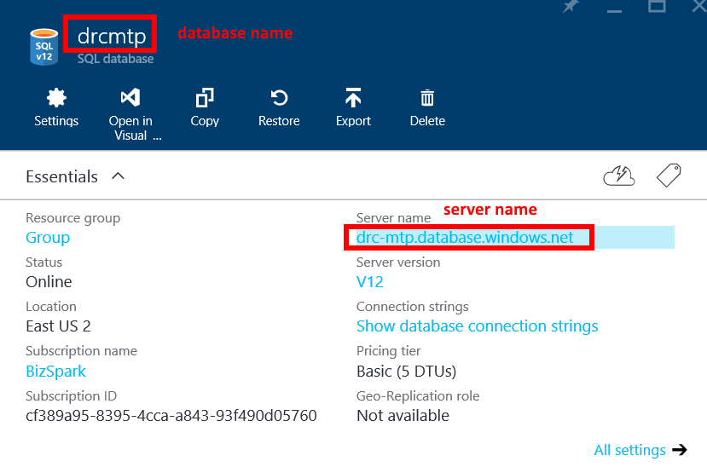
       2. 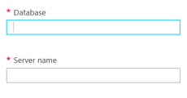
    3. Your username is “drcrook”
       1. Unless you specified otherwise
    4. Your password is “David!2345”
       1. Unless you specified otherwise
    5. For table, type “Temperatures” exactly as you did in the SQL DB Project
    6. Click “Create”
    7. 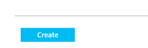
13. Repeat steps 9 – 12d
    1. Make the alias “sqlLightVals”
    2. For table, type “LightVals” exactly as you did in the SQL DB Project
    3. 
    4. Click “Create”
    5. 
14. Click on Query
    1. 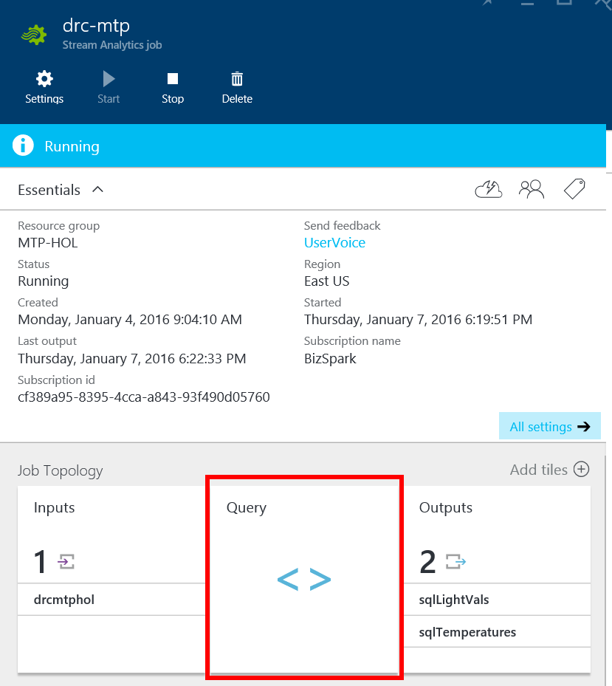
15. Type the following Query
    1. 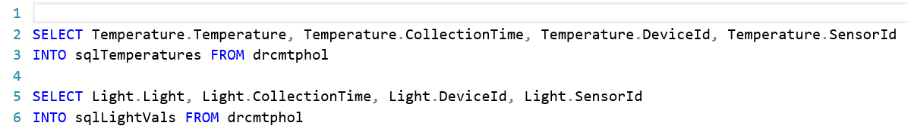
    2. The value after “INTO” should be your temperature and light output aliases
    3. The value after FROM should be your input alias
16. Click Save
    1. 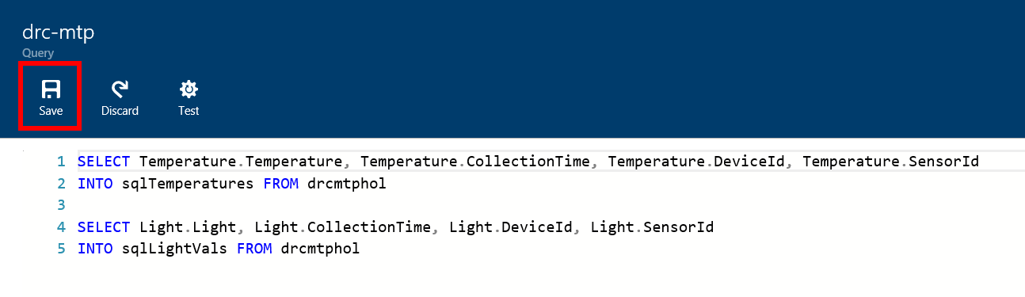
17. Click “Start” on the Stream Job
    1. 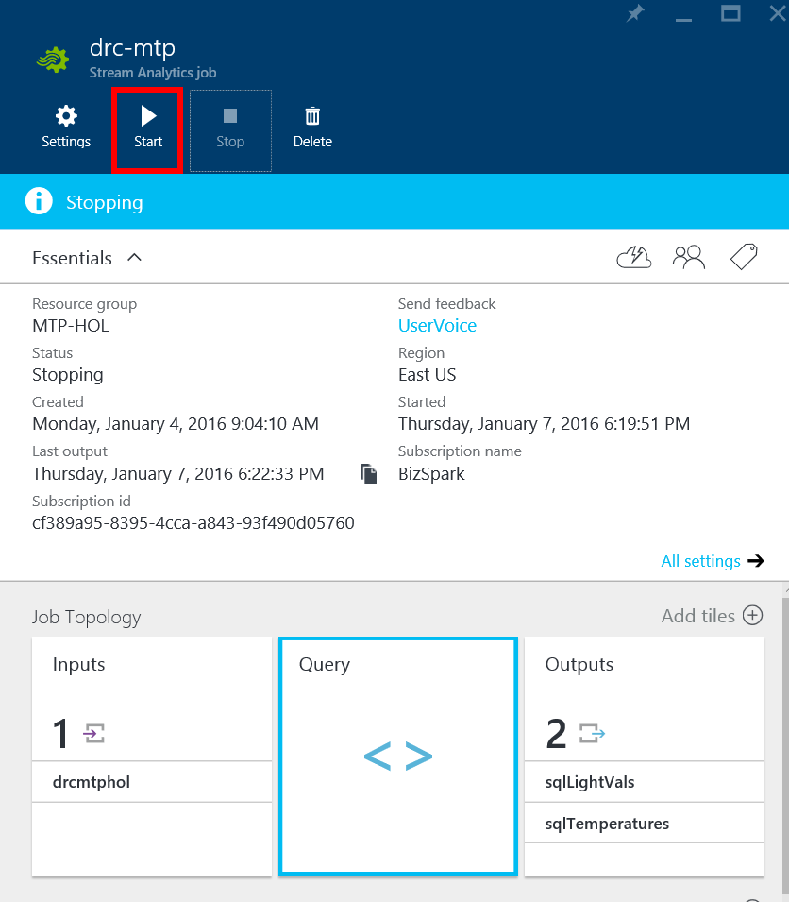

## Verify Stream To Storage

This is great and all, theoretically we have a data stream, which is an aggregate of telemetry from n devices dropping into two different outputs in SQL. But we should verify it.

1. From Visual Studio
   1. Click on View
      1. 
   2. Select “SQL Server Object Explorer”
2. Expand the Server hosting the mtp database.
   1. 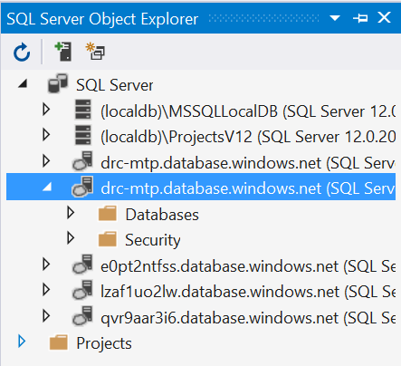
   2. Expand Databases
      1. 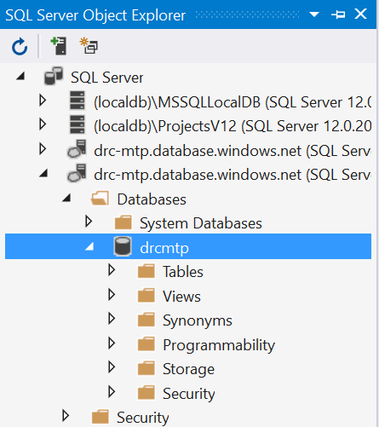
   3. Right click your database
   4. Select “New Query”
3. Execute the query “Select * from Temperatures”
   1. 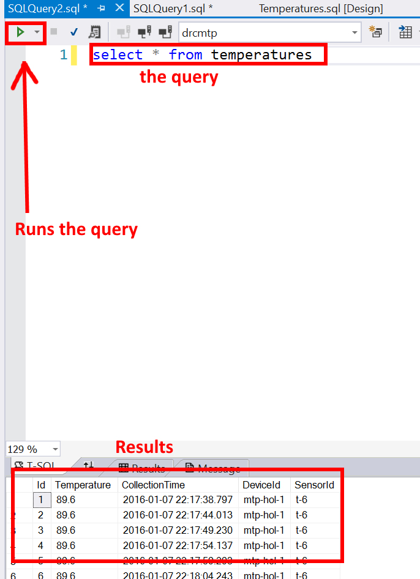
   2. If you have results, you are golden!
4. Repeat step 3 with the query
   1. “Select * from LightVals”
   2. 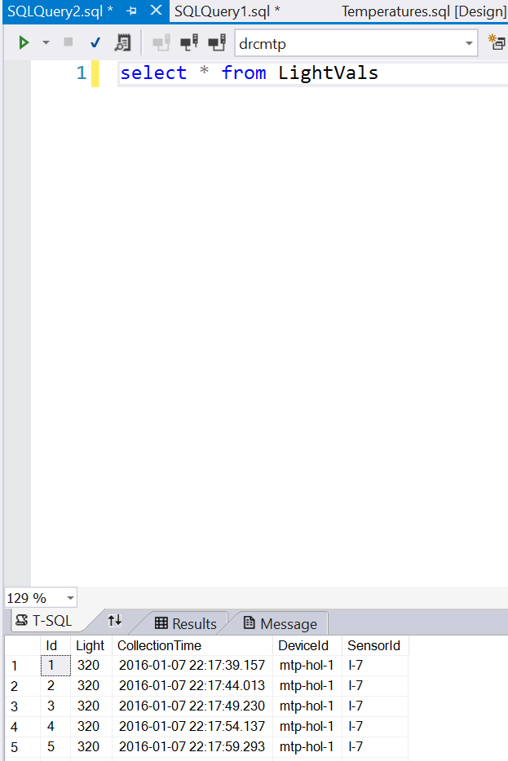

# Part 4: Real Time Visualization

For real time visualization, we are going to use Power BI. Power BI has extensive visualization capabilities that are built on top of d3js with the ability to add your own visualizations in or pull from the open community. Part of what is great about Power BI is the exports, permissions and ability to tie directly into Stream Analytics.

## Add Power BI Output to Stream ANalytics

We will not be creating a new domain user for this instance. You will need to use your work or edu email address until at a further time personal email addresses are enabled for power bi.

1. Navigate to the classic portal manage.windowsazure.com
2. On the left pane, scroll and click on “Stream Analytics”
   1. 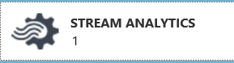
3. You should see the stream analytics instance we created in the provisioning section of this lab.
   1. 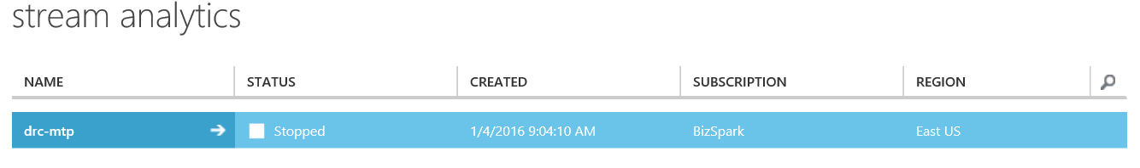
4. Click on the instance.
5. Click on “Outputs”
   1. 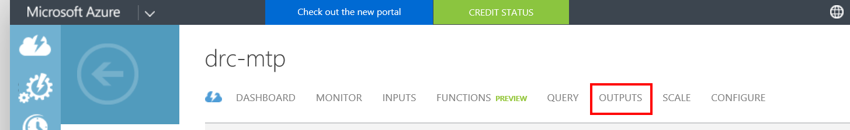
6. On the bottom pane, click “Add Output”
   1. 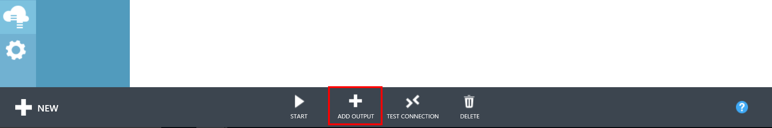
7. Select “Power BI”
   1. 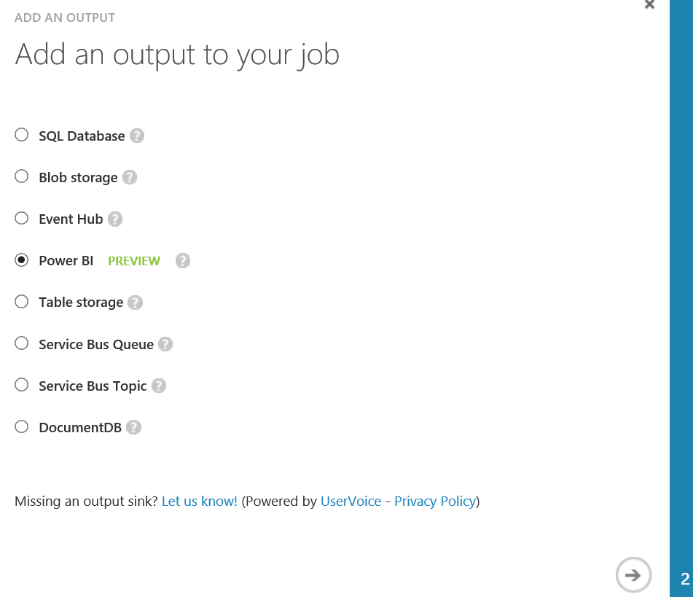
8. Click the “Authorize Now” link under Authorize Connection
   1. 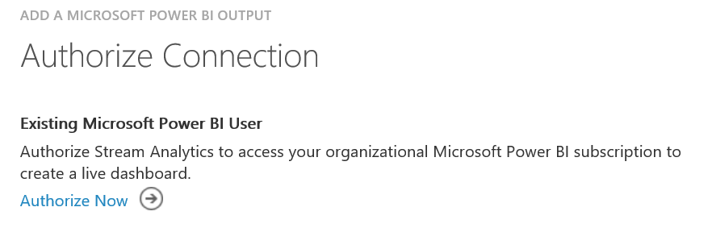
9. Enter your work or edu email address.
   1. Mine is: dacrook@microsoft.com
10. You will then be redirected to a new view. Populate the form
    1. 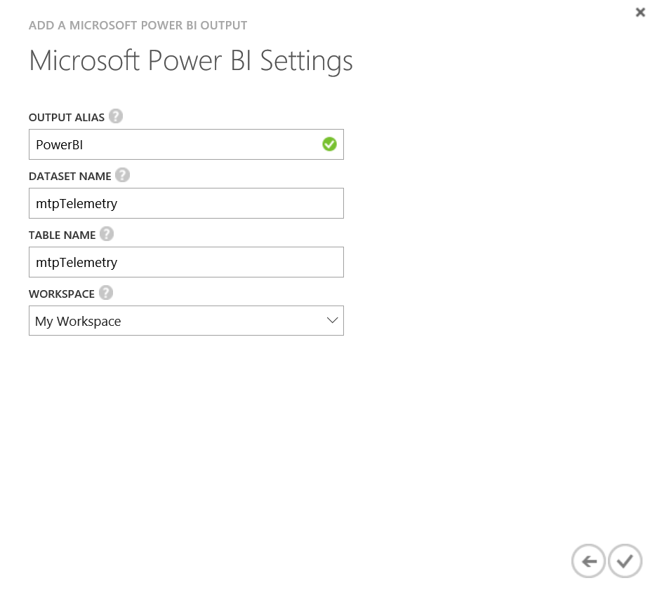
11. Click the checkbox

## Add Power BI to Query

1. Navigate back to the modern portal ([www.azure.com](http://www.azure.com))
   1. Click portal in the top right
   2. 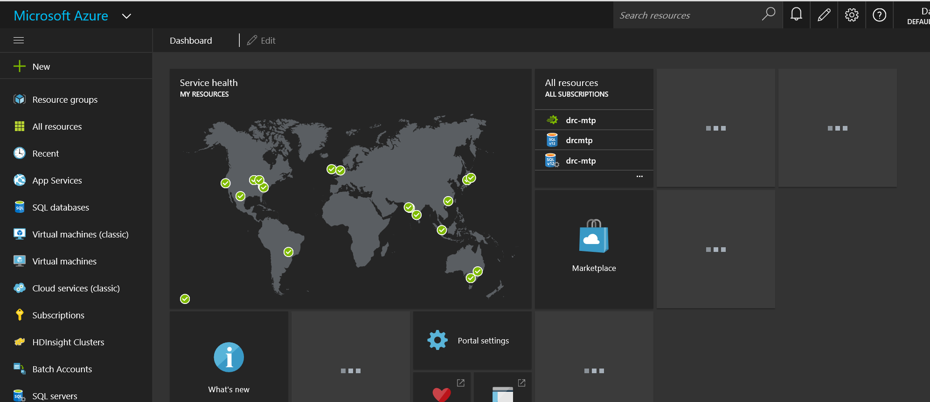
2. Click on your streaming job
3. Click on “Query”
4. Add the following Query at the bottom of the already existing queries
   1. 
5. Start the Job

## Visualize with Power BI

1. Navigate to <https://powerbi.microsoft.com/en-us/>
2. Click “Sign In”
3. Login with the same account you created your Stream Analytics Power BI output with.
4. You will see a view similar to below
   1. 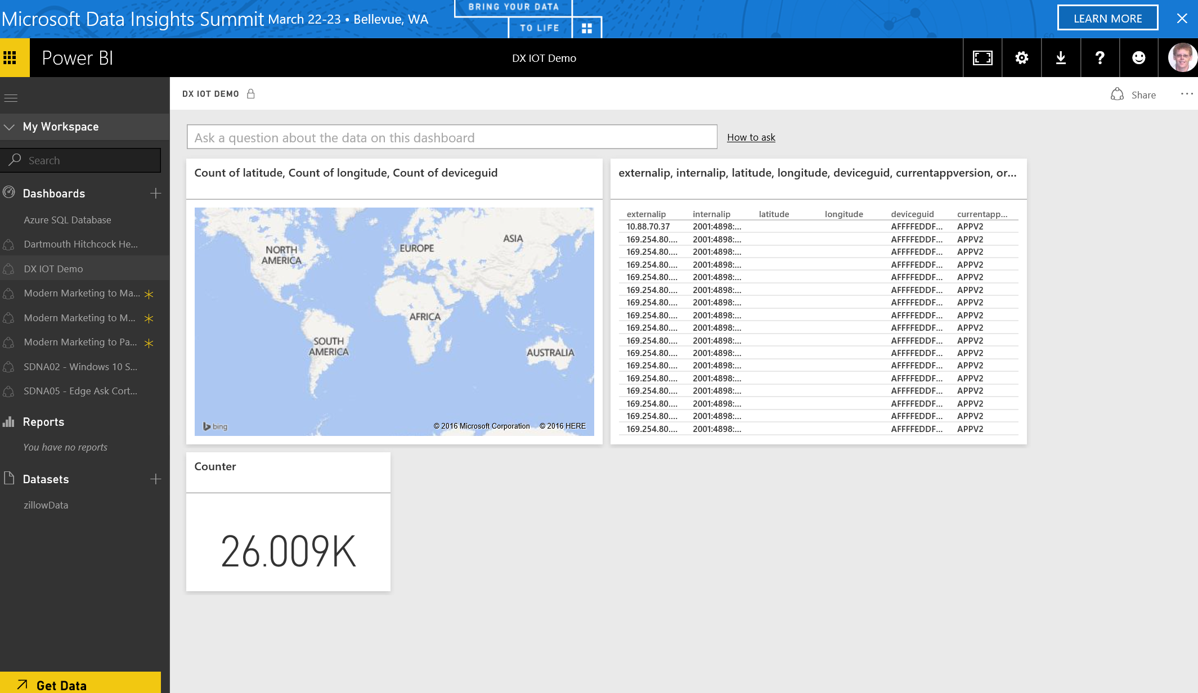
5. Click the + button next to dashboards
   1. 